# Supplementary Figures

**Distribution of recombination hotspots on a chromosome**

The distribution of recombination hotspots on a chromosome can influence the structural rearrangements in a genome. Chromosomes have different lengths, which could impact the distribution of recombination hotspots on a chromosome and overall rearrangements landscape in a genome. To ascertain whether chromosome length correlates with the distribution of recombination hotspots and if the distribution pattern is similar among chromosomes, we used kernel density estimate plots and cumulative distribution function plots. These plots showed the local and overall pattern of distribution of recombination hotspots between any pair of chromosomes. The results revealed that the distribution of recombination hotspots on a chromosome is independent of length and such distribution is different for every chromosome.

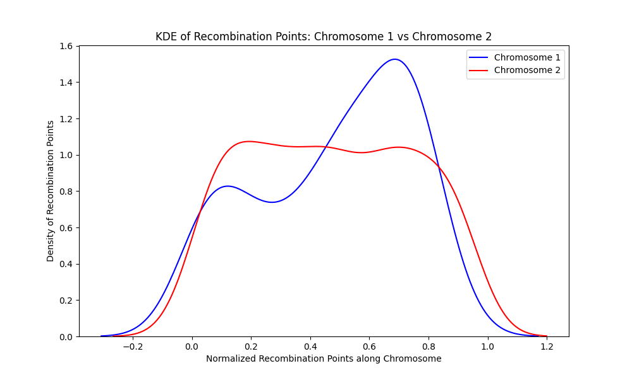

**Figure 1**. A kernel density estimates of chromosome 1 and chromosome 2 shows that recombination points are distributed differently along the length of the chromosomes. Chromosome 1 (blue) has a valley (area of sparse distribution of recombination points) and two peaks (area of concentrated recombination points) while chromosome 2 (red) has two valleys and two peaks. The sharp peak in chromosome 1 shows a high concentration of recombination points at that part of the chromosome.

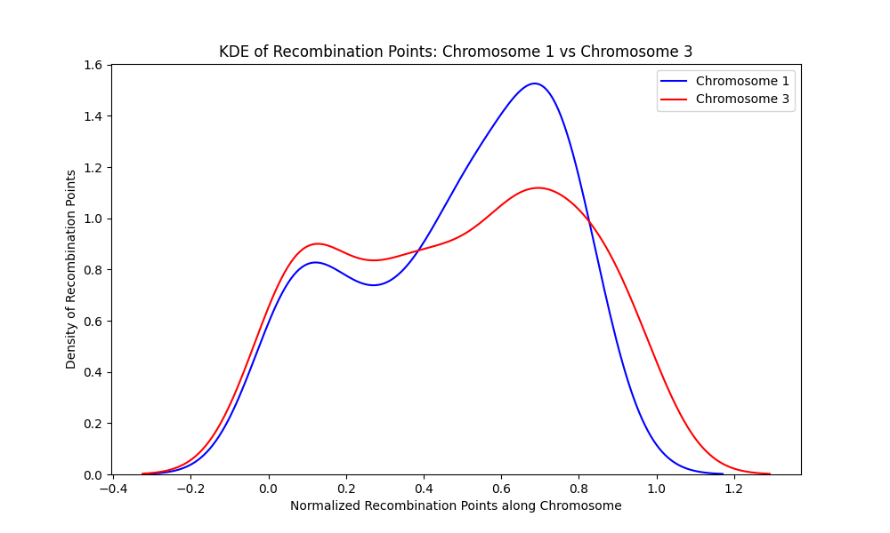

**Figure 2.** A kernel density estimate of chromosome 1 and chromosome 3 shows that recombination points are distributed differently along the length of the chromosomes. Chromosome 1 (blue) has a valley (area of sparse distribution of recombination points) and two peaks (area of concentrated recombination points) while chromosome 3 (red) has one valley and two peaks. The sharp peak in chromosome 1 shows a high concentration of recombination points at that part of the chromosome.

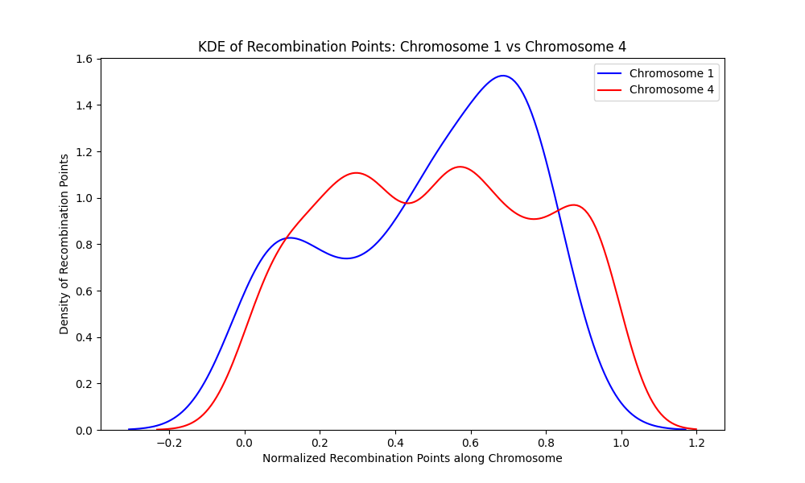

**Figure 3**. A kernel density estimate of chromosome 1 and chromosome 4 shows that recombination points are distributed differently along the length of the chromosomes. Chromosome 1 (blue) has a valley (area of sparse distribution of recombination points) and two peaks (area of concentrated recombination points) while chromosome 4 (red) has two valleys and three peaks. The sharp peak in chromosome 1 shows a high concentration of recombination points at that part of the chromosome.

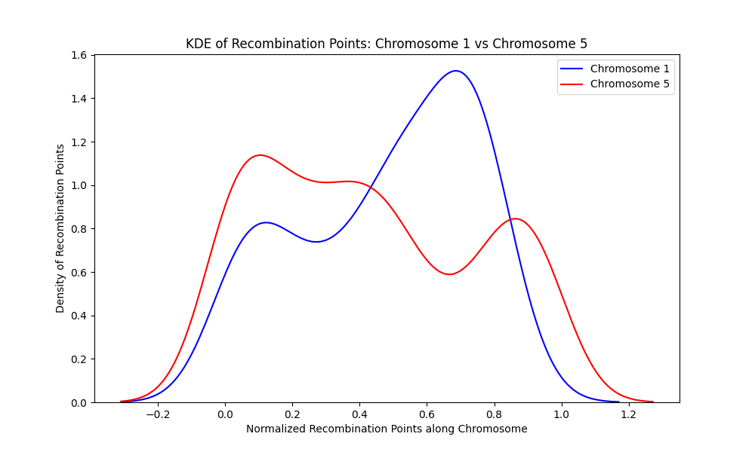

**Figure 4**. A kernel density estimate of chromosome 1 and chromosome 5 shows that recombination points are distributed differently along the length of the chromosomes. Chromosome 1 (blue) has a valley (area of sparse distribution of recombination points) and two peaks (area of concentrated recombination points) while chromosome 1 (red) has two valleys and three peaks. The sharp peak in chromosome 1 shows a high concentration of recombination points at that part of the chromosome.

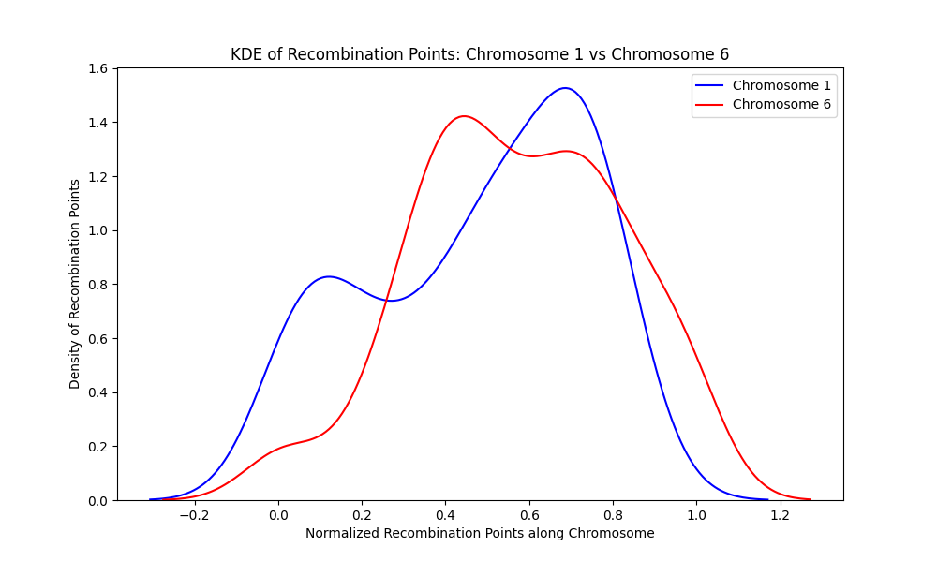

**Figure 5**. A kernel density estimate of chromosome 1 and chromosome 6 shows that recombination points are distributed differently along the length of the chromosomes. Chromosome 1 (blue) has a valley (area of sparse distribution of recombination points) and two peaks (area of concentrated recombination points) while chromosome 6 (red) has two valleys and two peaks. The sharp peak in chromosome 1 shows a high concentration of recombination points at that part of the chromosome.

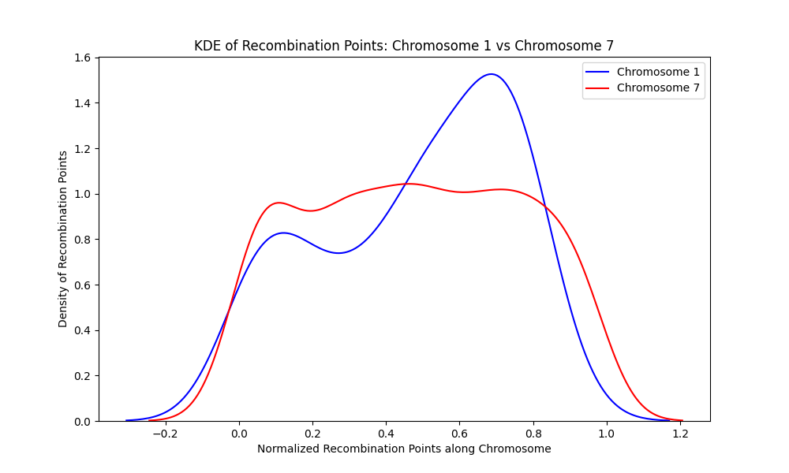

**Figure 6**. A kernel density estimate of chromosome 1 and chromosome 7 shows that recombination points are distributed differently along the length of the chromosomes. Chromosome 1 (blue) has a valley (area of sparse distribution of recombination points) and two peaks (area of concentrated recombination points) while chromosome 7 (red) has two valleys and three peaks. The sharp peak in chromosome 1 shows a high concentration of recombination points at that part of the chromosome.

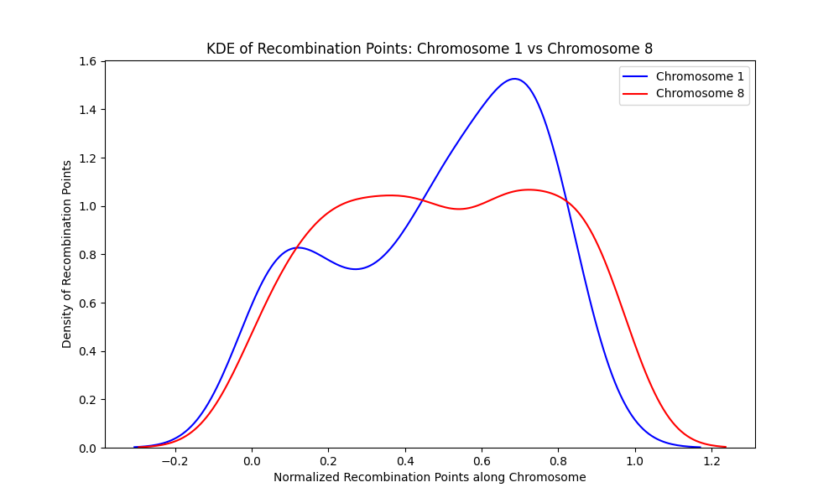

**Figure 7**. A kernel density estimate of chromosome 1 and chromosome 8 shows that recombination points are distributed differently along the length of the chromosomes. Chromosome 1 (blue) has a valley (area of sparse distribution of recombination points) and two peaks (area of concentrated recombination points) while chromosome 8 (red) has one valley and two peaks. The sharp peak in chromosome 1 shows a high concentration of recombination points at that part of the chromosome.

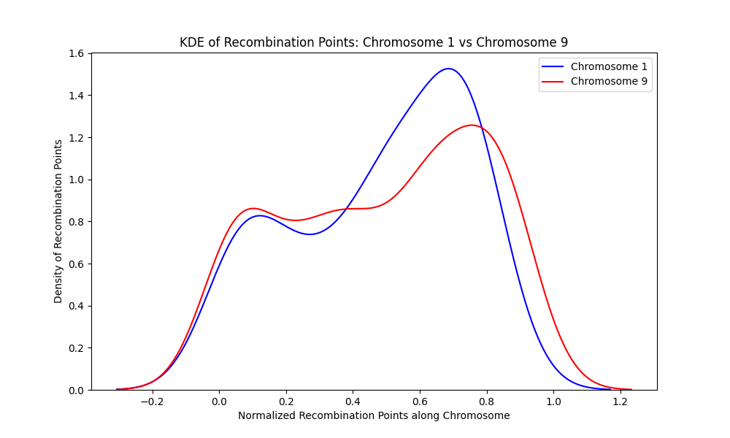

**Figure 8**. A kernel density estimate of chromosome 1 and chromosome 9 shows that recombination points are distributed differently along the length of the chromosomes. Chromosome 1 (blue) has a valley (area of sparse distribution of recombination points) and two peaks (area of concentrated recombination points) while chromosome 9 (red) has two valleys and three peaks. The sharp peak in chromosome 1 shows a high concentration of recombination points at that part of the chromosome.

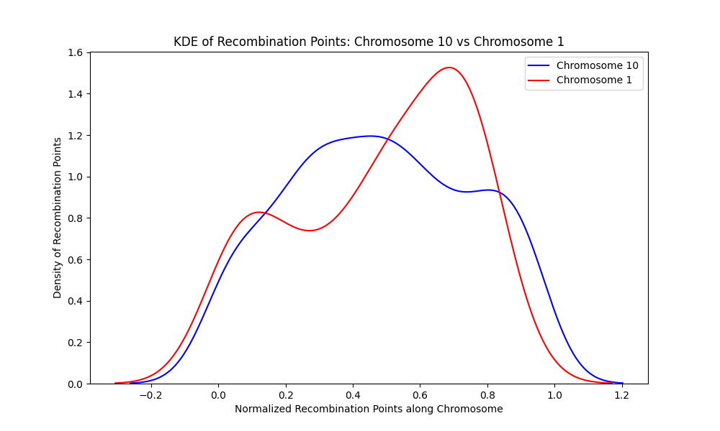

**Figure 9**. A kernel density estimate of chromosome 1 and chromosome 10 shows that recombination points are distributed differently along the length of the chromosomes. Chromosome 1 (red) has a valley (area of sparse distribution of recombination points) and two peaks (area of concentrated recombination points) while chromosome 10 (blue) has one valley and two peaks. The sharp peak in chromosome 1 shows a high concentration of recombination points at that part of the chromosome.

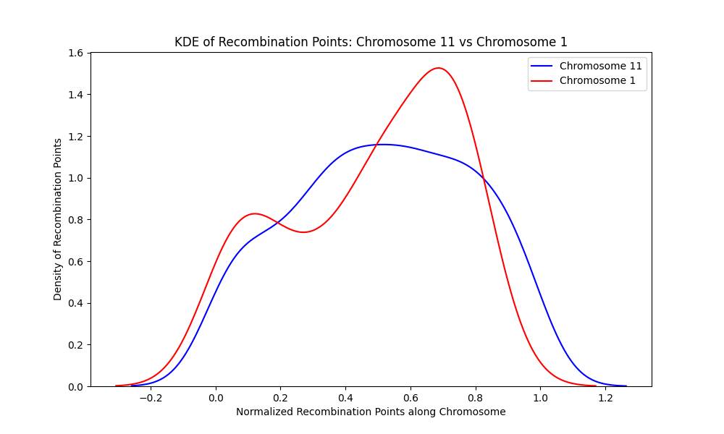

**Figure 10**. A kernel density estimate of chromosome 1 and chromosome 11 shows that recombination points are distributed differently along the length of the chromosomes. Chromosome 1 (red) has a valley (area of sparse distribution of recombination points) and two peaks (area of concentrated recombination points) while chromosome 11 (blue) has one valley and one peak. The sharp peak in chromosome 1 shows a high concentration of recombination points at that part of the chromosome.

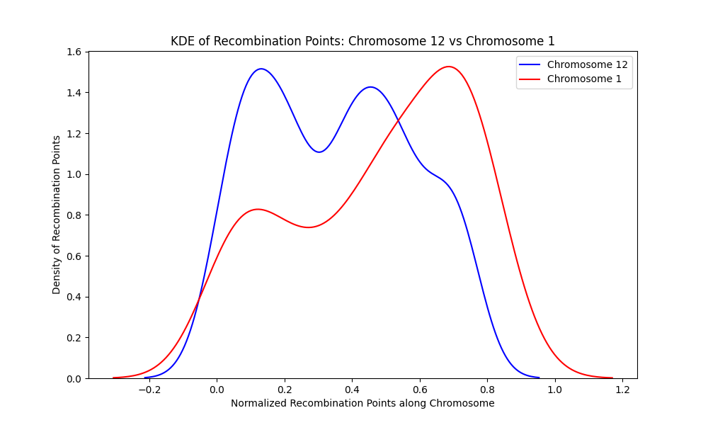

**Figure 11**. A kernel density estimate of chromosome 1 and chromosome 12 shows that recombination points are distributed differently along the length of the chromosomes. Chromosome 1 (red) has a valley (area of sparse distribution of recombination points) and two peaks (area of concentrated recombination points) while chromosome 12 (blue) has one valley and two peaks. The sharp peak in chromosome 1 shows a high concentration of recombination points at that part of the chromosome

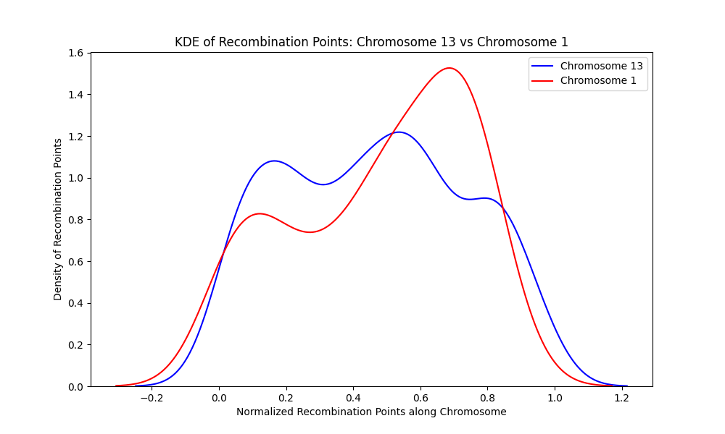

**Figure 12**. A kernel density estimate of chromosome 1 and chromosome 13 shows that recombination points are distributed differently along the length of the chromosomes. Chromosome 1 (red) has a valley (area of sparse distribution of recombination points) and two peaks (area of concentrated recombination points) while chromosome 13 (blue) has two valleys and three peaks.

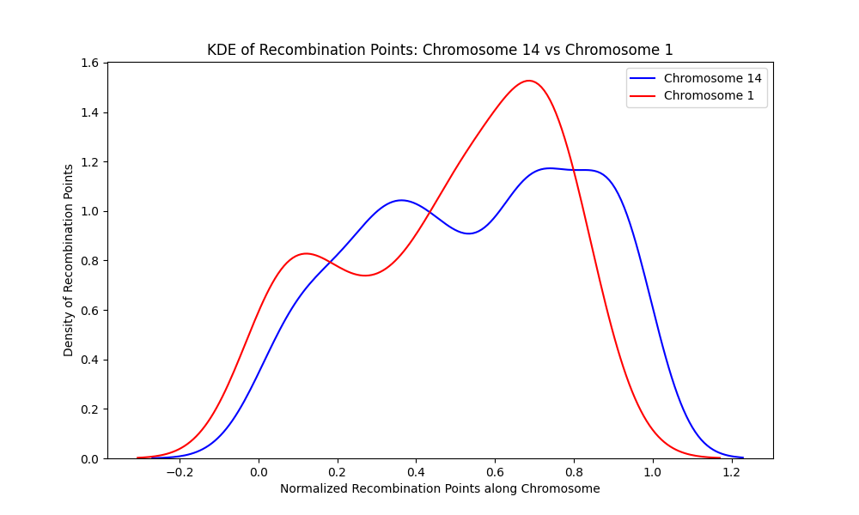

**Figure 13**. A kernel density estimate of chromosome 1 and chromosome 14 shows that recombination points are distributed differently along the length of the chromosomes. Chromosome 1 (red) has a valley (area of sparse distribution of recombination points) and two peaks (area of concentrated recombination points) while chromosome 14 (red) has one valley and two peaks. The sharp peak in chromosome 1 shows a high concentration of recombination points at that part of the chromosome

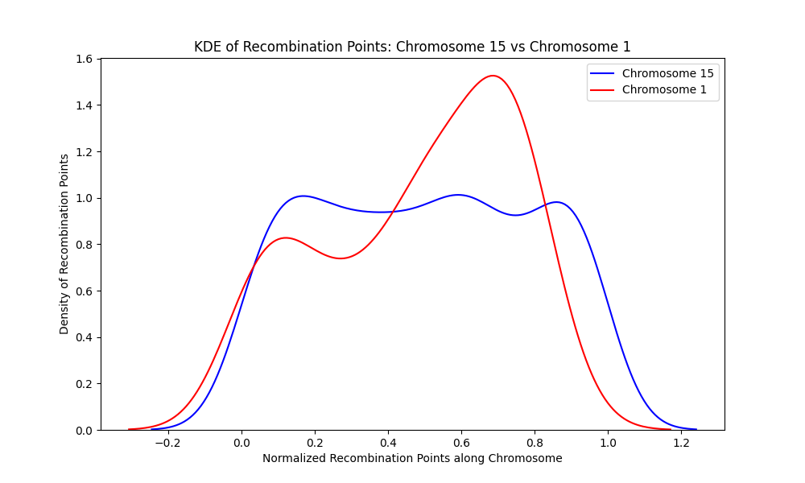

**Figure 14**. A kernel density estimate of chromosome 1 and chromosome 15 shows that recombination points are distributed differently along the length of the chromosomes. Chromosome 1 (red) has a valley (area of sparse distribution of recombination points) and two peaks (area of concentrated recombination points) while chromosome 15 (blue) has two valleys and three peaks.

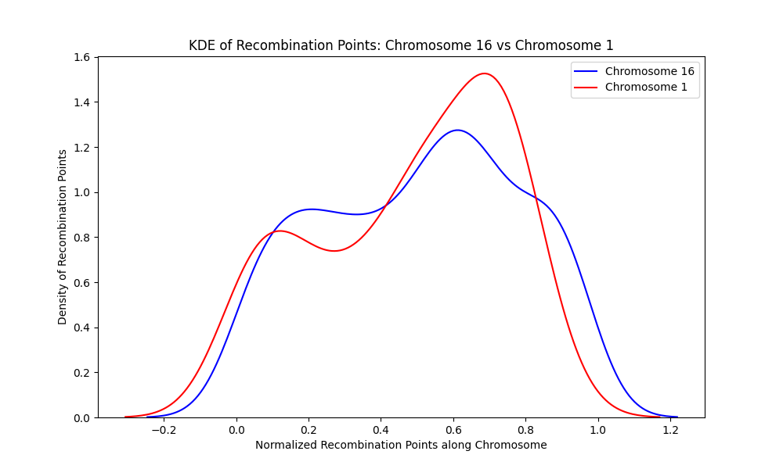

**Figure 15**. A kernel density estimate of chromosome 1 and chromosome 16 shows that recombination points are distributed differently along the length of the chromosomes. Chromosome 1 (red) has a valley (area of sparse distribution of recombination points) and two peaks (area of concentrated recombination points) while chromosome 16 (red) has one valley and two peaks.

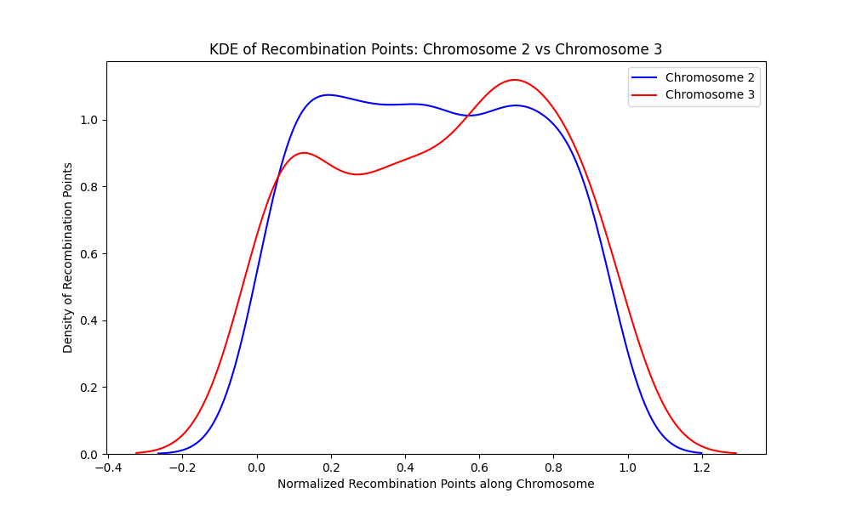

**Figure 16**. A kernel density estimate of chromosome 2 and chromosome 3 shows that recombination points are distributed differently along the length of the chromosomes. Chromosome 2 (blue) has two valleys (area of sparse distribution of recombination points) and two peaks (area of concentrated recombination points) while chromosome 3 also (red) has one valley and two peaks.

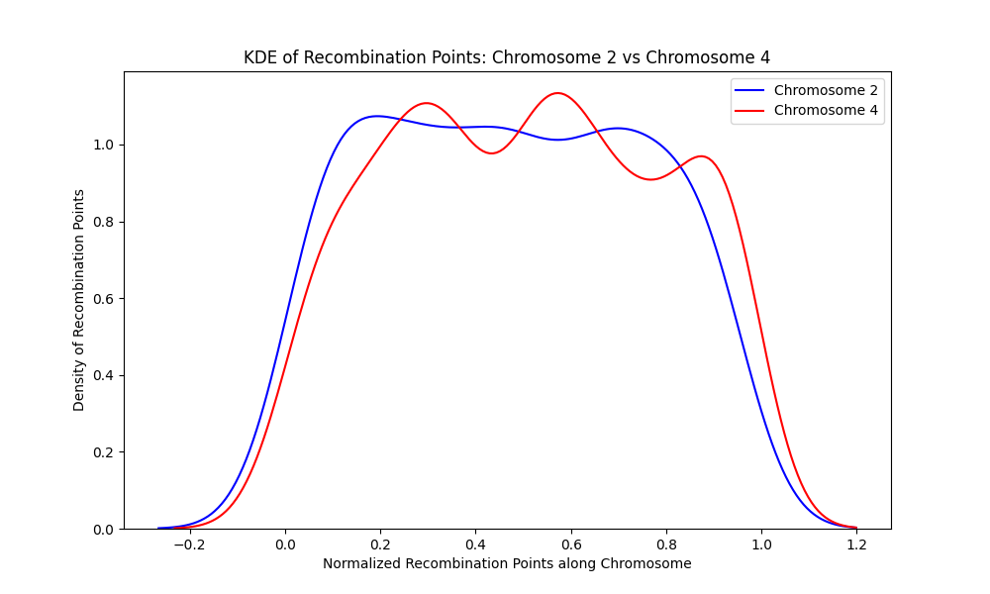

**Figure 17.** A kernel density estimate of chromosome 2 and chromosome 4 shows that recombination points are distributed differently along the length of the chromosomes. Chromosome 2 (blue) has two valleys (area of sparse distribution of recombination points) and two peaks (area of concentrated recombination points) while chromosome 4 (red) has two valleys and three peaks.

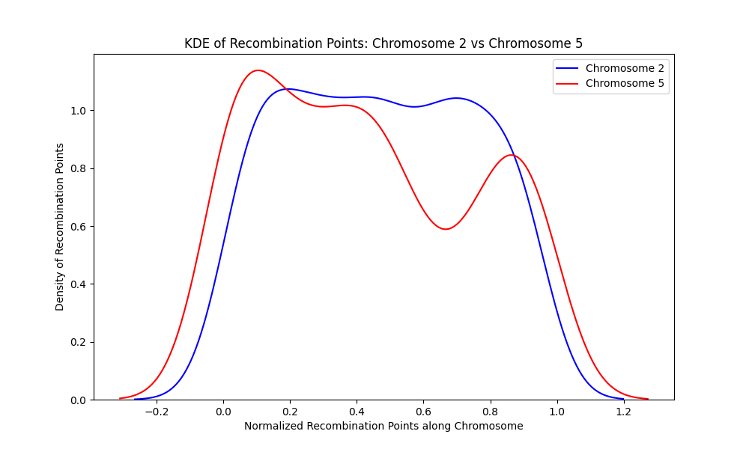

**Figure 18**. A kernel density estimate of chromosome 2 and chromosome 5 shows that recombination points are distributed differently along the length of the chromosomes. Chromosome 2 (blue) has two valleys (area of sparse distribution of recombination points) and two peaks (area of concentrated recombination points) while chromosome 5 (red) has two valleys and three peaks.

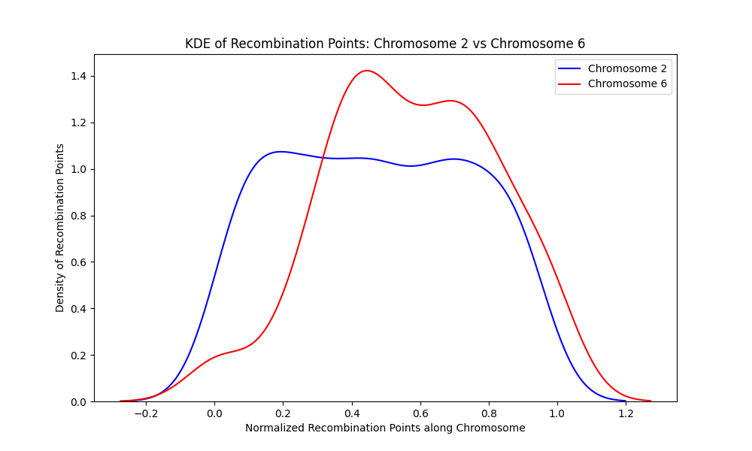

**Figure 19.** A kernel density estimate of chromosome 2 and chromosome 6 shows that recombination points are distributed differently along the length of the chromosomes. Chromosome 2 (blue) has two valleys (area of sparse distribution of recombination points) and two peaks (area of concentrated recombination points) while chromosome 6 (red) has one valley and two peaks

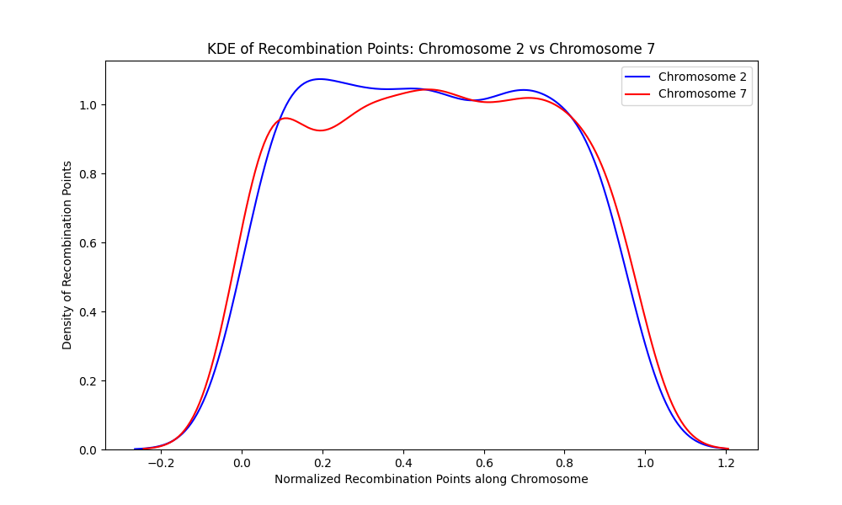

**Figure 20** A kernel density estimate of chromosome 2 and chromosome 7 shows that recombination points are distributed differently along the length of the chromosomes. Chromosome 2 (blue) has two valleys (area of sparse distribution of recombination points) and two peaks (area of concentrated recombination points) while chromosome 7 (red) has two valleys and three peaks.

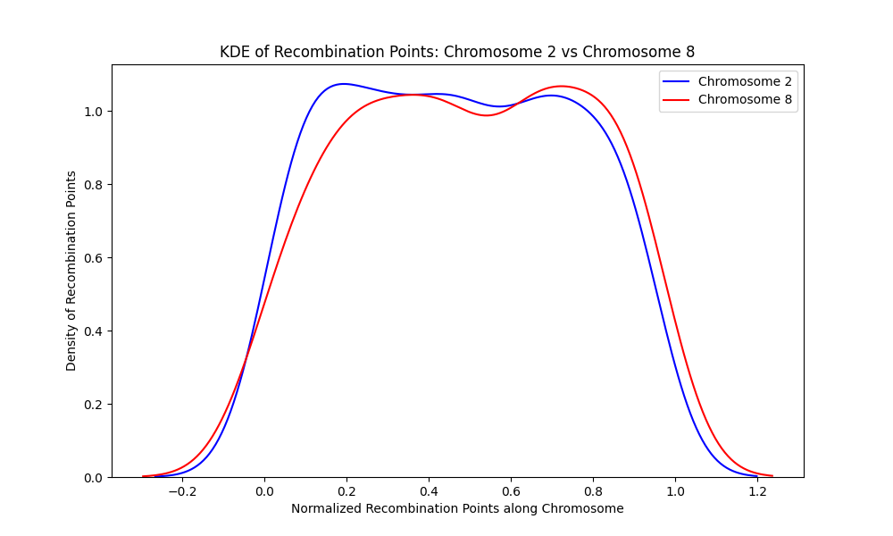

**Figure 21.** A kernel density estimate of chromosome 2 and chromosome 8 shows that recombination points are distributed differently along the length of the chromosomes. Chromosome 2 (blue) has two valleys (area of sparse distribution of recombination points) and two peaks (area of concentrated recombination points)while chromosome 8 (red) has one valley and two peaks.

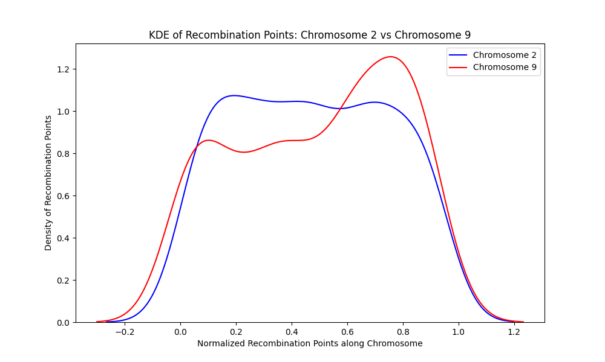

**Figure 22**. A kernel density estimate of chromosome 2 and chromosome 9 shows that recombination points are distributed differently along the length of the chromosomes. Chromosome 2 (blue) has two valleys (area of sparse distribution of recombination points) and two peaks (area of concentrated recombination points)while chromosome 9 (red) has two valleys and three peaks

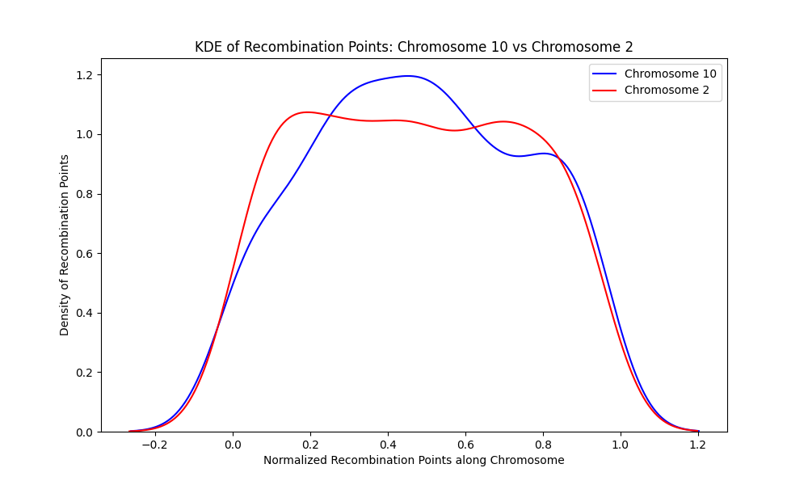

**Figure 23.** A kernel density estimate of chromosome 2 and chromosome 10 shows that recombination points are distributed differently along the length of the chromosomes. Chromosome 2 (red) has two valleys (area of sparse distribution of recombination points) and two peaks (area of concentrated recombination points) while chromosome 10 (blue) has one valley and one peak.

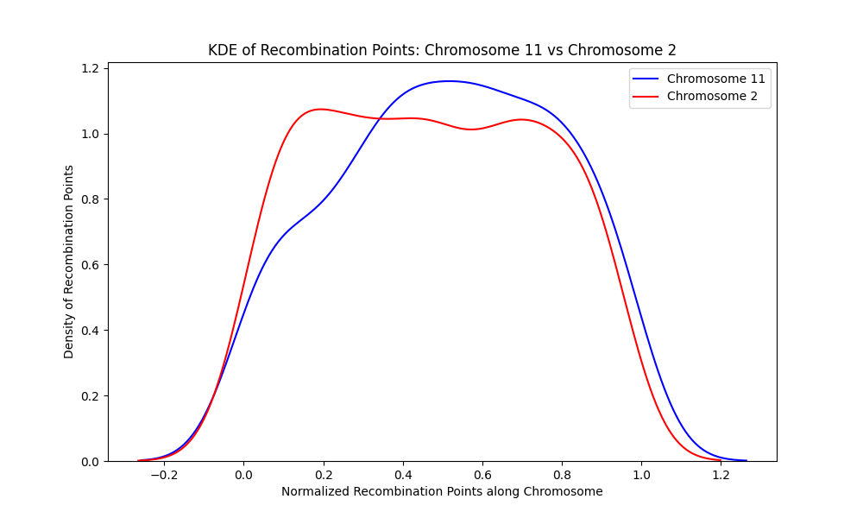

**Figure 24**. A kernel density estimate of chromosome 2 and chromosome 11 shows that recombination points are distributed differently along the length of the chromosomes. Chromosome 2 (red) has two valleys (area of sparse distribution of recombination points) and two peaks (area of concentrated recombination points) while chromosome 11 (blue) has one valley and one peak.

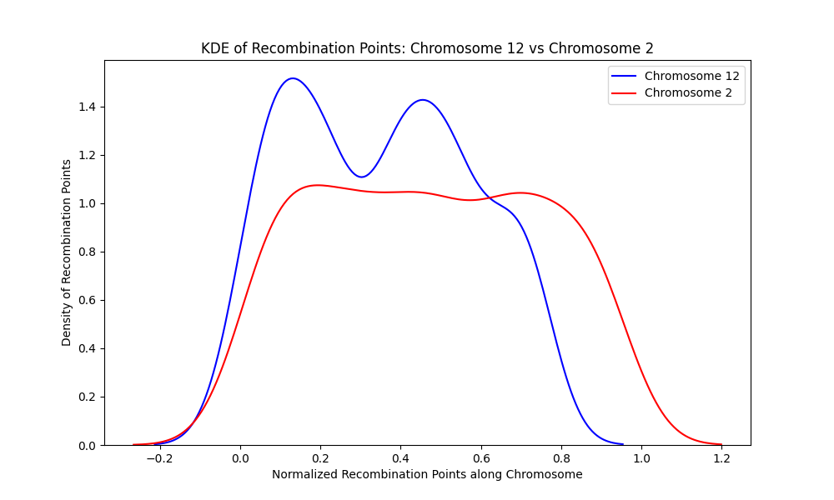

**Figure 25**. A kernel density estimate of chromosome 2 and chromosome 12 shows that recombination points are distributed differently along the length of the chromosomes. Chromosome 2 (red) has two valleys (area of sparse distribution of recombination points) and two peaks (area of concentrated recombination points)while chromosome 12 (blue) has one valley and two peaks.

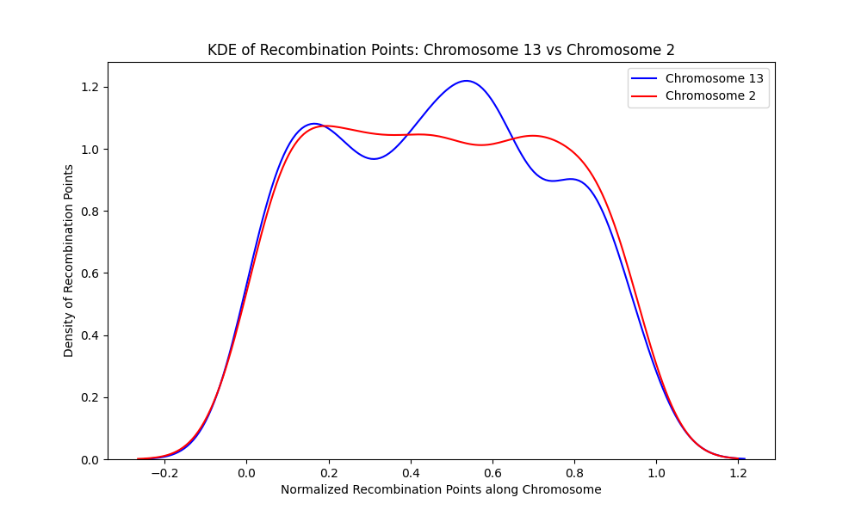

**Figure 26**. A kernel density estimate of chromosome 13 and chromosome 2 shows that recombination points are distributed differently along the length of the chromosomes. Chromosome 2 (red) has two valleys (area of sparse distribution of recombination points) and two peaks (area of concentrated recombination points) while chromosome 13 (red) has two valleys and three peaks.

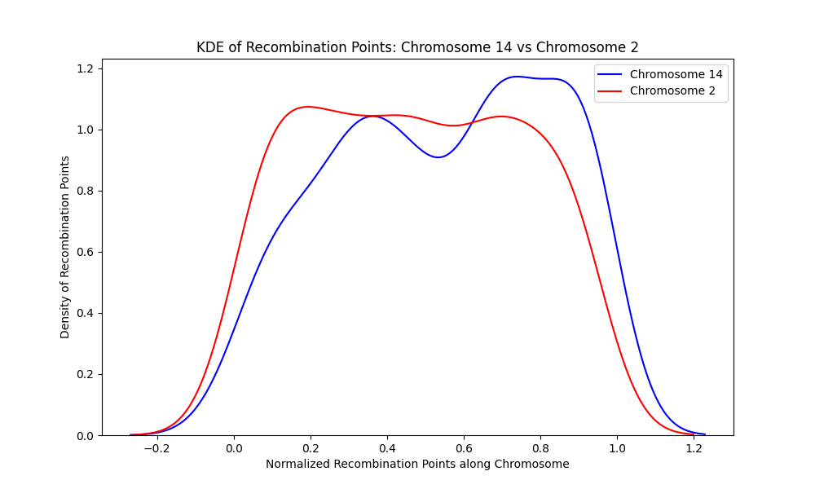

**Figure 27**. A kernel density estimate of chromosome 14 and chromosome 2 shows that recombination points are distributed differently along the length of the chromosomes. Chromosome 2 (red) has two valleys (area of sparse distribution of recombination points) and two peaks (area of concentrated recombination points) while chromosome 14 (red) has one valley and two peaks.

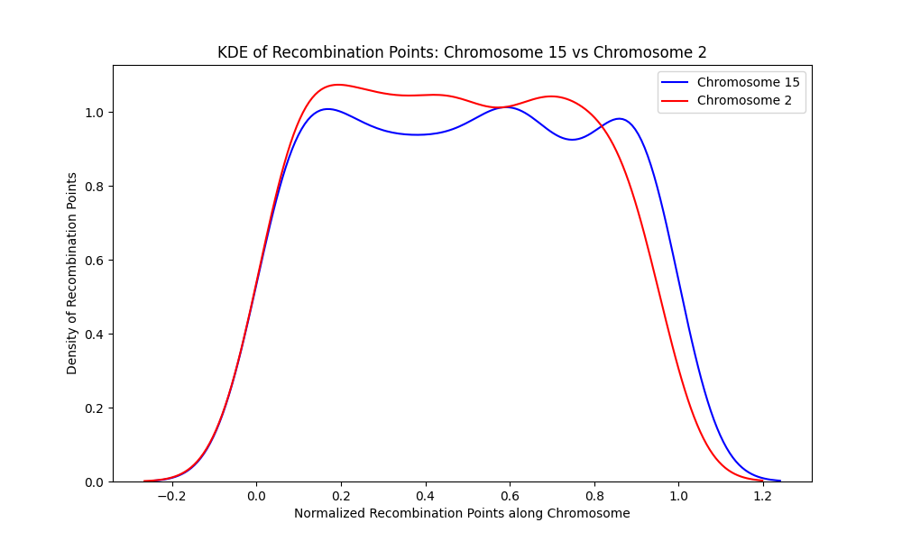

**Figure 28.** A kernel density estimate of chromosome 15 and chromosome 2 shows that recombination points are distributed differently along the length of the chromosomes. Chromosome 15 (blue) has two valleys (area of sparse distribution of recombination points) and three peaks (area of concentrated recombination points) while chromosome 2 (red) has two valleys and two peaks.

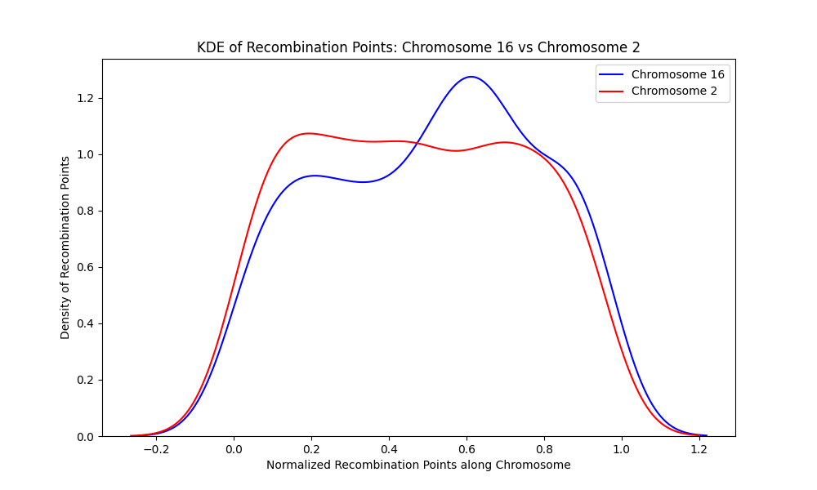

**Figure 29**. A kernel density estimate of chromosome 16 and chromosome 2 shows that recombination points are distributed differently along the length of the chromosomes. Chromosome 16 (blue) has a valley (area of sparse distribution of recombination points) and a peak (area of concentrated recombination points) while chromosome 2 (red) has two valleys and two peaks.

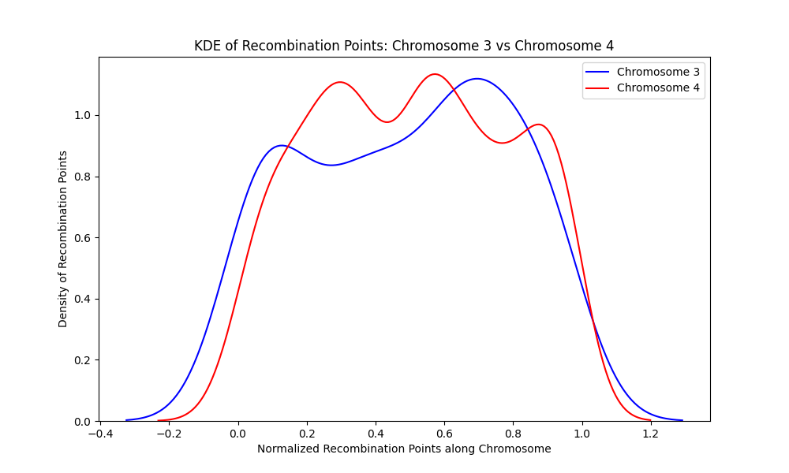

**Figure 30**. A kernel density estimate of chromosome 3 and chromosome 4 shows that recombination points are distributed differently along the length of the chromosomes. Chromosome 3 (blue) has a valley (area of sparse distribution of recombination points) and two peaks (area of concentrated recombination points) while chromosome 4 (red) has two valleys and three peaks. 4

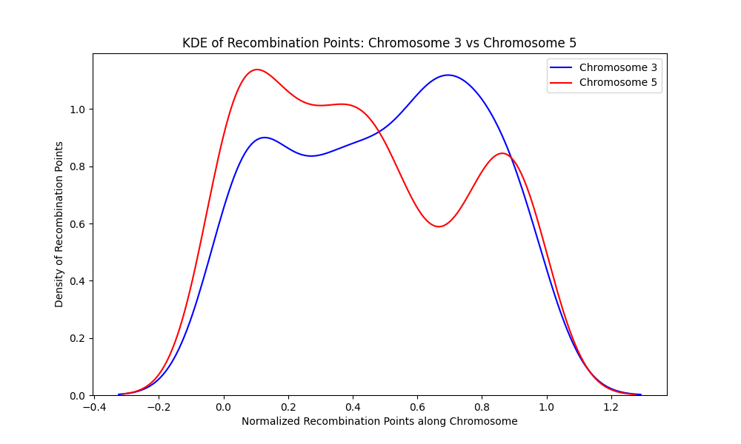

**Figure 31**. A kernel density estimate of chromosome 3 and chromosome 5 shows that recombination points are distributed differently along the length of the chromosomes. Chromosome 3 (blue) has a valley (area of sparse distribution of recombination points) and two peaks (area of concentrated recombination points)while chromosome 5 (red) has two valleys and three peaks.

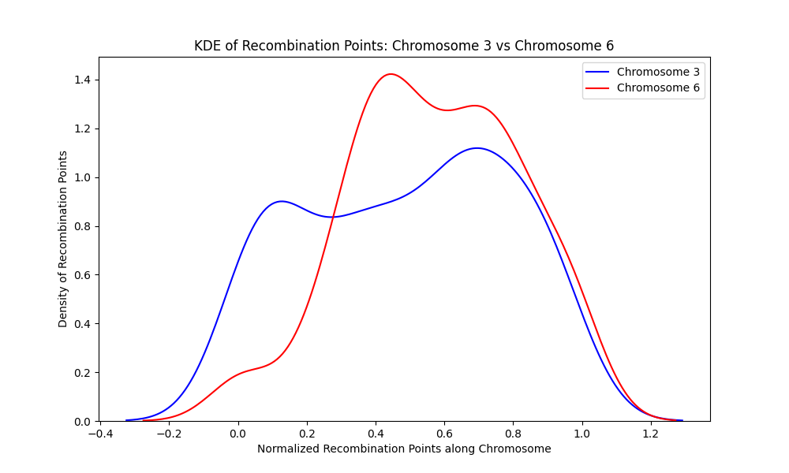

**Figure 32.** A kernel density estimate of chromosome 3 and chromosome 6 shows that recombination points are distributed differently along the length of the chromosomes. Chromosome 3 (blue) has a valley (area of sparse distribution of recombination points) and two peaks (area of concentrated recombination points) while chromosome 6 (red) has one valley and two peaks.

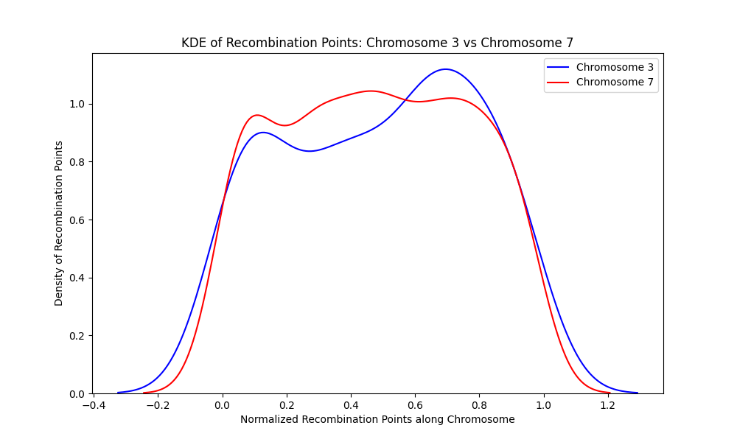

**Figure 33.** A kernel density estimate of chromosome 3 and chromosome 7 shows that recombination points are distributed differently along the length of the chromosomes. Chromosome 3 (blue) has a valley (area of sparse distribution of recombination points) and two peaks (area of concentrated recombination points) while chromosome 7 (red) has two valleys and three peaks.

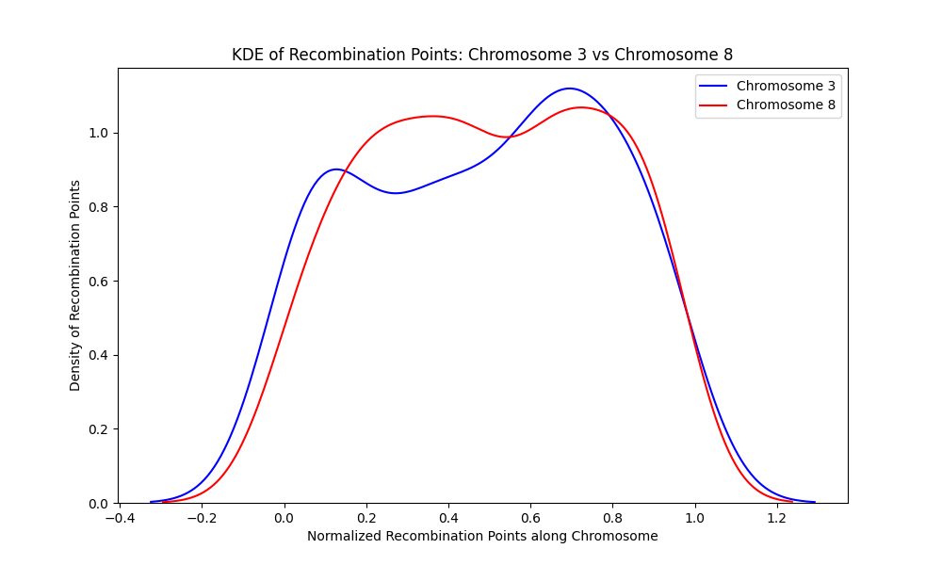

**Figure 34**. A kernel density estimate of chromosome 3 and chromosome 8 shows that recombination points are distributed differently along the length of the chromosomes. Chromosome 3 (blue) has a valley (area of sparse distribution of recombination points) and two peaks (area of concentrated recombination points) while chromosome 8 (red) has one valley and two peaks.

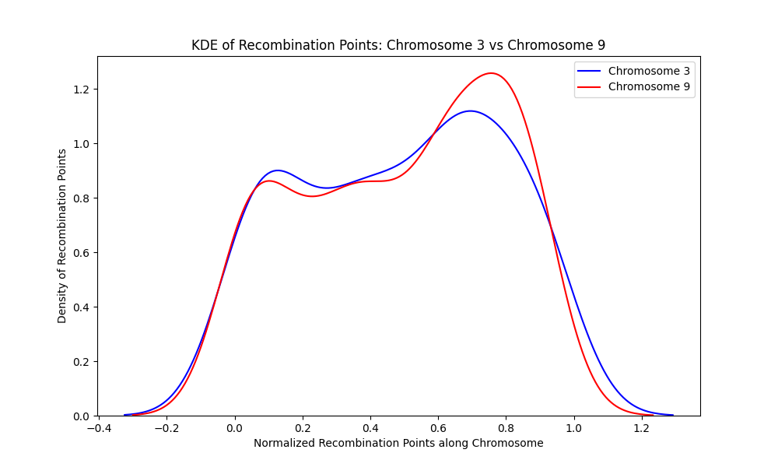

**Figure 35**. A kernel density estimate of chromosome 3 and chromosome 9 shows that recombination points are distributed differently along the length of the chromosomes. Chromosome 3 (blue) has a valley (area of sparse distribution of recombination points) and two peaks (area of concentrated recombination points) while chromosome 9 (red) has two valleys and three peaks.

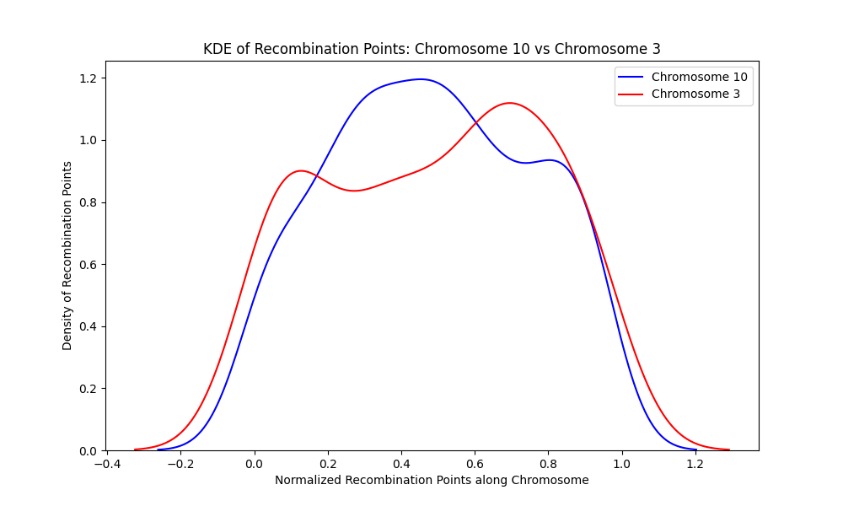

**Figure 36**. A kernel density estimate of chromosome 3 and chromosome 10 shows that recombination points are distributed differently along the length of the chromosomes. Chromosome 3 (blue) has a valley (area of sparse distribution of recombination points) and two peaks (area of concentrated recombination points) while chromosome 10 (red) has one valley and three peaks.

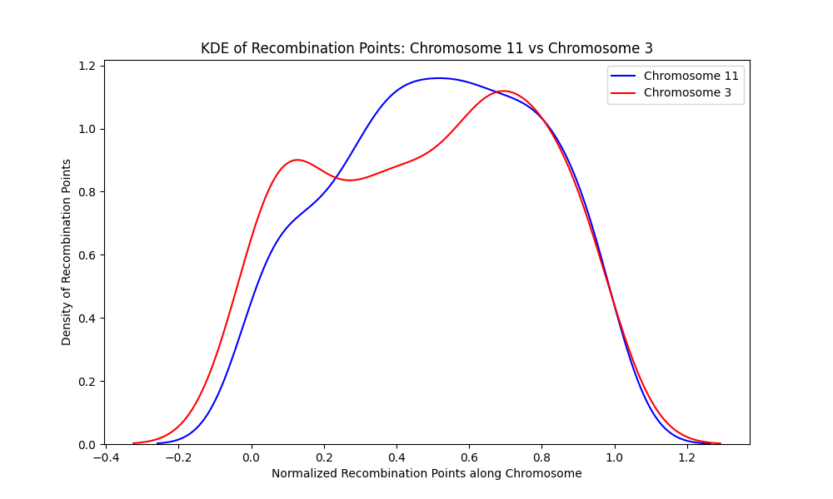

**Figure 37.** A kernel density estimate of chromosome 11 and chromosome 3 shows that recombination points are distributed differently along the length of the chromosomes. Chromosome 11 (blue) has no valley (area of sparse distribution of recombination points) but a peak (area of concentrated recombination points) at the center of the chromosome while chromosome 3 (red) has a valley and two peaks.

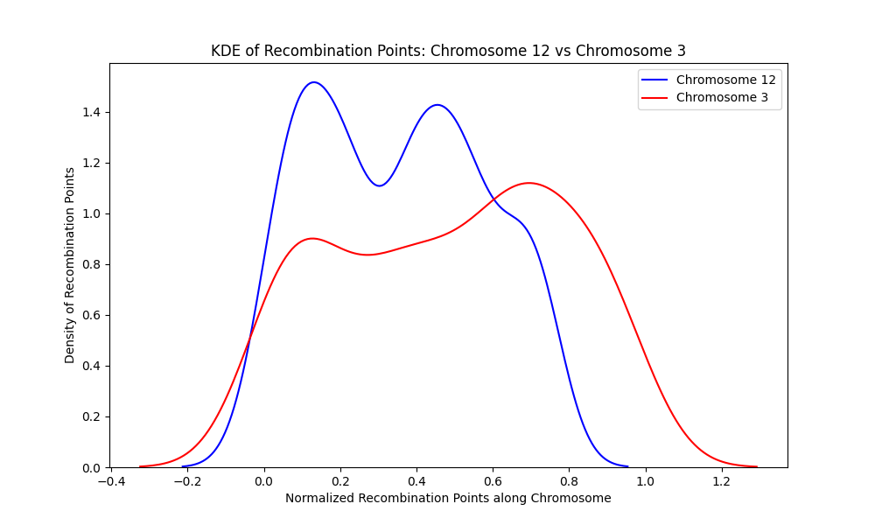

**Figure 38.** A kernel density estimate of chromosome 12 and chromosome 3 shows that recombination points are distributed differently along the length of the chromosomes. Chromosome 12 (blue) has a valley (area of sparse distribution of recombination points) and two peaks (area of concentrated recombination points) and chromosome 3 (red) has a valley and two peaks, these peaks and valleys occurred at separate locations on the chromosomes.

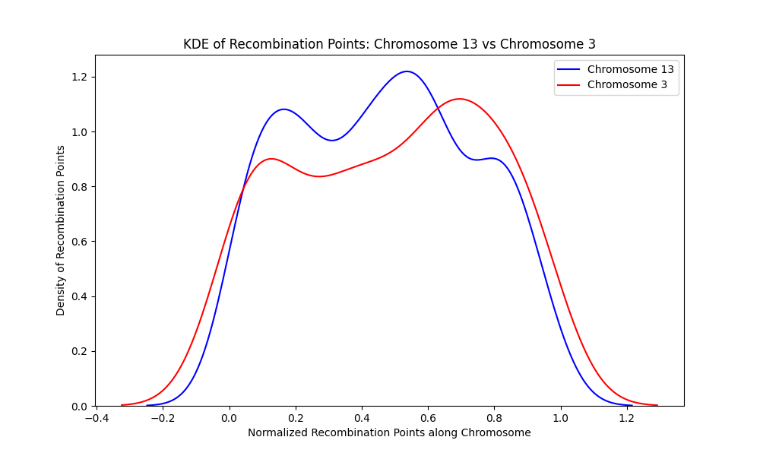

**Figure 39** **.** A kernel density estimate of chromosome 13 and chromosome 3 shows that recombination points are distributed differently along the length of the chromosomes. Chromosome 1 (blue) has two valleys (area of sparse distribution of recombination points) and three peaks (area of concentrated recombination points) while chromosome 3 (red) has one valley and two peaks.

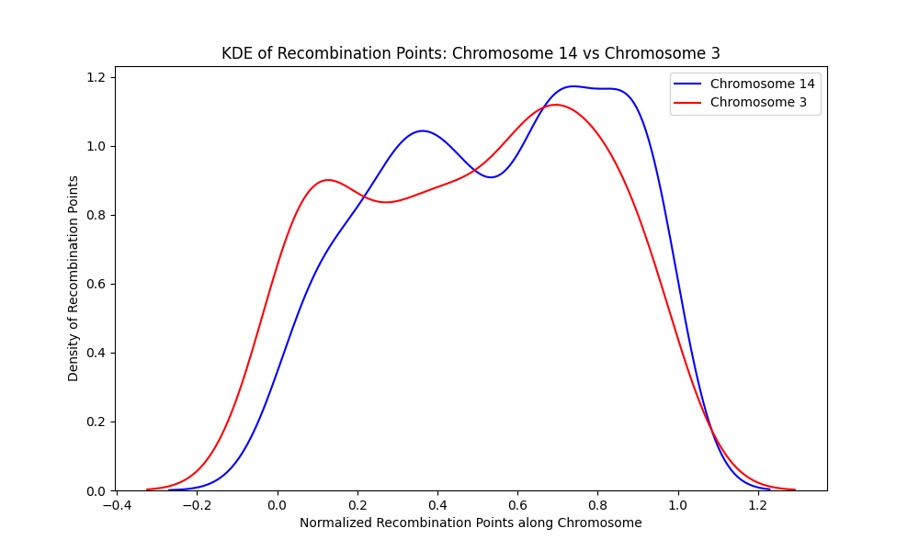

**Figure 40**. A kernel density estimate of chromosome 14 and chromosome 3 shows that recombination points are distributed differently along the length of the chromosomes. Chromosome 14 (blue) has a valley (area of sparse distribution of recombination points) and two peaks (area of concentrated recombination points) and chromosome 3 (red) also has a valley and two peaks.

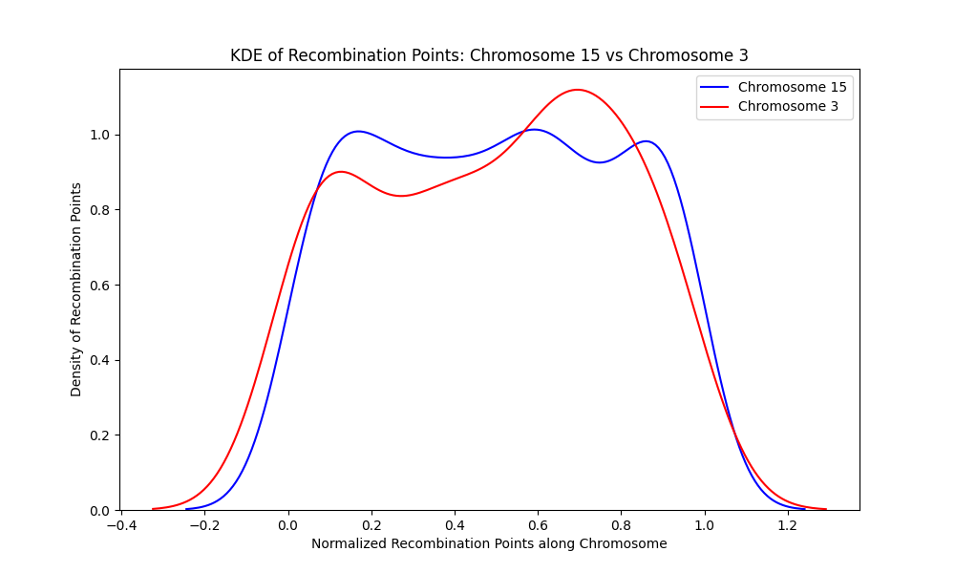

**Figure 41**. A kernel density estimate of chromosome 15 and chromosome 3 shows that recombination points are distributed differently along the length of the chromosomes. Chromosome 15 (blue) has two valleys (area of sparse distribution of recombination points) and three peaks (area of concentrated recombination points) while chromosome 3 (red) has one valley and two peaks.

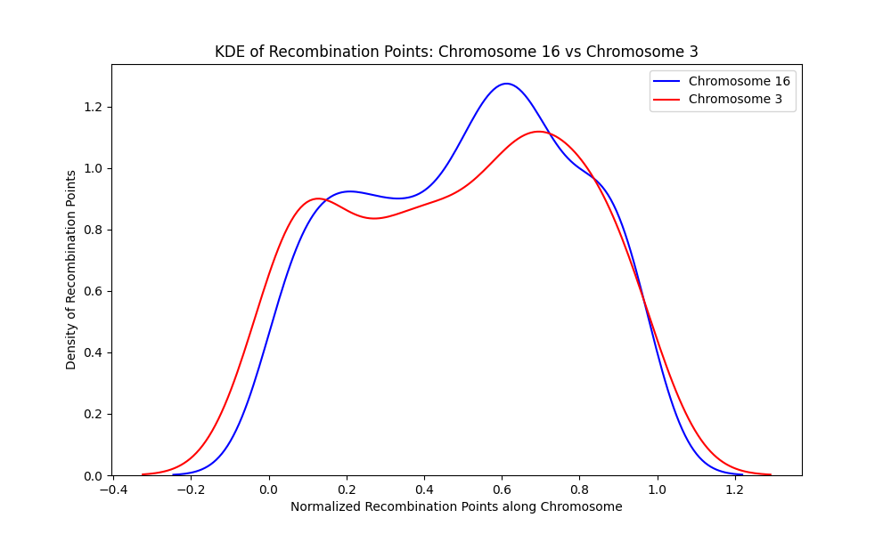

**Figure 42**. A kernel density estimate of chromosome 16 and chromosome 3 shows that recombination points are distributed differently along the length of the chromosomes. Chromosome 16 (blue) has a valley (area of sparse distribution of recombination points) and two peaks (area of concentrated recombination points) and chromosome 3 (red) also has a valley and two peaks, but these peaks and valleys occurred at different positions on the chromosome.

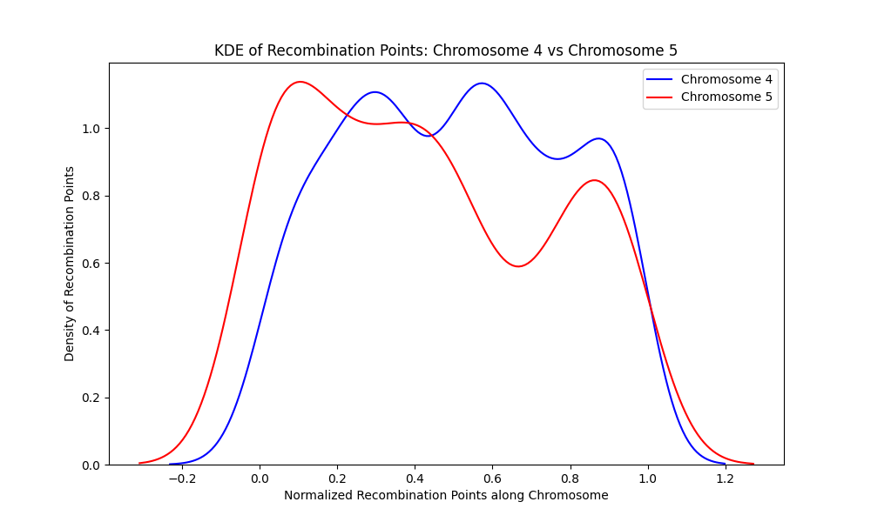

**Figure 43**. A kernel density estimate of chromosome 4 and chromosome 5 shows that recombination points are distributed differently along the length of the chromosomes. Chromosome 4 (blue) has two valleys (area of sparse distribution of recombination points) and three peaks (area of concentrated recombination points) and chromosome 5 (red) also have two valleys and three peaks. These peaks and valleys are different locations on the chromosomes.

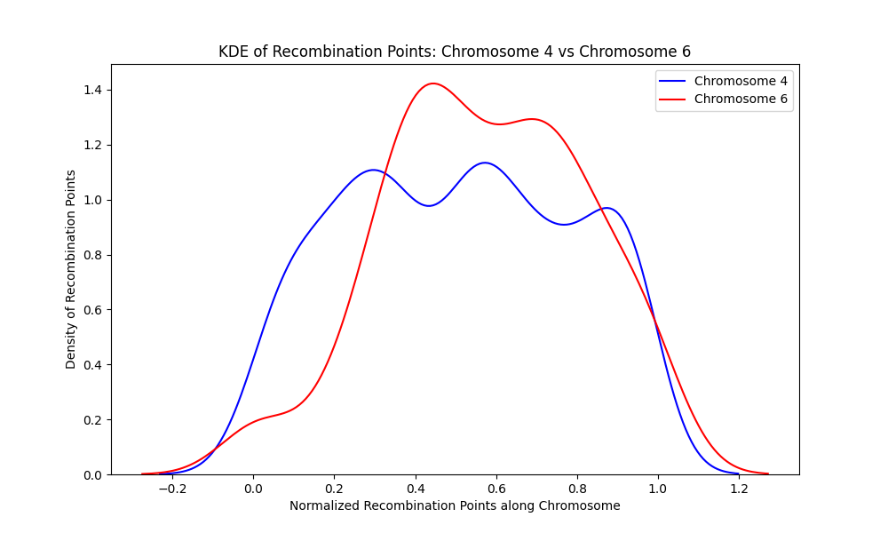

**Figure 44.** A kernel density estimate of chromosome 4 and chromosome 6 shows that recombination points are distributed differently along the length of the chromosomes. Chromosome 4 (blue) has two valleys (area of sparse distribution of recombination points) and three peaks (area of concentrated recombination points) while chromosome 6 (red) has one valley and two peaks. These peaks and valleys are at different loci on the chromosomes.

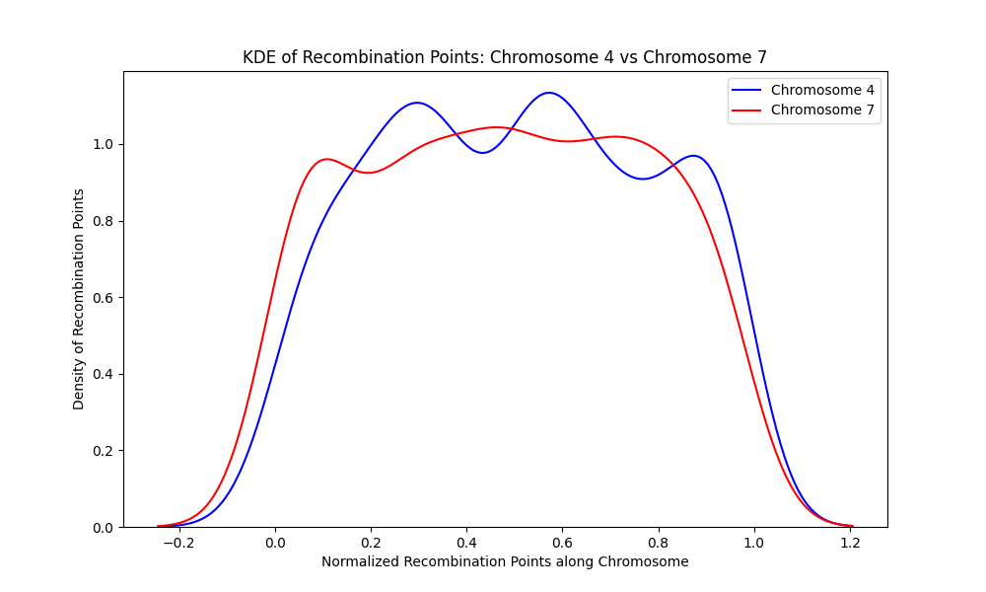

**Figure 45**. A kernel density estimate of chromosome 4 and chromosome 7 shows that recombination points are distributed differently along the length of the chromosomes. Chromosome 4 (blue) has two valleys (area of sparse distribution of recombination points) and three peaks (area of concentrated recombination points) and chromosome 7 (red) also have two valleys and three peaks. These peaks and valleys are at separate locations on the chromosomes.

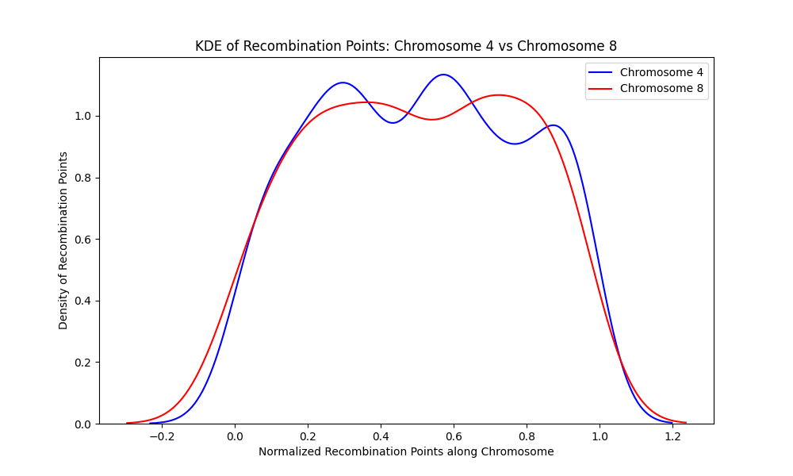

**Figure 46** A kernel density estimate of chromosome 4 and chromosome 8 shows that recombination points are distributed differently along the length of the chromosomes. Chromosome 4 (blue) has two valleys (area of sparse distribution of recombination points) and three peaks (area of concentrated recombination points) while chromosome 8 (red) has just one valley and two peaks. These peaks and valleys are at distinct locations on the chromosomes.

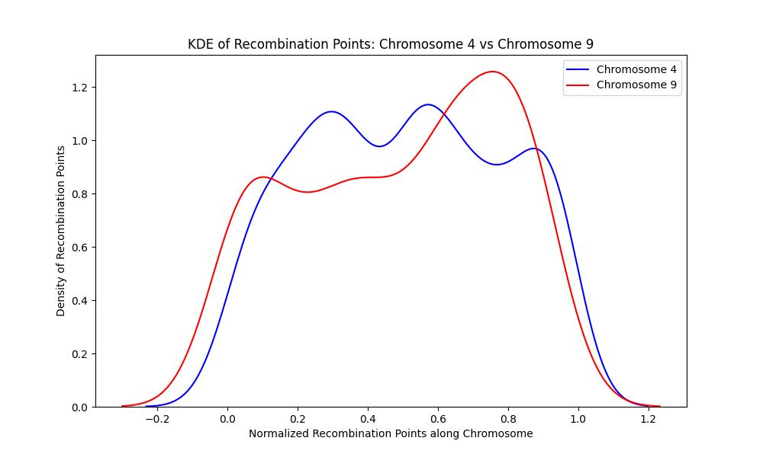

**Figure 47.** A kernel density estimate of chromosome 4 and chromosome 9 shows that recombination points are distributed differently along the length of the chromosomes. Chromosome 4 (blue) has two valleys (area of sparse distribution of recombination points) and three peaks (area of concentrated recombination points) and chromosome 9 (red) also have two valleys and three peaks. These peaks and valleys have different heights and depths and are located at different loci on the chromosomes.

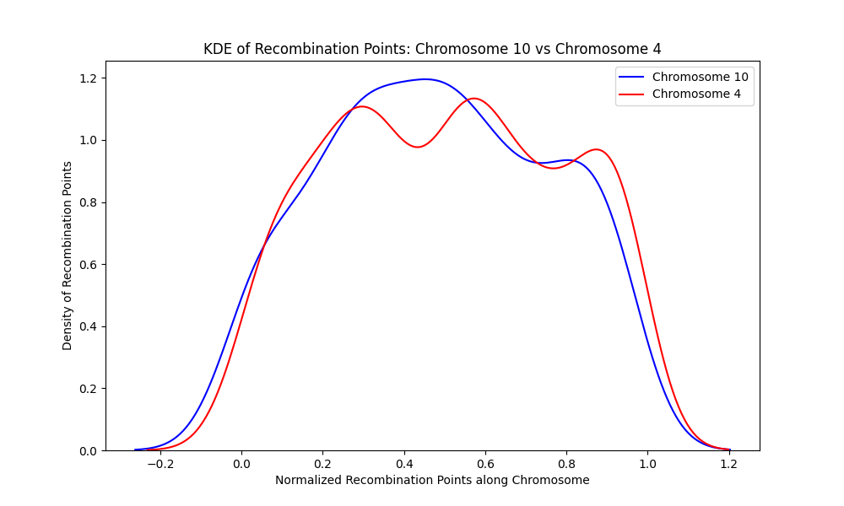

**Figure 48**. A kernel density estimate of chromosome 10 and chromosome 4 shows that recombination points are distributed differently along the length of the chromosomes. Chromosome 10 (blue) has one valley (area of sparse distribution of recombination points) and two peaks (area of concentrated recombination points) while chromosome 4 (red) have two valleys and three peaks. These peaks and valleys have different heights and depths and are located at different loci on the chromosomes.

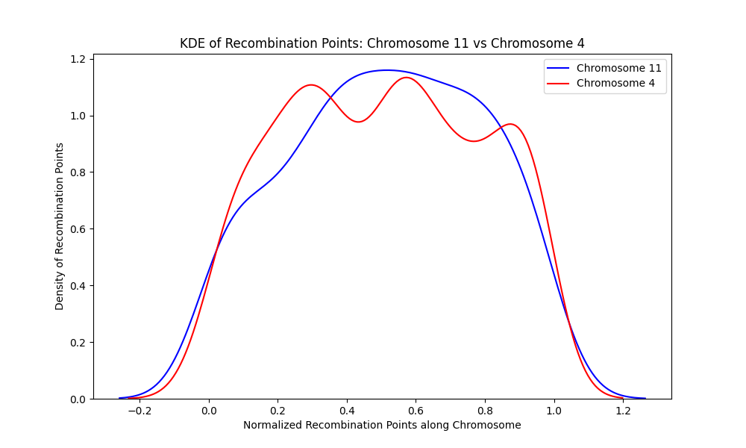

**Figure 49**. A kernel density estimate of chromosome 11 and chromosome 4 shows that recombination points are distributed differently along the length of the chromosomes. Chromosome 11 (blue) has no valley (area of sparse distribution of recombination points)but a broad peak (area of concentrated recombination points) while chromosome 4 (red) have two valleys and three peaks. These peaks and valleys have different heights and depths and are located at distinct positions on the chromosomes.

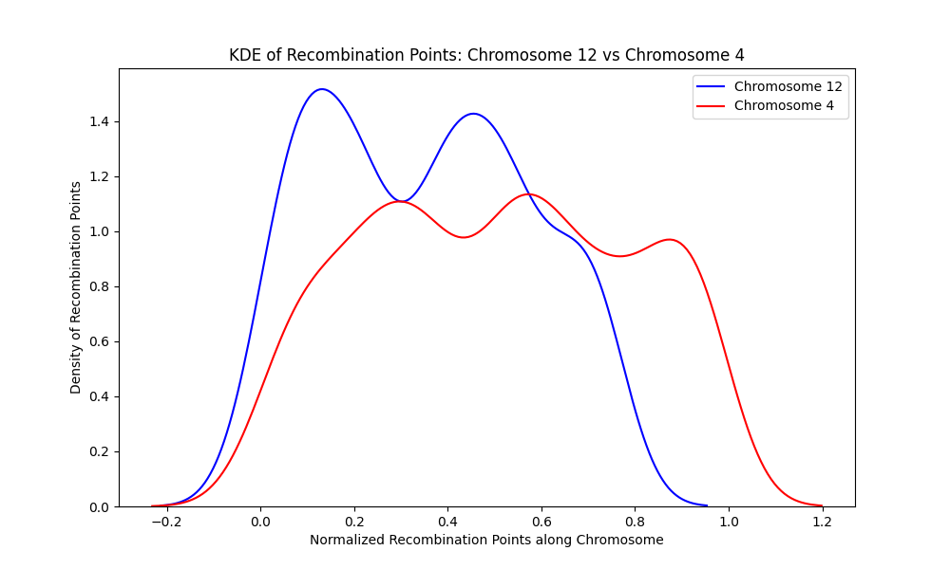

**Figure 50**. A kernel density estimate of chromosome 12 and chromosome 4 shows that recombination points are distributed differently along the length of the chromosomes. Chromosome 12 (blue) has a valley (area of sparse distribution of recombination points) and two peaks (area of concentrated recombination points) while chromosome 4 (red) have two valleys and three peaks. These peaks and valleys have different heights and depths and are located at different loci on the chromosomes.

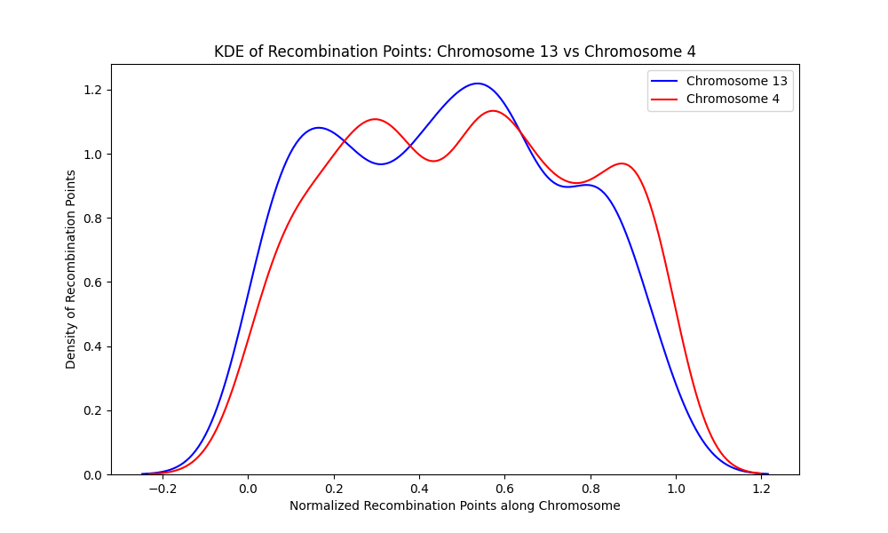

**Figure 51**. A kernel density estimate of chromosome 13 and chromosome 4 shows that recombination points are distributed differently along the length of the chromosomes. Chromosome 13 (blue) has two valleys (area of sparse distribution of recombination points) and three peaks (area of concentrated recombination points) while chromosome 4 (red) has two valleys and three peaks. These peaks and valleys have different heights and depths and are located at distinct positions on the chromosomes

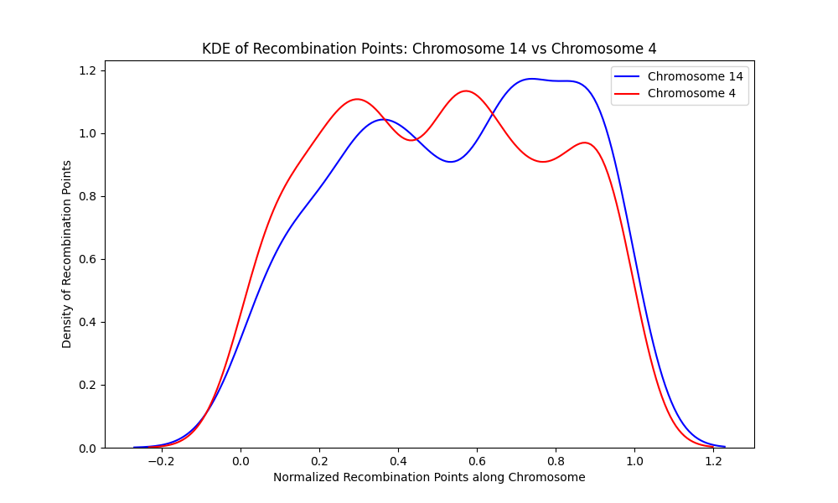

**Figure 52.** A kernel density estimate of chromosome 14 and chromosome 4 shows that recombination points are distributed differently along the length of the chromosomes. Chromosome 14 (blue) has one valley (area of sparse distribution of recombination points) and two peaks (area of concentrated recombination points) while chromosome 4 (red) have two valleys and three peaks. These peaks and valleys have different heights and depths and are located at different loci on the chromosomes.

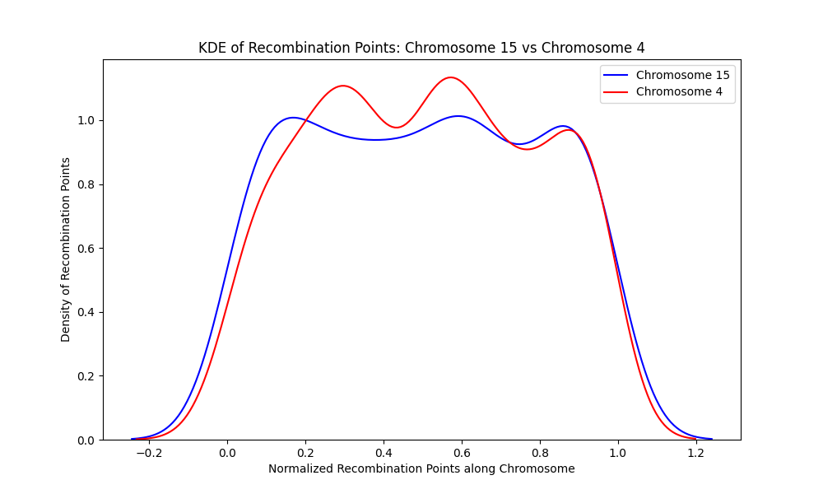

**Figure 53.** A kernel density estimate of chromosome 15 and chromosome 4 shows that recombination points are distributed differently along the length of the chromosomes. Chromosome 15 (blue) has two valleys (area of sparse distribution of recombination points) and three peaks (area of concentrated recombination points) while chromosome 4 (red) has two valleys and three peaks. These peaks and valleys have different heights and depths and are located at different loci on the chromosomes.

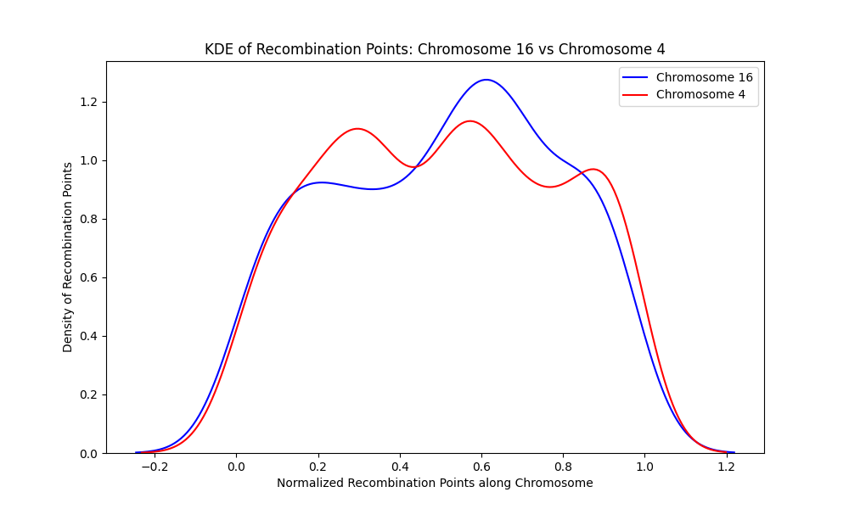

**Figure 54**. A kernel density estimate of chromosome 16 and chromosome 4 shows that recombination points are distributed differently along the length of the chromosomes. Chromosome 16 (blue) has one valley (area of sparse distribution of recombination points) and two peaks (area of concentrated recombination points) while chromosome 4 (red) have two valleys and three peaks. These peaks and valleys have different heights and depths and are located at different loci on the chromosomes

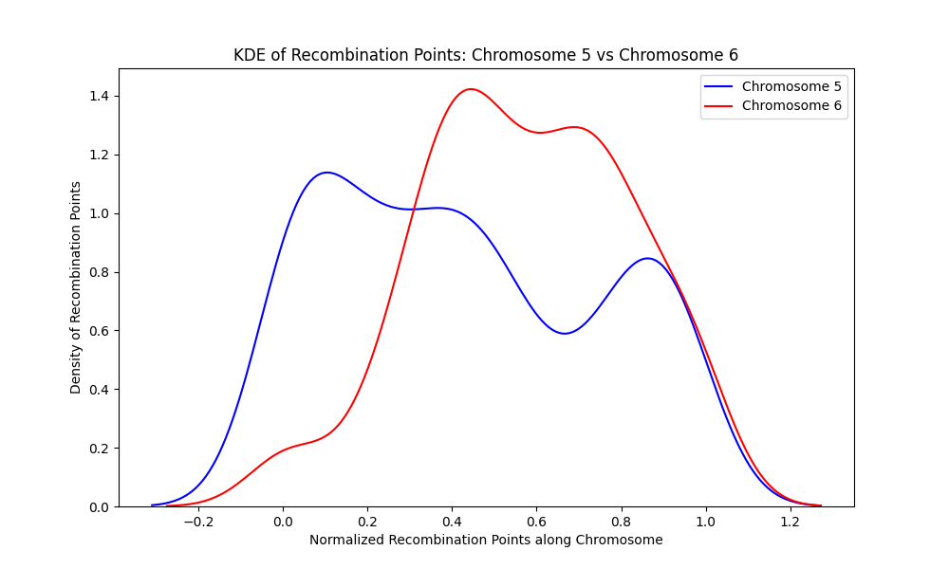

**Figure 55.** A kernel density estimates of chromosome 5 and chromosome 6 shows that recombination points are distributed differently along the length of the chromosomes. Chromosome 5 (blue) has two valleys (area of sparse distribution of recombination points) and three peaks (area of concentrated recombination points) while chromosome 6 (red) has one valley and two peaks. These peaks and valleys are varied according to the number of recombination points at that locus.

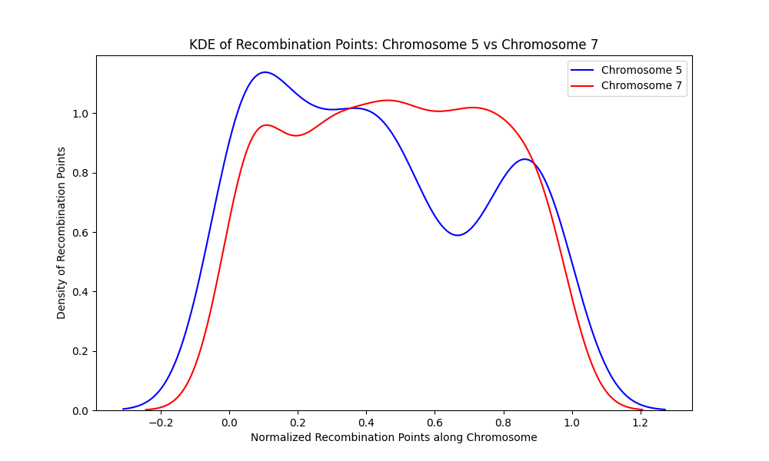

**Figure 56**. A kernel density estimate of chromosome 5 and chromosome 7 shows that recombination points are distributed differently along the length of the chromosomes. Chromosome 5 (blue) has two valleys (area of sparse distribution of recombination points) and three peaks (area of concentrated recombination points) and chromosome 7 (red) has a similar pattern but at different loci on the chromosome.

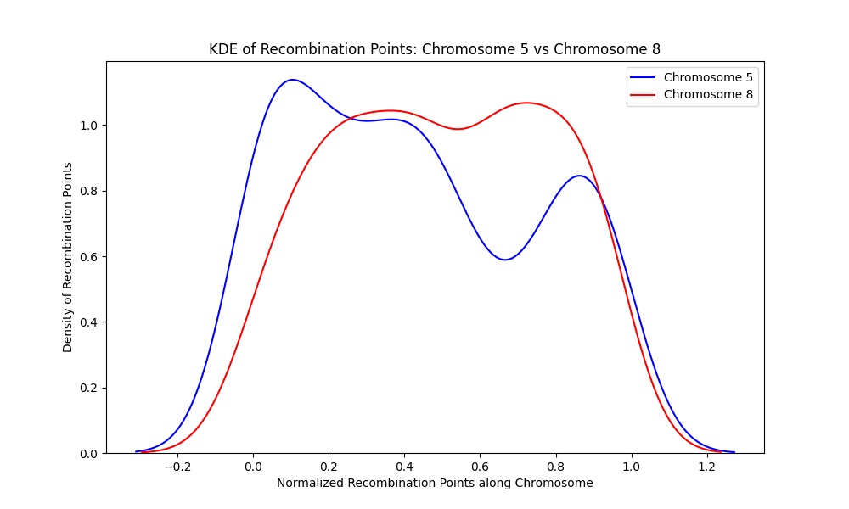

**Figure 57**. A kernel density estimate of chromosome 5 and chromosome 8 shows that recombination points are distributed differently along the length of the chromosomes. Chromosome 5 (blue) has two valleys (area of sparse distribution of recombination points) and three peaks (area of concentrated recombination points) while chromosome 8 (red) has one valley and two peaks. These peaks and valleys are varied according to the number of recombination points at that locus.

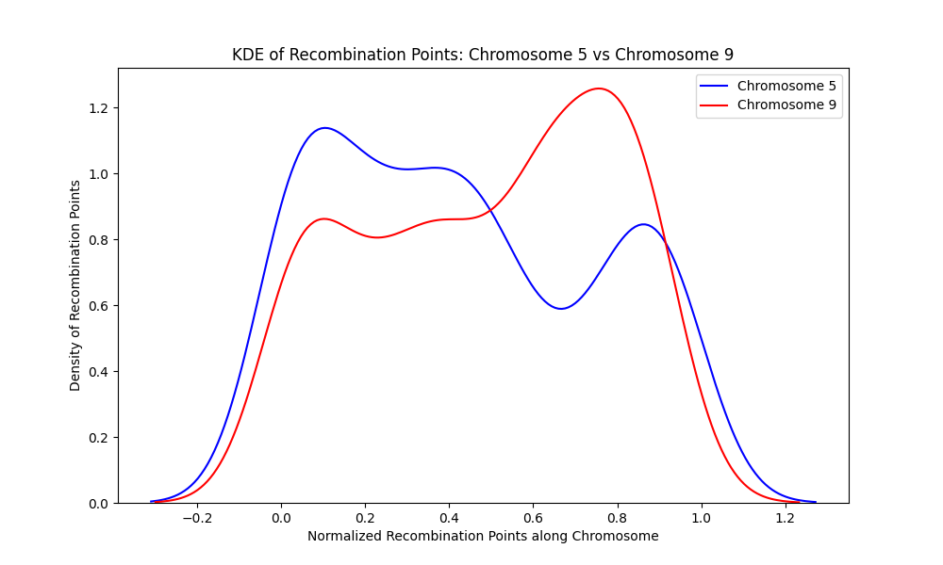

**Figure 58**. A kernel density estimate of chromosome 5 and chromosome 9 shows that recombination points are distributed differently along the length of the chromosomes. Chromosome 5 (blue) has two valleys (area of sparse distribution of recombination points) and three peaks (area of concentrated recombination points) and chromosome 9 (red) has the same number of peaks and valleys but located at different loci on the chromosome. These peaks and valleys are varied according to the number of recombination points at that locus.

.

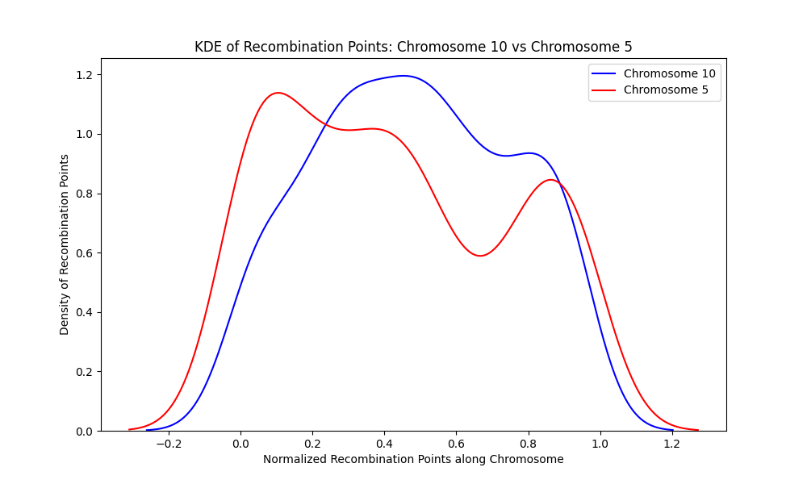

**Figure 59**. A kernel density estimate of chromosome 10 and chromosome 5 shows that recombination points are distributed differently along the length of the chromosomes. Chromosome 10 (blue) has one valley (area of sparse distribution of recombination points) and two peaks (area of concentrated recombination points) while chromosome 5 (red) has two valleys and three peaks. These peaks and valleys are varied according to the number of recombination points at that locus.

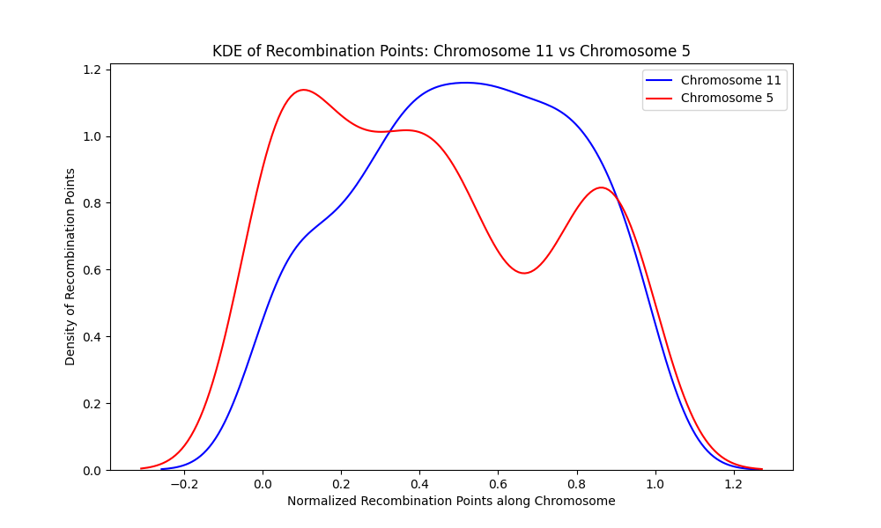

**Figure 60**. A kernel density estimate of chromosome 11 and chromosome 5 shows that recombination points are distributed differently along the length of the chromosomes. Chromosome 11 (blue) has no valley (area of sparse distribution of recombination points) but one broad peak (area of concentrated recombination points) at the middle of the chromosome while chromosome 5 (red) has two valleys and three peaks. These peaks and valleys are varied according to the number of recombination points at that locus.

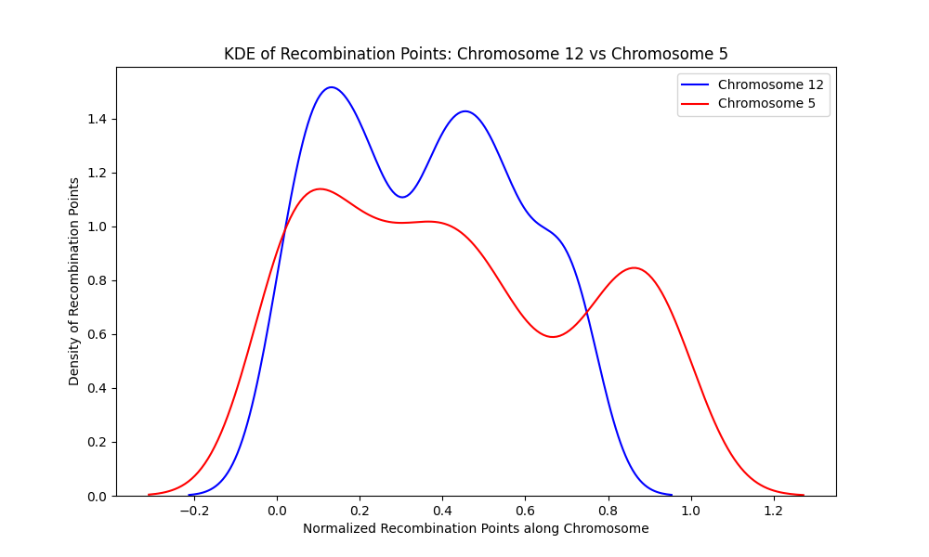

Figure 61. A kernel density estimate of chromosome 12 and chromosome 5 shows that recombination points are distributed differently along the length of the chromosomes. Chromosome 12 (blue) has one valley (area of sparse distribution of recombination points) and two peaks (area of concentrated recombination points) while chromosome 5 (red) has two valleys and three peaks. These peaks and valleys are varied according to the number of recombination points at that locus.

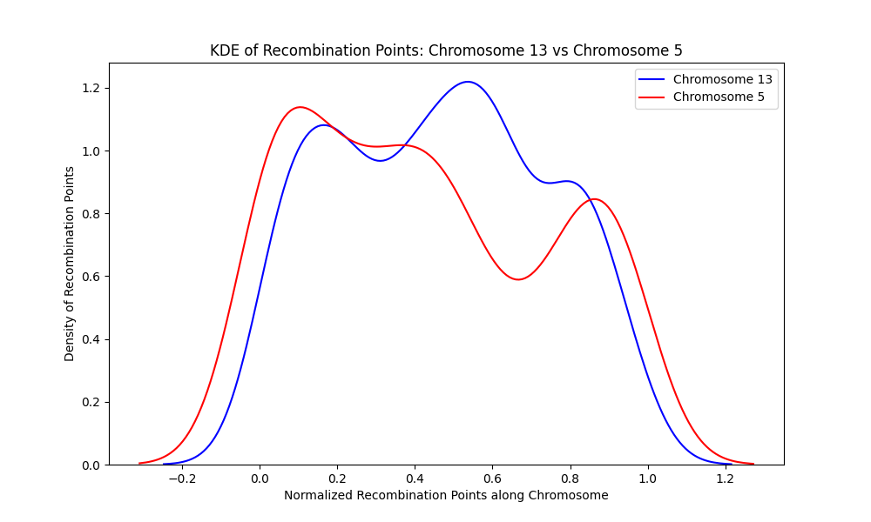

**Figure 62**. A kernel density estimate of chromosome 13 and chromosome 5 shows that recombination points are distributed differently along the length of the chromosomes. Chromosome 13 (blue) has two valleys (area of sparse distribution of recombination points) and three peaks (area of concentrated recombination points) and chromosome 5 (red) has same number of valleys and peaks but located differently. These peaks and valleys are varied according to the number of recombination points at that locus.

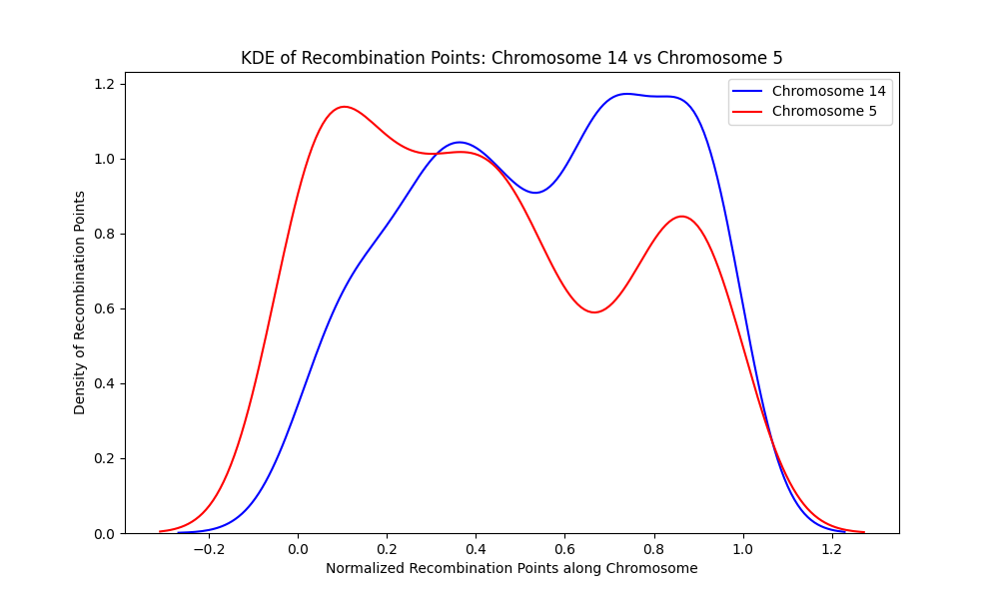

**Figure 63**. A kernel density estimate of chromosome 14 and chromosome 5 shows that recombination points are distributed differently along the length of the chromosomes. Chromosome 14 (blue) has one valley (area of sparse distribution of recombination points) and two peaks (area of concentrated recombination points) while chromosome 5 (red) has two valleys and three peaks. These peaks and valleys are varied according to the number of recombination points at that locus.

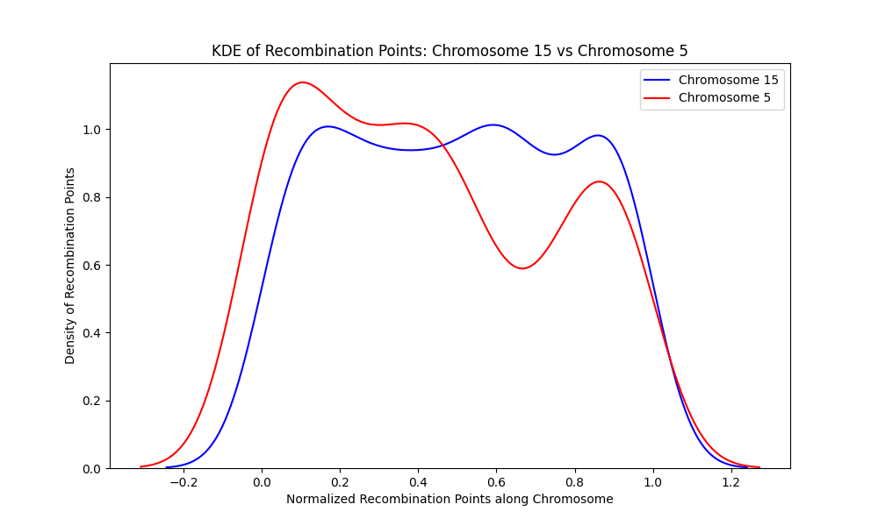

**Figure 64**. A kernel density estimate of chromosome 15 and chromosome 5 shows that recombination points are distributed differently along the length of the chromosomes. Chromosome 15 (blue) has two valleys (area of sparse distribution of recombination points) and three peaks (area of concentrated recombination points) while chromosome 5 (red) has two valleys and three peaks. These peaks and valleys are varied according to the number of recombination points at that locus.

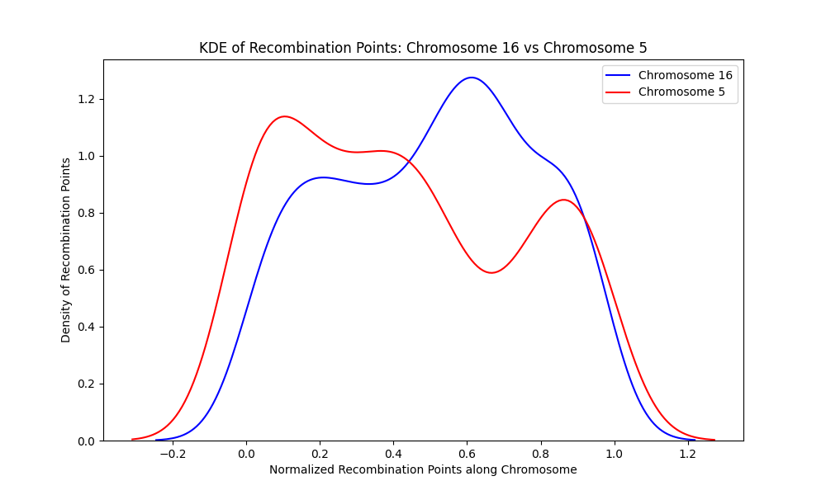

**Figure 65**. A kernel density estimate of chromosome 16 and chromosome 5 shows that recombination points are distributed differently along the length of the chromosomes. Chromosome 16 (blue) has one valley (area of sparse distribution of recombination points) and two peaks (area of concentrated recombination points) while chromosome 5 (red) has two valleys and three peaks. These peaks and valleys are varied according to the number of recombination points at that locus.

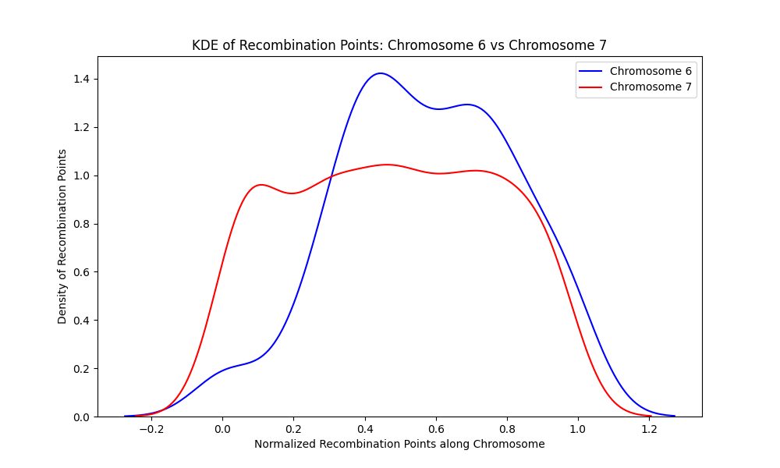

**Figure 66**. A kernel density estimate of chromosome 6 and chromosome 7 shows that recombination points are distributed differently along the length of the chromosomes. Chromosome 6 (blue) has a valley (area of sparse distribution of recombination points) and two peaks (area of concentrated recombination points) while chromosome 7 (red) has two valleys and three peaks.

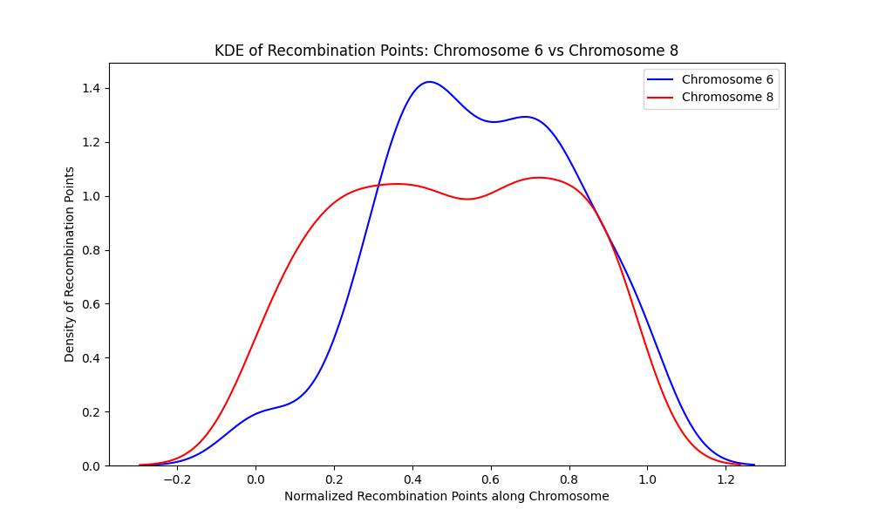

**Figure 67**. A kernel density estimate of chromosome 6 and chromosome 8 shows that recombination points are distributed differently along the length of the chromosomes. Chromosome 6 (blue) has a valley (area of sparse distribution of recombination points) and two peaks (area of concentrated recombination points) and chromosome 8 (red) also has same number of peaks and valleys but at different locus on the chromosomes.

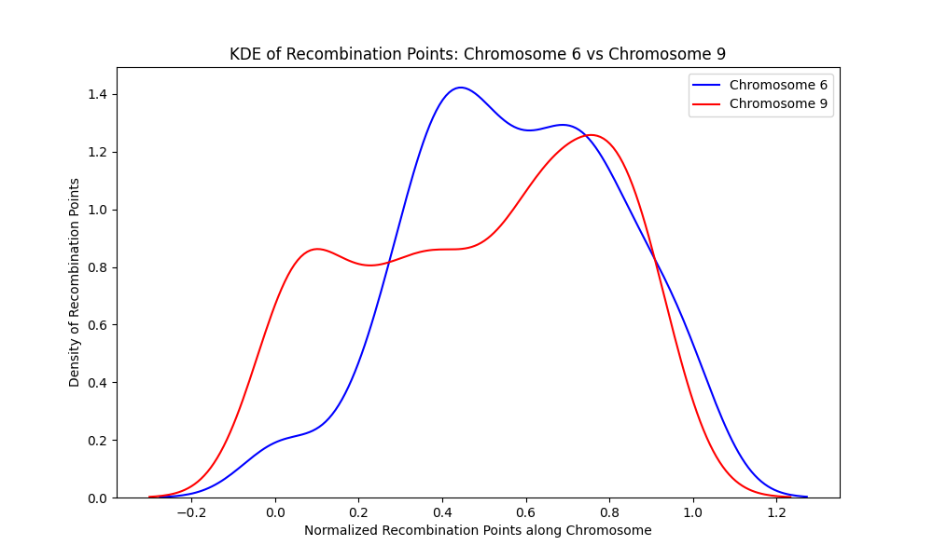

**Figure 68.** A kernel density estimate of chromosome 6 and chromosome 9 shows that recombination points are distributed differently along the length of the chromosomes. Chromosome 6 (blue) has a valley (area of sparse distribution of recombination points) and two peaks (area of concentrated recombination points) while chromosome 9 (red) has two valleys and three peaks. The valleys and peaks are varied according to the number of recombination points at that locus.

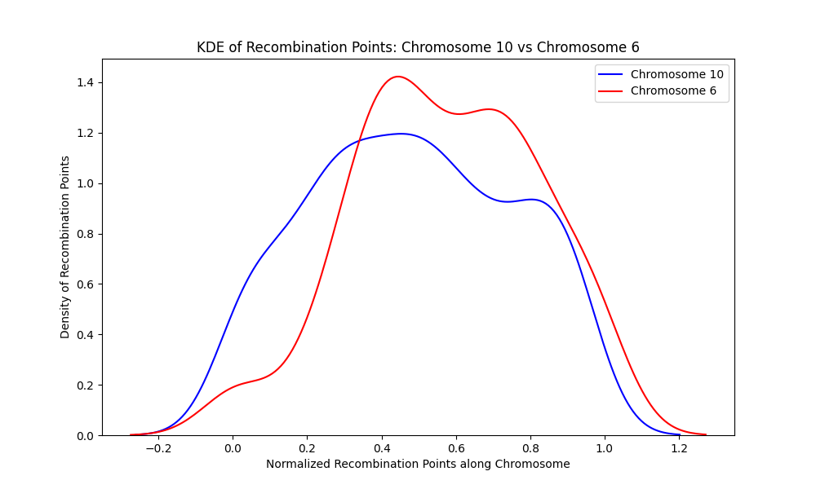

**Figure 69**. A kernel density estimate of chromosome 10 and chromosome 6 shows that recombination points are distributed differently along the length of the chromosomes. Chromosome 10 (blue) has a valley (area of sparse distribution of recombination points) and two peaks (area of concentrated recombination points) and chromosome 6 (red) has same number of valleys and peaks but with different height and depths and at different loci.

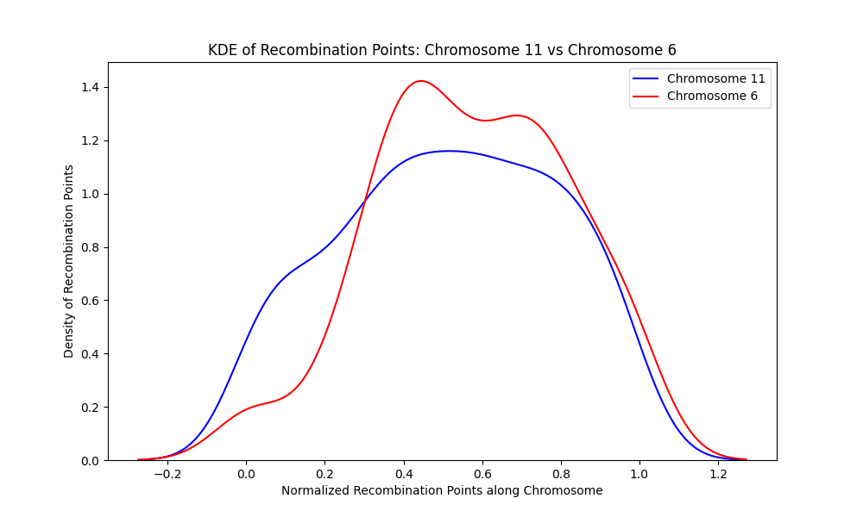

**Figure 70**. A kernel density estimate of chromosome 11 and chromosome 6 shows that recombination points are distributed differently along the length of the chromosomes. Chromosome 10 (blue) has no valley (area of sparse distribution of recombination points) but a large peak (area of concentrated recombination points) and chromosome 6 (red) has one valley and two peaks at different loci.

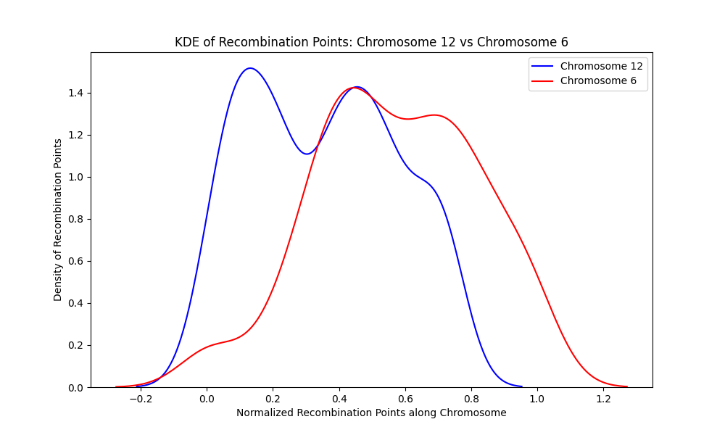

Figure 71. A kernel density estimate of chromosome 12 and chromosome 6 shows that recombination points are distributed differently along the length of the chromosomes. Chromosome 12 (blue) has a valley (area of sparse distribution of recombination points) and two peaks (area of concentrated recombination points) and chromosome 6 (red) has same number of valleys and peaks but with different height and depths and at different loci.

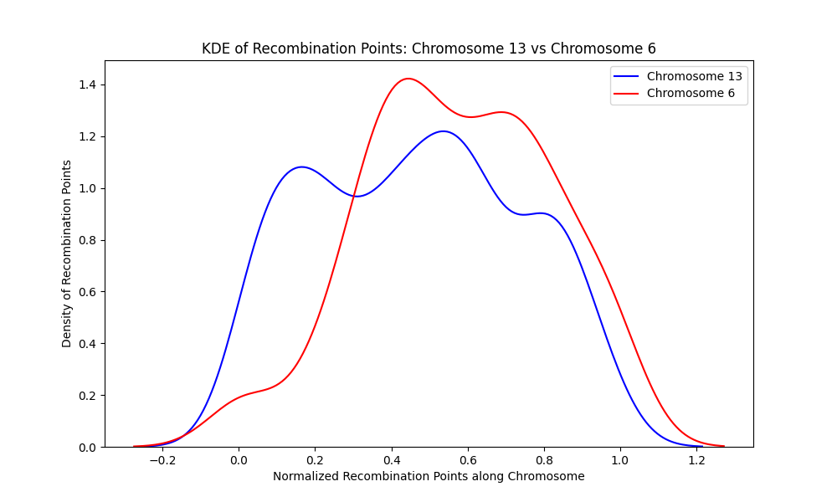

**Figure 72**. A kernel density estimate of chromosome 13 and chromosome 6 shows that recombination points are distributed differently along the length of the chromosomes. Chromosome 13 (blue) has two valleys (area of sparse distribution of recombination points) and two peaks (area of concentrated recombination points) and chromosome 6 (red) has one valley and two peaks but with different height and depths and at different loci.

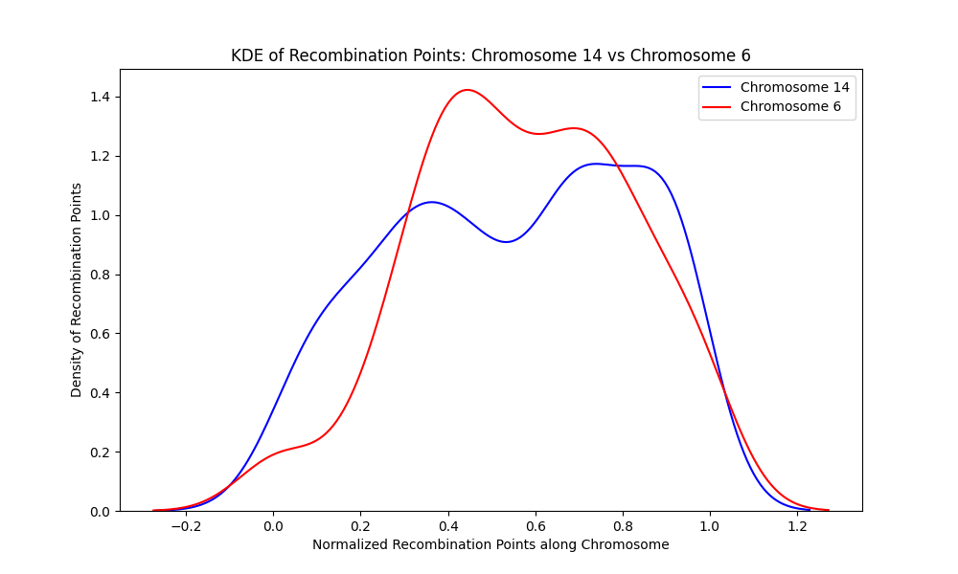

**Figure 73**. A kernel density estimate of chromosome 14 and chromosome 6 shows that recombination points are distributed differently along the length of the chromosomes. Chromosome 14 (blue) has a valley (area of sparse distribution of recombination points) and two peaks (area of concentrated recombination points) and chromosome 6 (red) has same number of valleys and peaks but with different height and depths and at different loci.

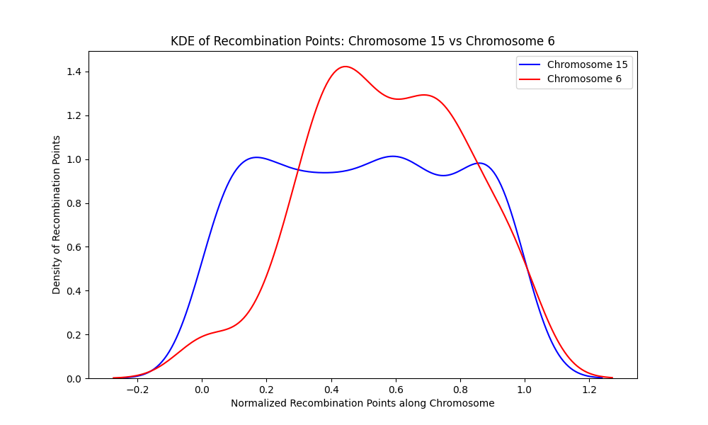

**Figure 74** A kernel density estimate of chromosome 15 and chromosome 6 shows that recombination points are distributed differently along the length of the chromosomes. Chromosome 15 (blue) has two valleys (area of sparse distribution of recombination points) and three peaks (area of concentrated recombination points) while chromosome 6 (red) has same number of valleys and peaks but with different height and depths and at different loci.

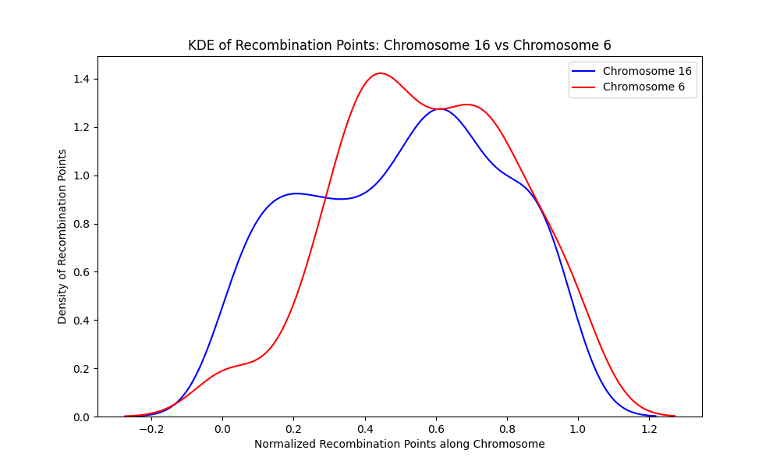

**Figure 75**. A kernel density estimate of chromosome 16 and chromosome 6 shows that recombination points are distributed differently along the length of the chromosomes. Chromosome 16 (blue) has a valley (area of sparse distribution of recombination points) and two peaks (area of concentrated recombination points) and chromosome 6 (red) has same number of valleys and peaks but with different height and depths and at different loci.

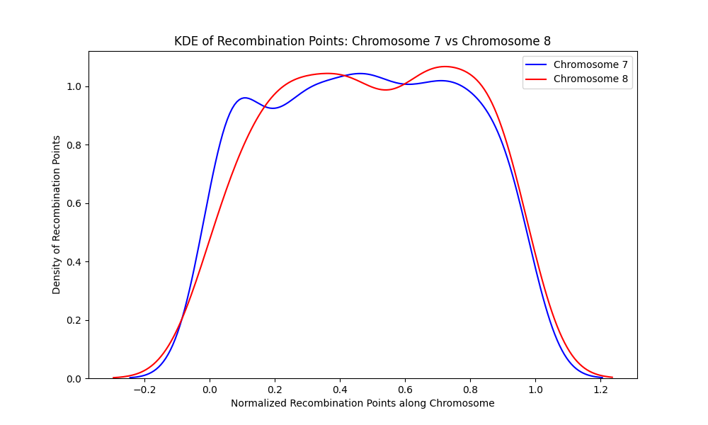

**Figure 76**. A kernel density estimate of chromosome 7 and chromosome 8 shows that recombination points are distributed differently along the length of the chromosomes. Chromosome 7 (blue) has two valleys (area of sparse distribution of recombination points) and three peaks (area of concentrated recombination points) while chromosome 8 (red) has one valley and two peaks.

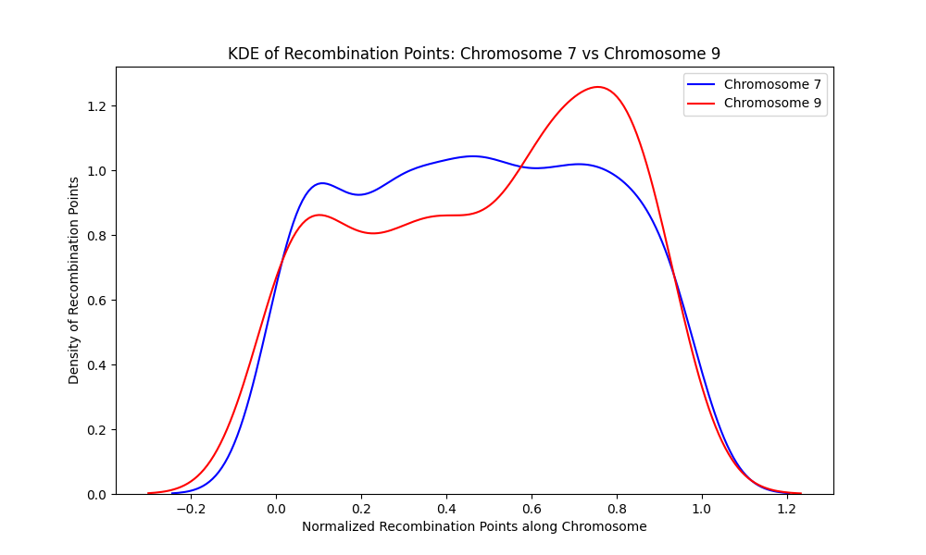

**Figure 77**. . A kernel density estimate of chromosome 7 and chromosome 9 shows that recombination points are distributed differently along the length of the chromosomes. Chromosome 7 (blue) has two valleys (area of sparse distribution of recombination points) and three peaks (area of concentrated recombination points) while chromosome 9 (red) has two valleys and two peaks.

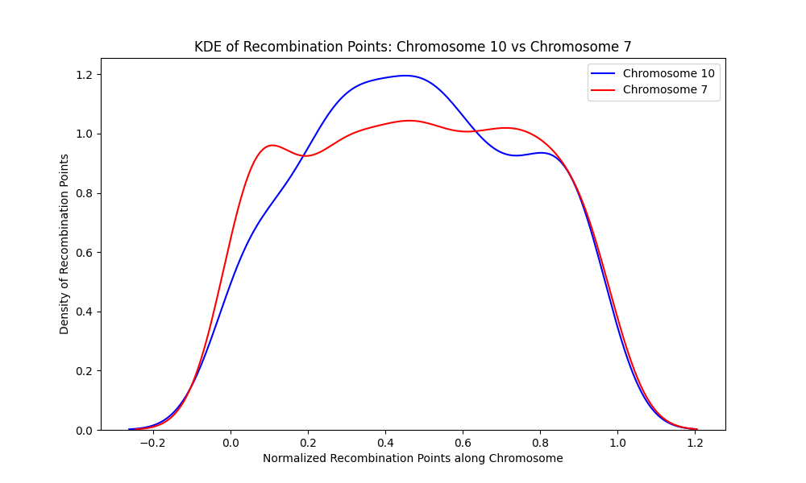

**Figure 78**. A kernel density estimate of chromosome 10 and chromosome 7 shows that recombination points are distributed differently along the length of the chromosomes. Chromosome 10 (blue) has one valley (area of sparse distribution of recombination points) and two peaks (area of concentrated recombination points) while chromosome 7 (red) has two valleys and three peaks.

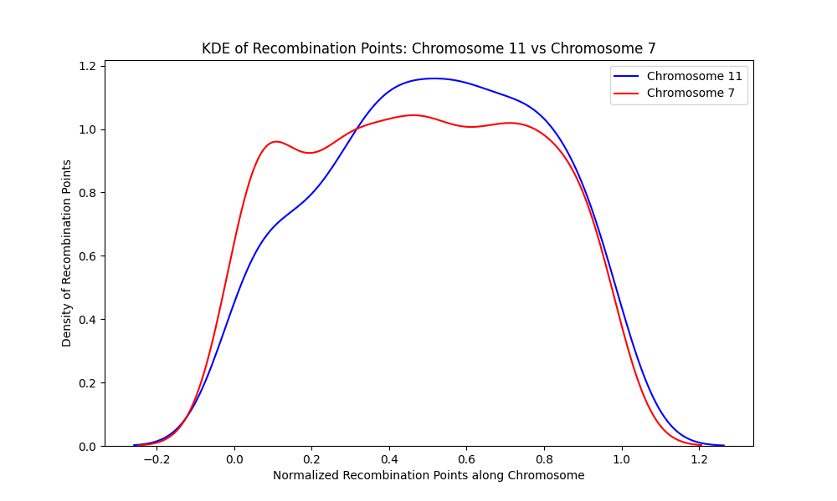

**Figure 79**. A kernel density estimate of chromosome 11 and chromosome 7 shows that recombination points are distributed differently along the length of the chromosomes. Chromosome 11 (blue) has no valley (area of sparse distribution of recombination points) but one peak (area of concentrated recombination points) while chromosome 7 (red) has two valleys and three peaks.

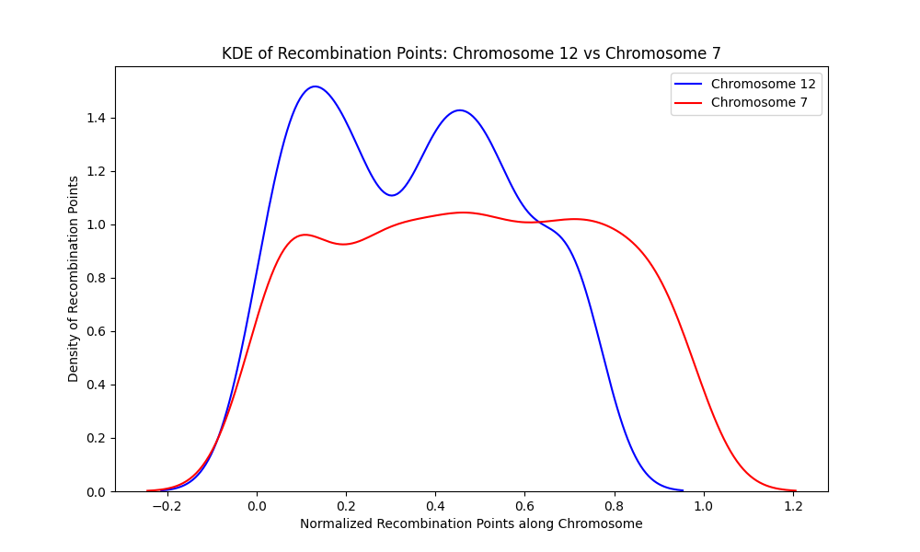

**Figure 80**. A kernel density estimate of chromosome 12 and chromosome 7 shows that recombination points are distributed differently along the length of the chromosomes. Chromosome 12 (blue) has one valley (area of sparse distribution of recombination points) and two peaks (area of concentrated recombination points) while chromosome 7 (red) has two valleys and three peaks.

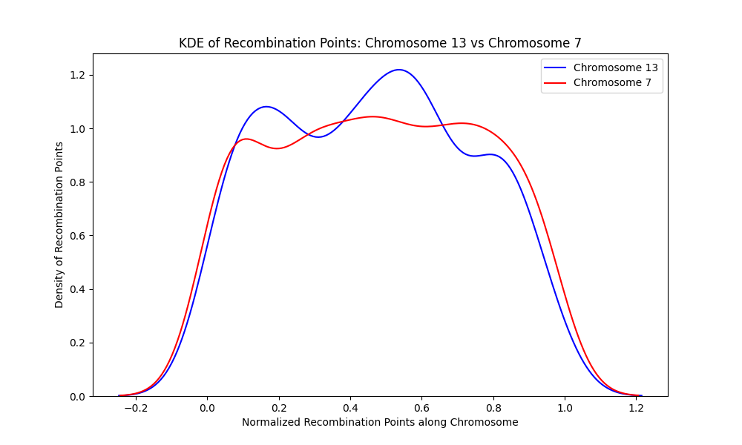

**Figure 81**. A kernel density estimate of chromosome 13 and chromosome 7 shows that recombination points are distributed differently along the length of the chromosomes. Chromosome 13 (blue) has two valleys (area of sparse distribution of recombination points) and three peaks (area of concentrated recombination points) and chromosome 7 (red) has two valleys and three peaks but at different loci.

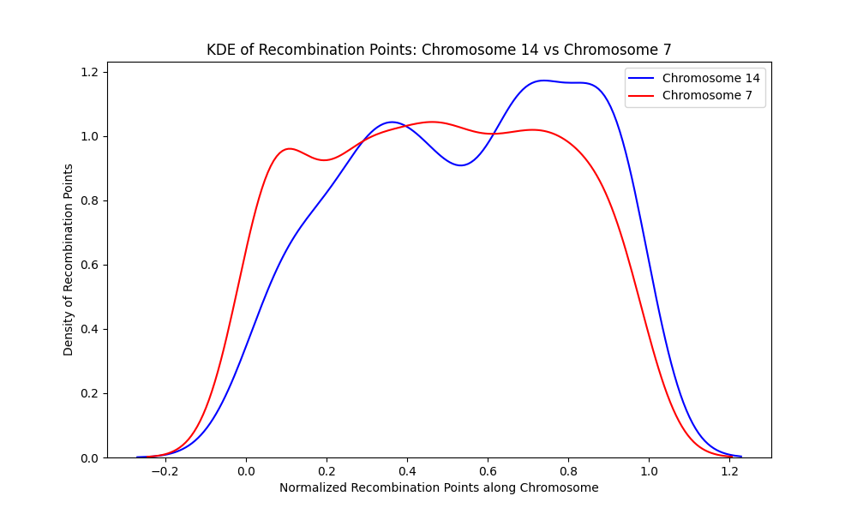

**Figure 82**. A kernel density estimate of chromosome 14 and chromosome 7 shows that recombination points are distributed differently along the length of the chromosomes. Chromosome 14 (blue) has one valley (area of sparse distribution of recombination points) and two peaks (area of concentrated recombination points) while chromosome 7 (red) has two valleys and three peaks.

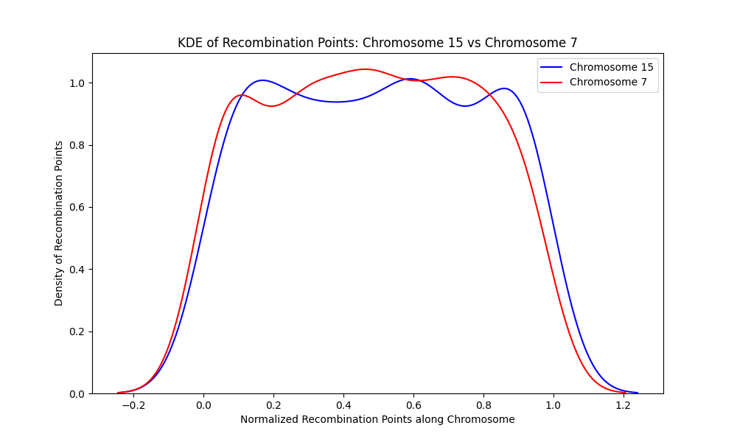

**Figure 83**. A kernel density estimate of chromosome 15 and chromosome 7 shows that recombination points are distributed differently along the length of the chromosomes. Chromosome 15 (blue) has two valleys (area of sparse distribution of recombination points) and three peaks (area of concentrated recombination points) and chromosome 7 (red) has two valleys and three peaks.

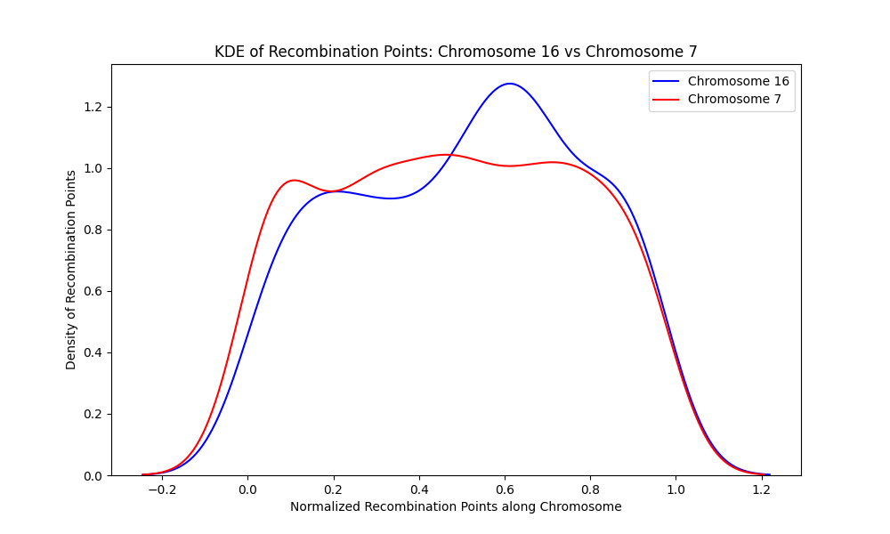

**Figure 84**. A kernel density estimate of chromosome 16 and chromosome 7 shows that recombination points are distributed differently along the length of the chromosomes. Chromosome 16 (blue) has one valley (area of sparse distribution of recombination points) and two peaks (area of concentrated recombination points) while chromosome 7 (red) has two valleys and three peaks.

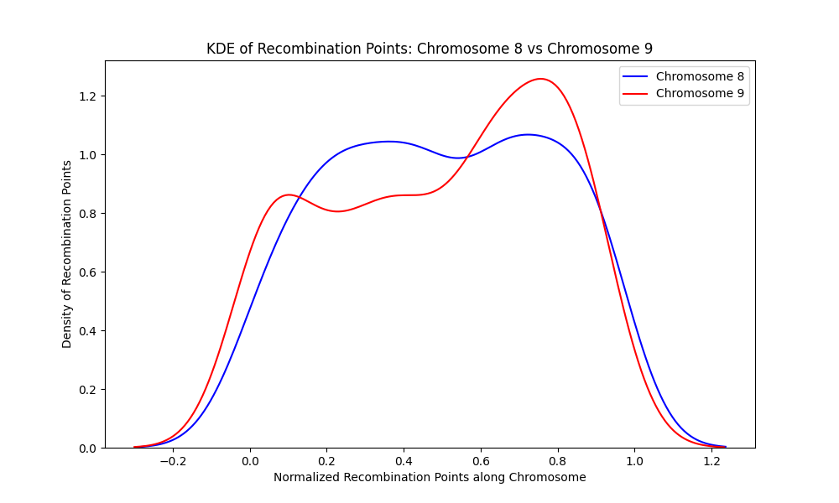

**Figure 85**. A kernel density estimate of chromosome 8 and chromosome 9 shows that recombination points are distributed differently along the length of the chromosomes. Chromosome 8 (blue) has a valley (area of sparse distribution of recombination points) and two peaks (area of concentrated recombination points) while chromosome 9 (red) has two valleys and three peaks.

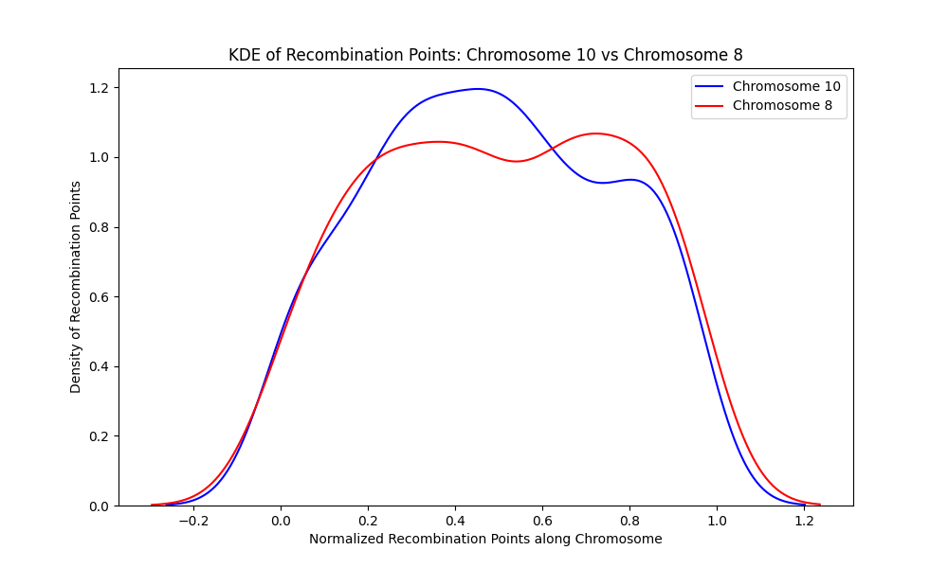

**Figure 86**. A kernel density estimate of chromosome 10 and chromosome 8 shows that recombination points are distributed differently along the length of the chromosomes. Chromosome 10 (blue) has a valley (area of sparse distribution of recombination points) and two peaks (area of concentrated recombination points) while chromosome 8 (red) has a valley and two peaks.

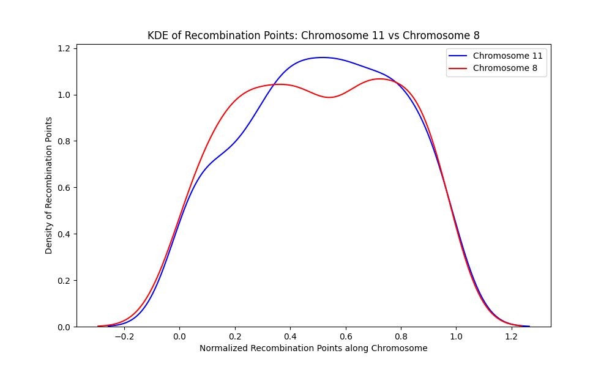

**Figure 87**. A kernel density estimate of chromosome 11 and chromosome 8 shows that recombination points are distributed differently along the length of the chromosomes. Chromosome 11 (blue) has no valley (area of sparse distribution of recombination points) but one broad peak at the middle of the chromosome (area of concentrated recombination points) while chromosome 8 (red) has a valley and two peaks.

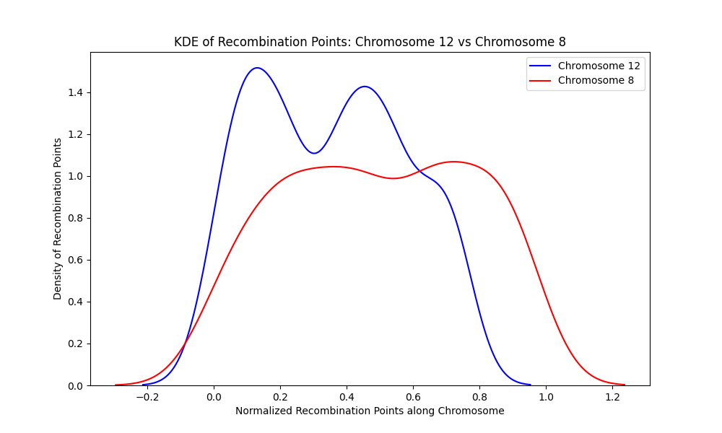

**Figure 88.** A kernel density estimate of chromosome 12 and chromosome 8 shows that recombination points are distributed differently along the length of the chromosomes. Chromosome 10 (blue) has a valley (area of sparse distribution of recombination points) and two peaks (area of concentrated recombination points) and chromosome 8 (red) also has a valley and two peaks but with different heights and depths and at different locus

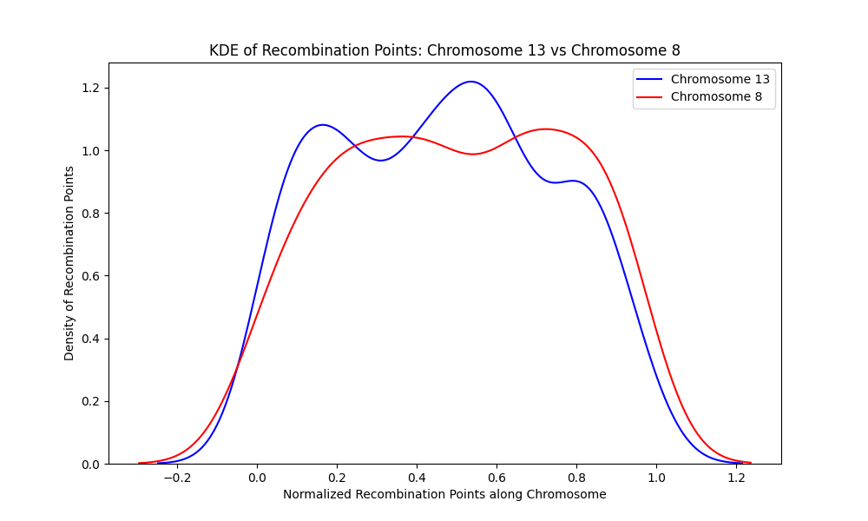

**Figure 89** A kernel density estimate of chromosome 13 and chromosome 8 shows that recombination points are distributed differently along the length of the chromosomes. Chromosome 13 (blue) has two valleys (area of sparse distribution of recombination points) and three peaks (area of concentrated recombination points) while chromosome 8 (red) has a valley and two peaks.

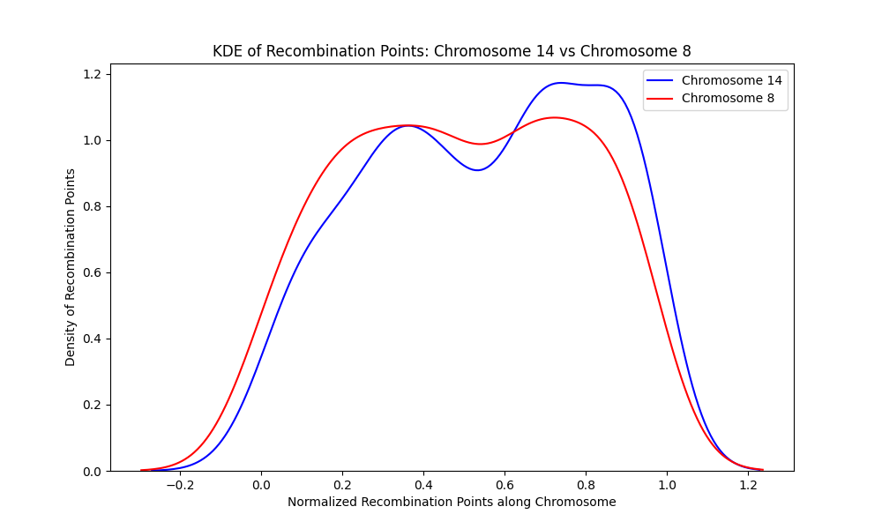

**Figure 90**. A kernel density estimate of chromosome 14 and chromosome 8 shows that recombination points are distributed differently along the length of the chromosomes. Chromosome 14 (blue) has a valley (area of sparse distribution of recombination points) and two peaks (area of concentrated recombination points) and chromosome 8 (red) also has a valley and two peaks but these peaks and valleys are located differently on their respective chromosomes.

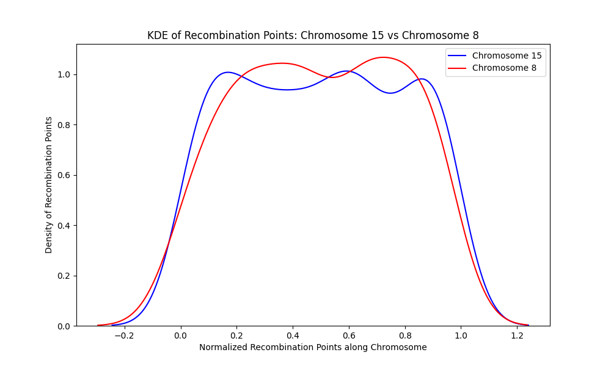

**Figure 91**. A kernel density estimate of chromosome 15 and chromosome 8 shows that recombination points are distributed differently along the length of the chromosomes. Chromosome 15 (blue) has two valleys (area of sparse distribution of recombination points) and three peaks (area of concentrated recombination points) while chromosome 8 (red) has a valley and two peaks.

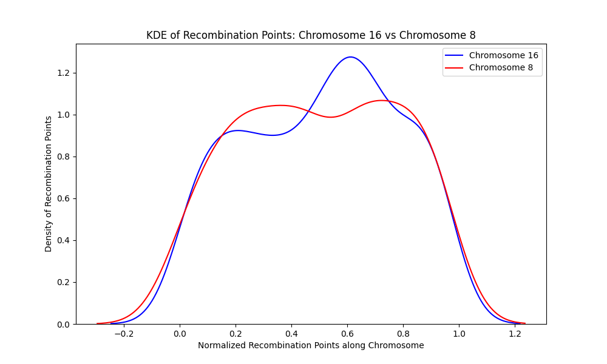

**Figure 92**. A kernel density estimate of chromosome 16 and chromosome 8 shows that recombination points are distributed differently along the length of the chromosomes. Chromosome 16 (blue) has a valley (area of sparse distribution of recombination points) and two peaks (area of concentrated recombination points) and chromosome 8 (red) has same number of valleys and peaks but different heights, depths, and loci.

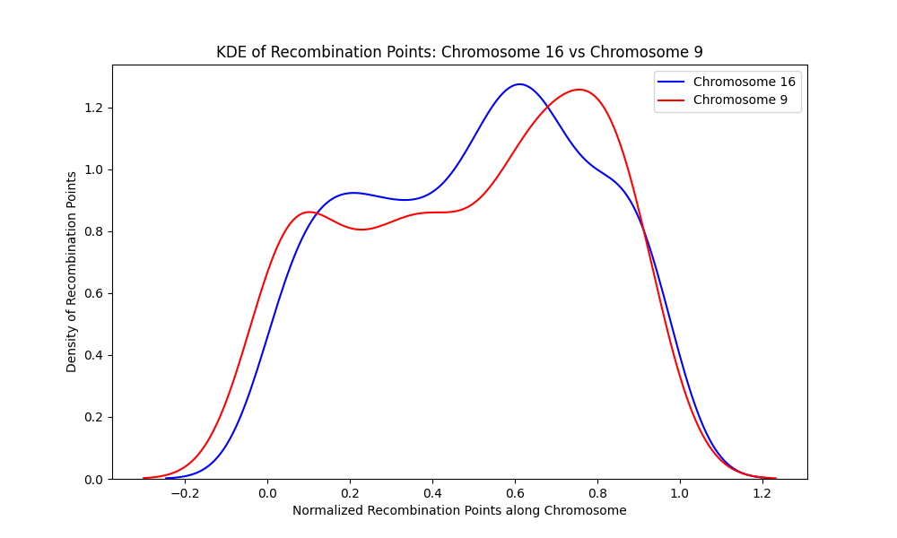

**Figure 93**. A kernel density estimate of chromosome 16 and chromosome 9 shows that recombination points are distributed differently along the length of the chromosomes. Chromosome 16 (blue) has a valley (area of sparse distribution of recombination points)and two peaks (area of concentrated recombination points) while chromosome 9 (red) has two valleys and three peaks.

For further investigation into the distribution of recombination points on a chromosome, cumulative distribution function (CDF) plots were generated for different pairs of chromosomes. The CDF plots help visualize how probabilities accumulate over the possible values of recombination points on a chromosome, providing insights into the central tendency, spread, and general distribution characteristics. It provides a visual representation of how recombination points are distributed across the length of the chromosome. If the CDF rises steeply, the distribution has a lot of recombination points in that location. A more gradual rise means the values are more spread out. The flat sections of the plot indicate intervals with no recombination points.

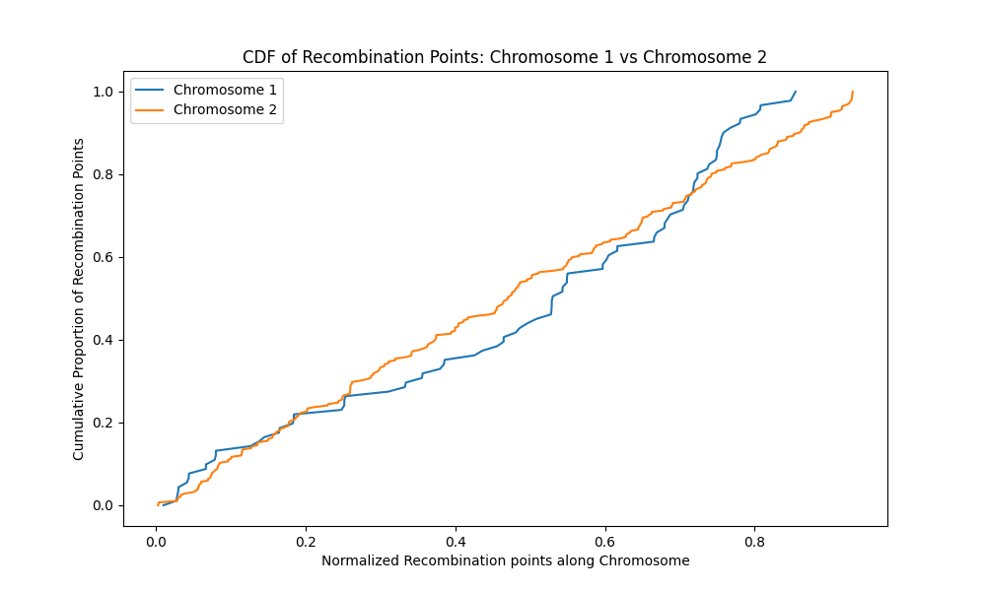

**Figure 94**. Recombination points on chromosome 2 (yellow) are more concentrated across its length compared to chromosome 1 (blue). Chromosome 1 has more flat sections ( no recombination points), and the rise is more gradual than chromosome 2.

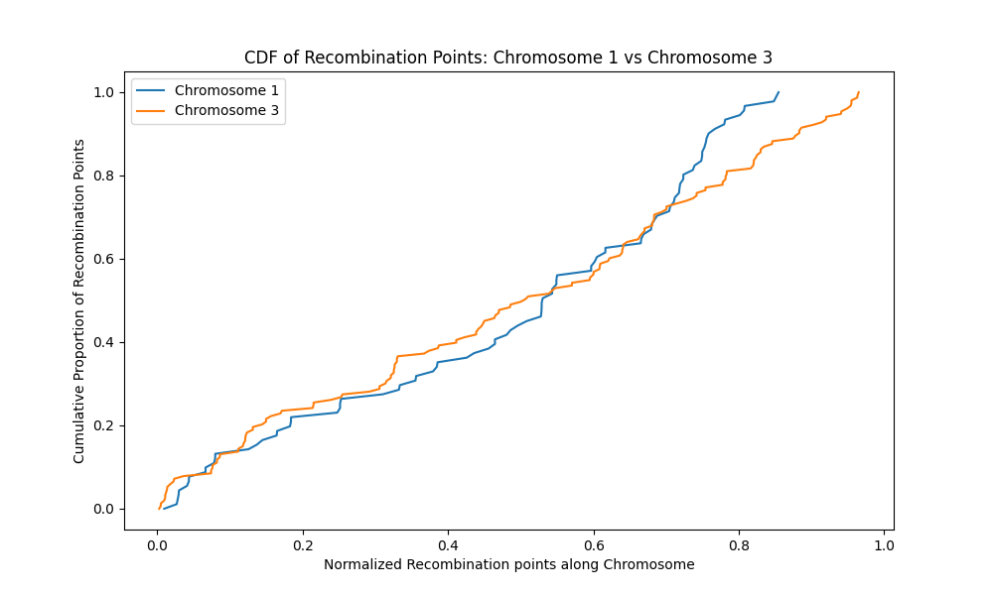

**Figure 95**. Recombination points on chromosome 3 (yellow) are more concentrated across its length compared to chromosome 1 (blue). Chromosome 1 has more flat sections ( no recombination points), and the rise is more gradual than chromosome 3.

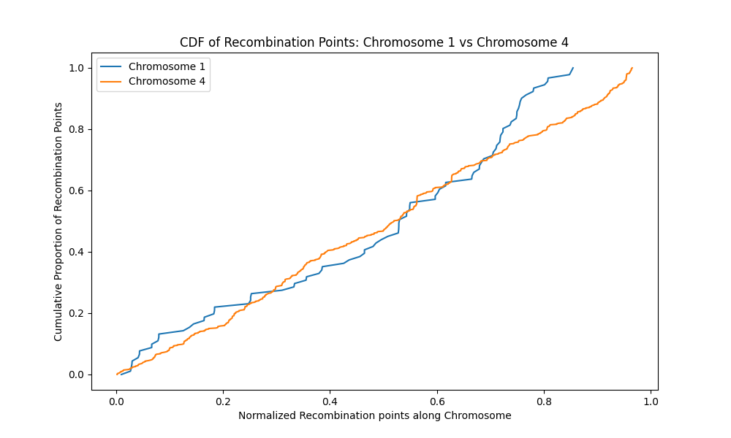

**Figure 96.** Recombination points on chromosome 4 (yellow) are more concentrated across its length compared to chromosome 1 (blue). Chromosome 1 has more flat sections ( no recombination points), and the rise is more gradual than chromosome 4.

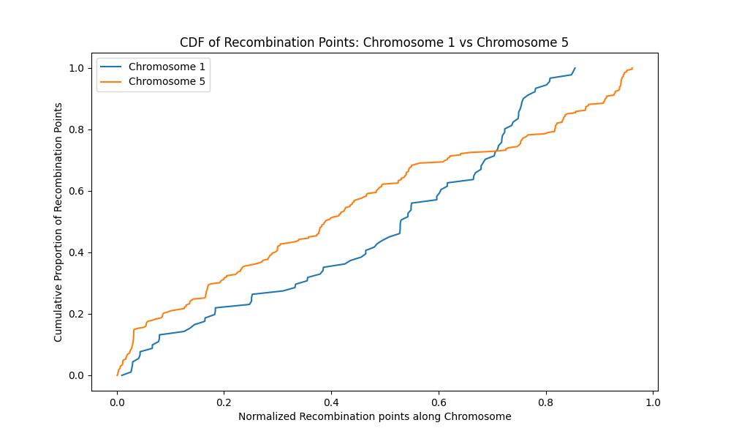

**Figure 97.** Recombination points on chromosome 5 (yellow) are more concentrated across its length compared to chromosome 1 (blue). Chromosome 1 has more flat sections ( no recombination points), and the rise is more gradual than chromosome 5

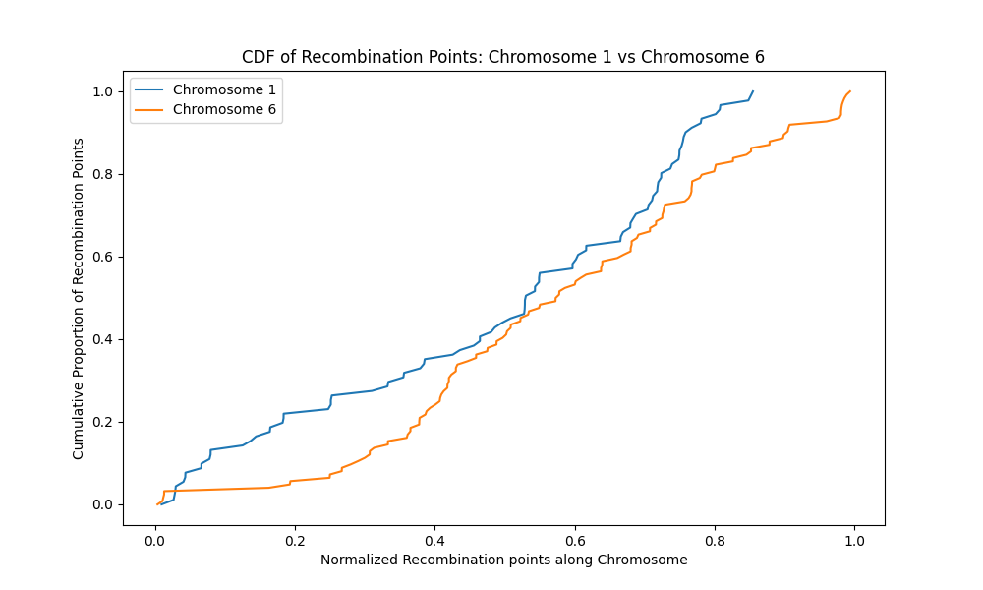

**Figure 98**. Recombination points on chromosome 6 (yellow) are evenly distributed across its length compared to chromosome 1 (blue). Chromosome 1 has more flat sections ( no recombination points), but both chromosomes have gradual rise, indicating an even distribution of recombination points.

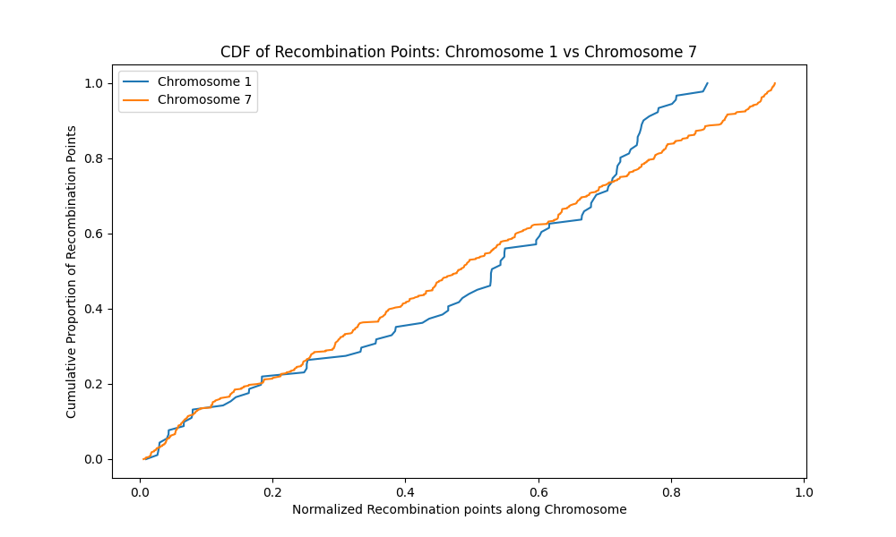

**Figure 99**. Recombination points on chromosome 7 (yellow) are more concentrated across its length compared to chromosome 1 (blue). Chromosome 1 has more flat sections ( no recombination points), and the rise is more gradual than chromosome 7.

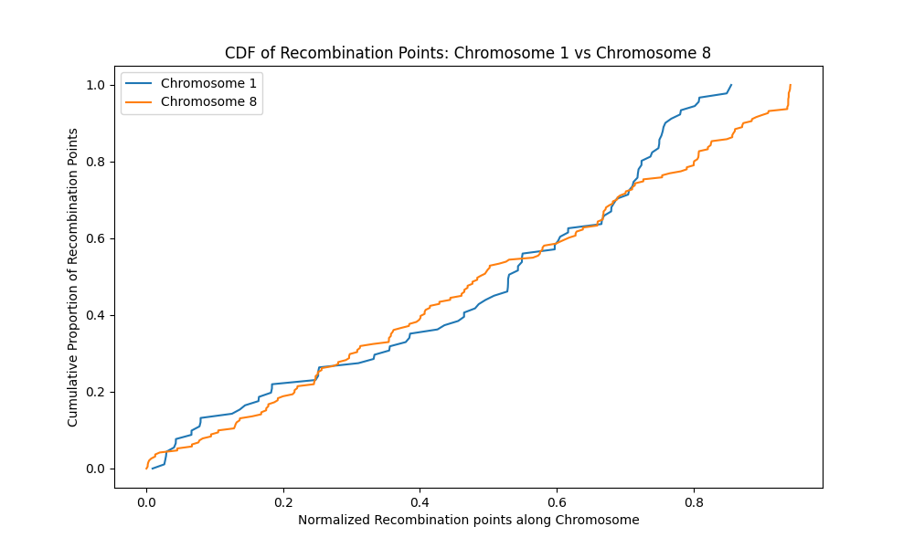

**Figure 100**. Recombination points on chromosome 8 (yellow) are more concentrated across its length compared to chromosome 1 (blue). Chromosome 1 has more flat sections ( no recombination points), and the rise is more gradual than chromosome 8.

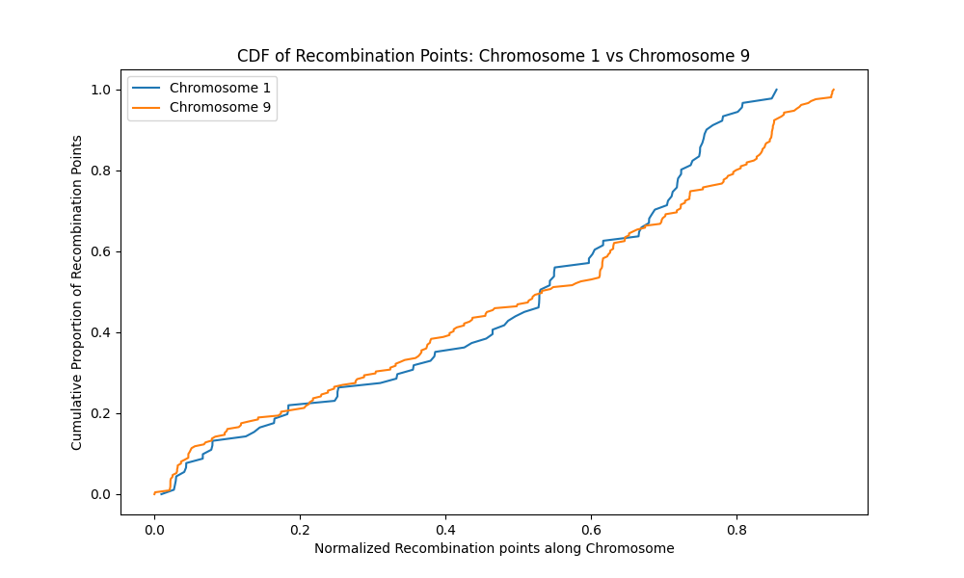

**Figure 101**. Recombination points on chromosome 9 (yellow) are more concentrated across its length compared to chromosome 1 (blue). Chromosome 1 has more flat sections ( no recombination points), and the rise is more gradual than chromosome 4

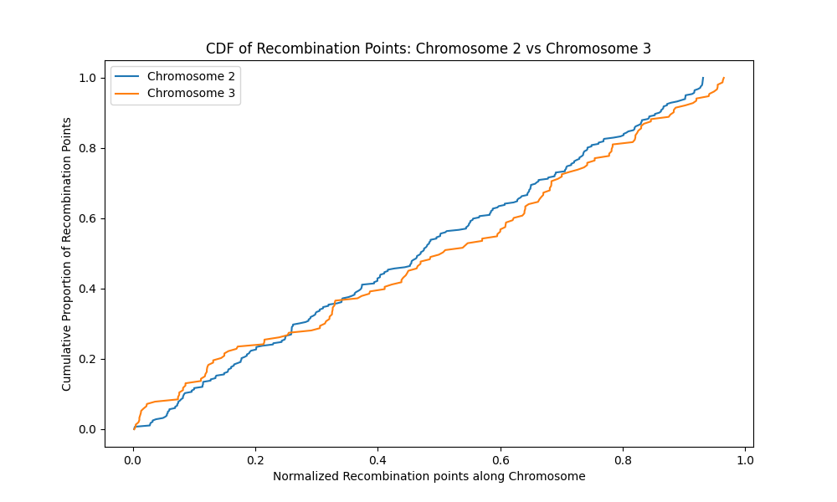

**Figure 102**. Recombination points on chromosome 3 (yellow) are evenly distributed across its length as chromosome 2 (blue). Both chromosomes has a steep rise indicating a high probability encountering recombination points anywhere along the chromosome length.

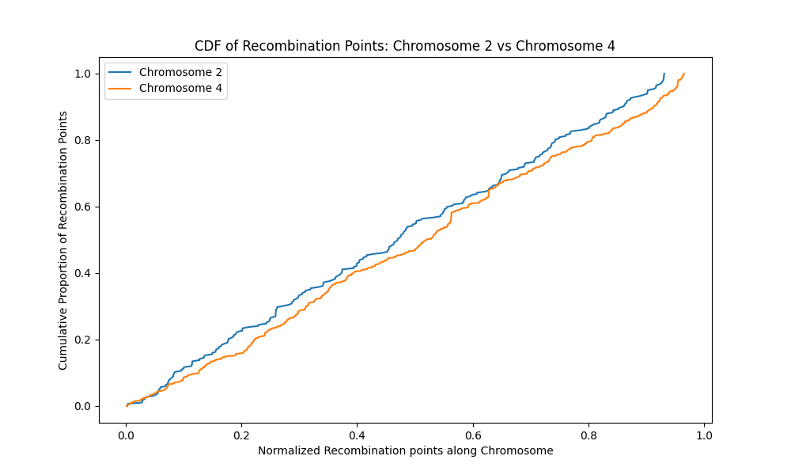

**Figure 103**. Recombination points on chromosome 4 (yellow) are evenly distributed across its length as chromosome 2 (blue). Both chromosomes has a steep rise indicating a high probability encountering recombination points anywhere along the chromosome length.

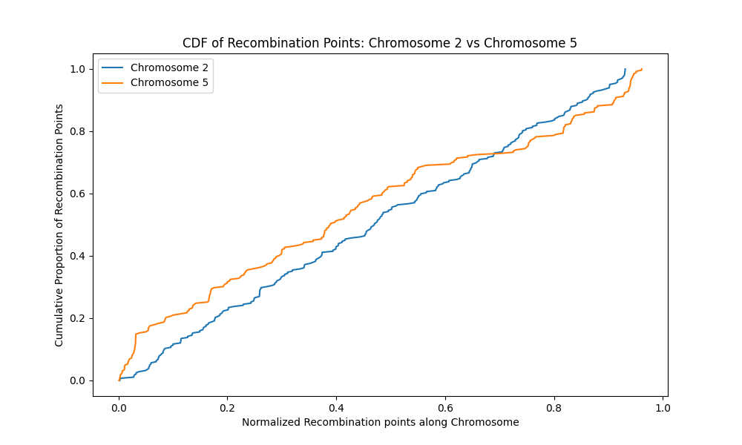

**Figure 104**. Recombination points on chromosome 5 (yellow) are evenly distributed across its length as chromosome 2 (blue). Both chromosomes has a steep rise indicating a high probability encountering recombination points anywhere along the chromosome length.

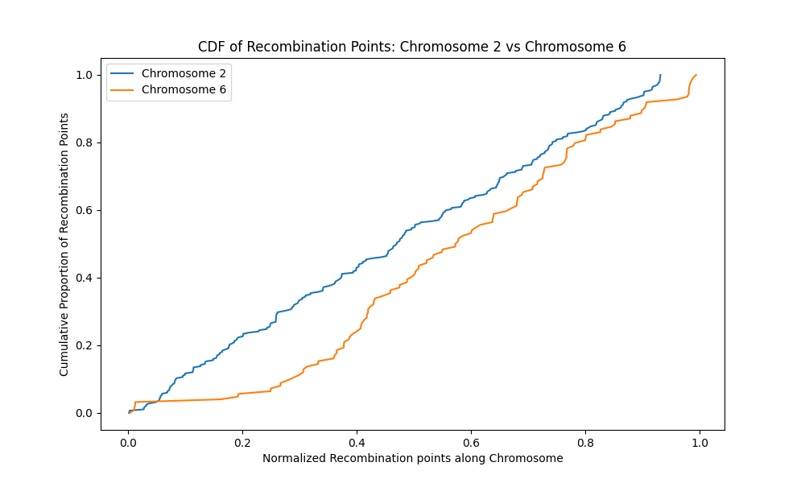

**Figure 105** .Recombination points on chromosome 6 (yellow) are less evenly distributed across its length compared to chromosome 2 (blue). Chromosome 2 has a steep rise, indicating a high probability encountering recombination points anywhere along the chromosome length compared to chromosome 6.

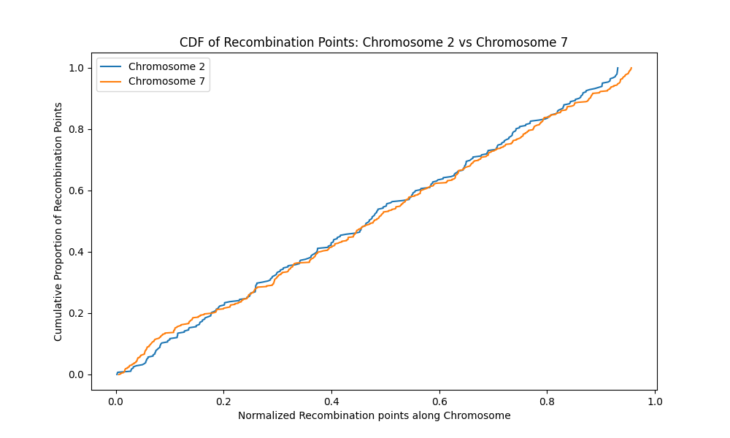

**Figure 106**. Recombination points on chromosome 7 (yellow) are evenly distributed across its length as chromosome 2 (blue). Both chromosomes has a steep rise indicating a high probability encountering recombination points anywhere along the chromosome length.

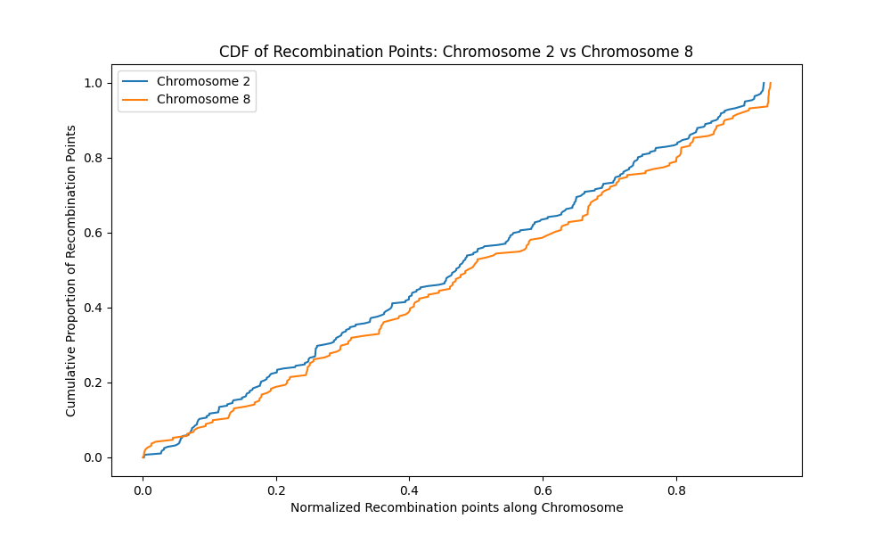

**Figure 107**. Recombination points on chromosome 8 (yellow) are evenly distributed across its length as chromosome 2 (blue). Both chromosomes has a steep rise indicating a high probability encountering recombination points anywhere along the chromosome length.

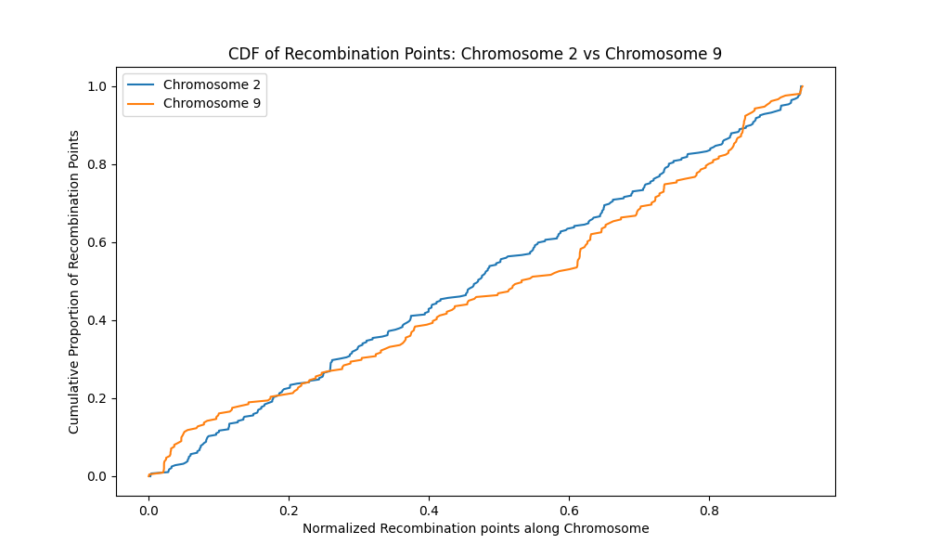

**Figure 108.** Recombination points on chromosome 9 (yellow) are evenly distributed across its length as chromosome 2 (blue). Both chromosomes has a steep rise indicating a high probability encountering recombination points anywhere along the chromosome length.

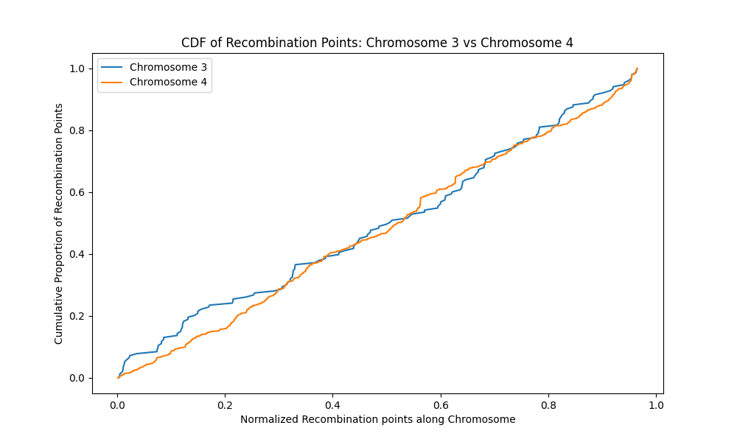

**Figure 109**. Recombination points on chromosome 4 (yellow) are evenly distributed across its length compared to chromosome 3 (blue). Chromosome 4 has a steep rise and less flat sections indicating a high probability encountering recombination points anywhere along the chromosome length compared to chromosome 3.

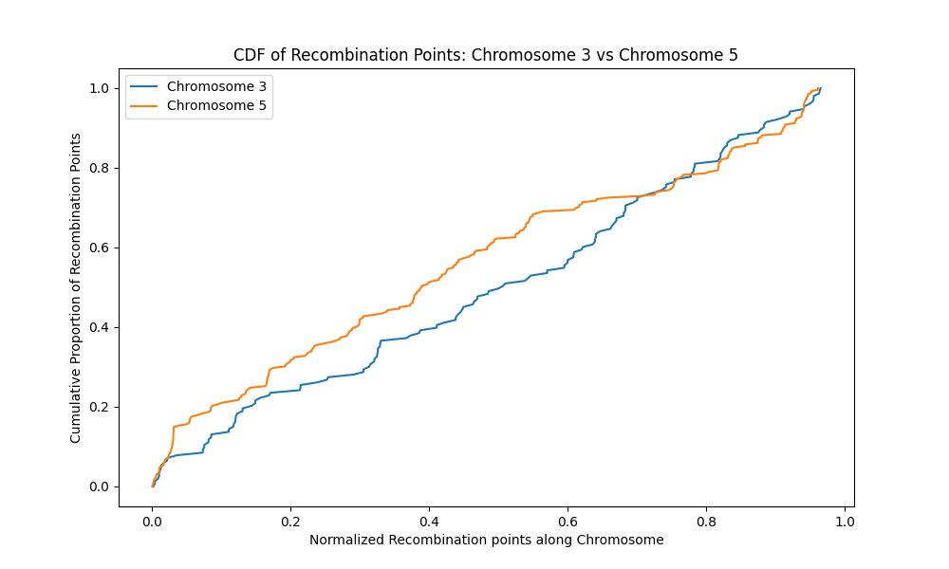

**Figure 110**. Recombination points on chromosome 5 (yellow) are less evenly distributed across its length as chromosome 3 (blue). Both chromosomes has flatter sections indicating areas of no recombination points on both chromosomes.

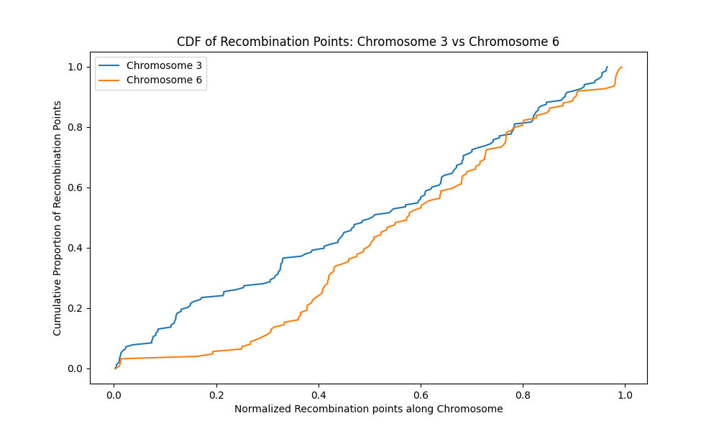

**Figure 111**. Recombination points on chromosome 6 (yellow) are less evenly distributed across its length as chromosome 3 (blue). Both chromosomes has flatter sections indicating areas of no recombination points on both chromosomes.

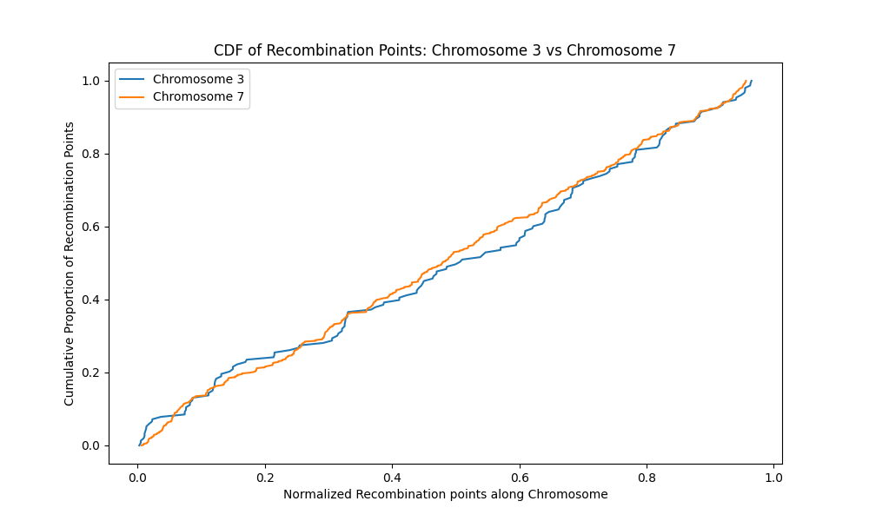

**Figure 112**. Recombination points on chromosome 7 (yellow) are more evenly distributed across its length compared to chromosome 3 (blue). Chromosome 3 has flatter sections than chromosome 7, indicating sparse recombination points at those locations.

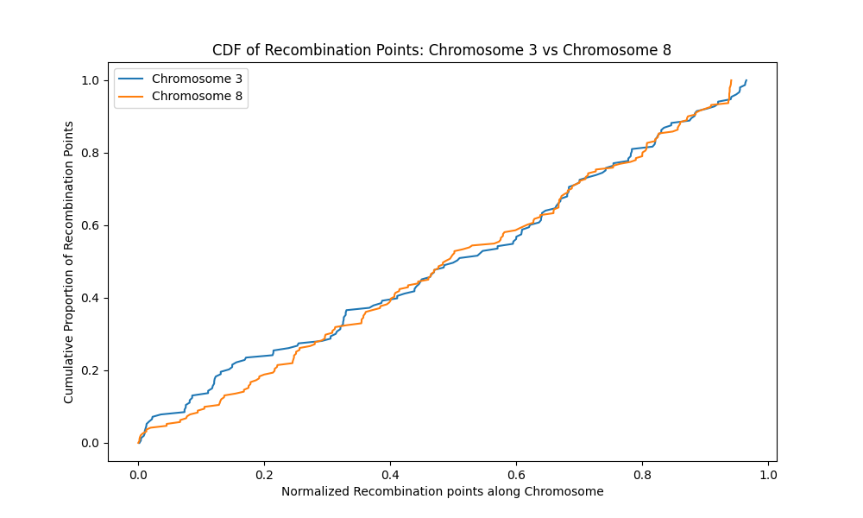

**Figure 113**. Recombination points on chromosome 8 (yellow) are less evenly distributed across its length as chromosome 3 (blue). Both chromosomes have areas of low recombination points distribution (flatter sections).

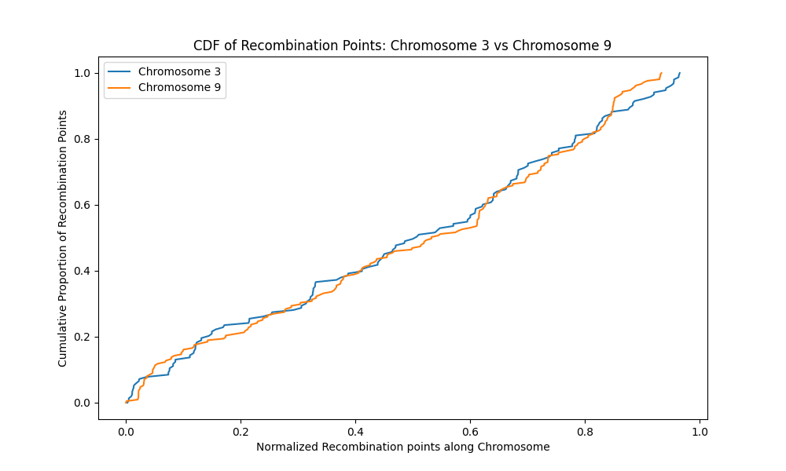

**Figure 114**. Recombination points on chromosome 9 (yellow) are less evenly distributed across its length as chromosome 3 (blue). Both chromosomes have areas of low recombination points distribution (flatter sections).

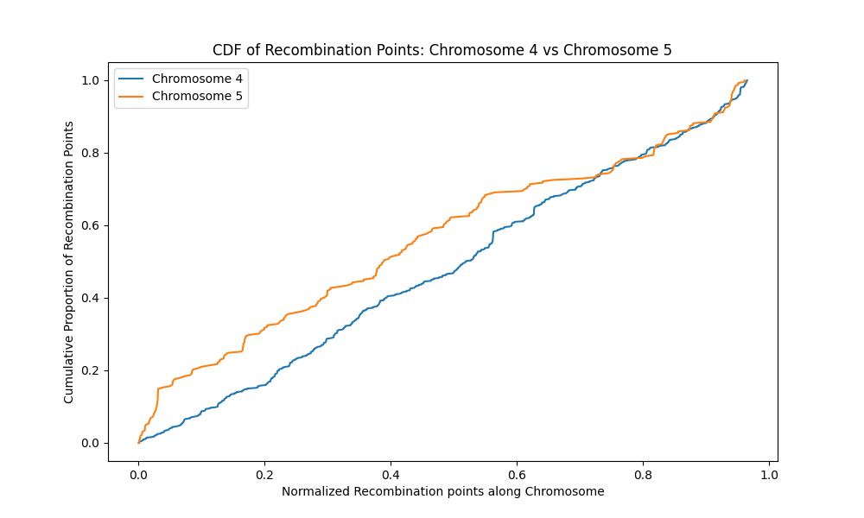

**Figure 115**. The plot shows chromosome 4 (blue) has evenly distributed recombination points along its length compared to chromosome 5 (yellow). Recombination points are sparsely distributed on chromosome 5 as indicated by flat sections on the graph.

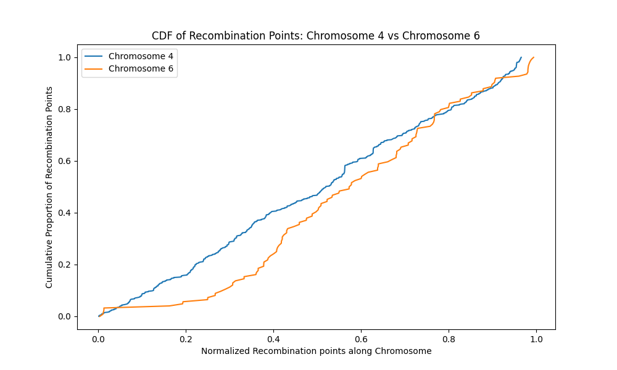

**Figure 116**. The plot shows chromosome 4 (blue) has evenly distributed recombination points along its length compared to chromosome 6 (yellow). Recombination points are sparsely distributed on chromosome 6 as indicated by flat sections on the graph and the gradual rise of the graph.

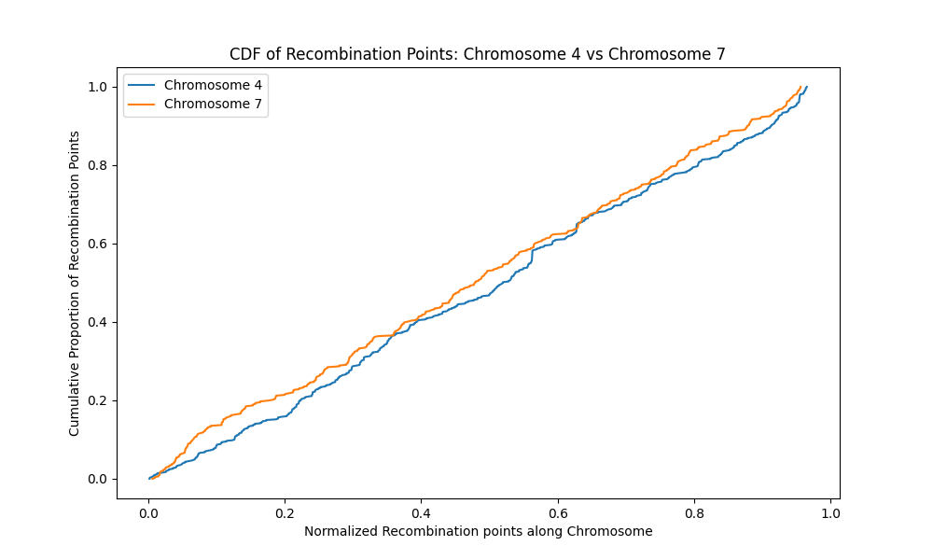

**Figure 117.** The plot shows chromosome 4 (blue) has evenly distributed recombination points along its length as chromosome 7 (yellow). Both chromosomes have a gradual rise indicating an evenly distributed recombination points pattern.

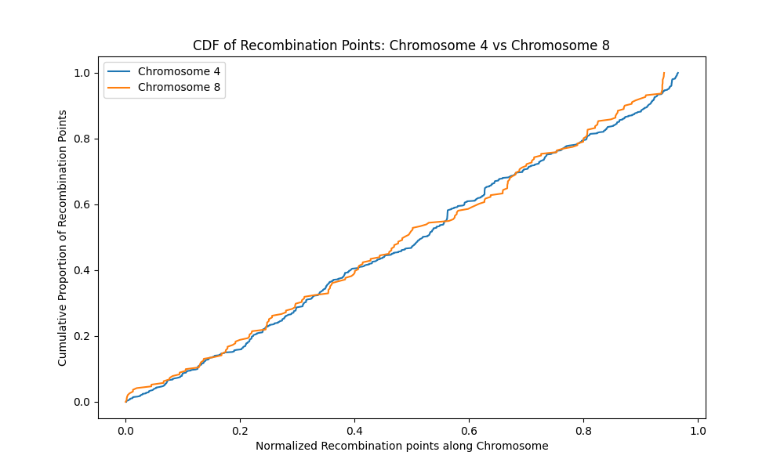

**Figure 118**. The plot shows chromosomes 4 (blue) and 8 (yellow) have similar distribution recombination points. Both chromosomes have a gradual rise indicating an evenly distributed recombination points pattern.

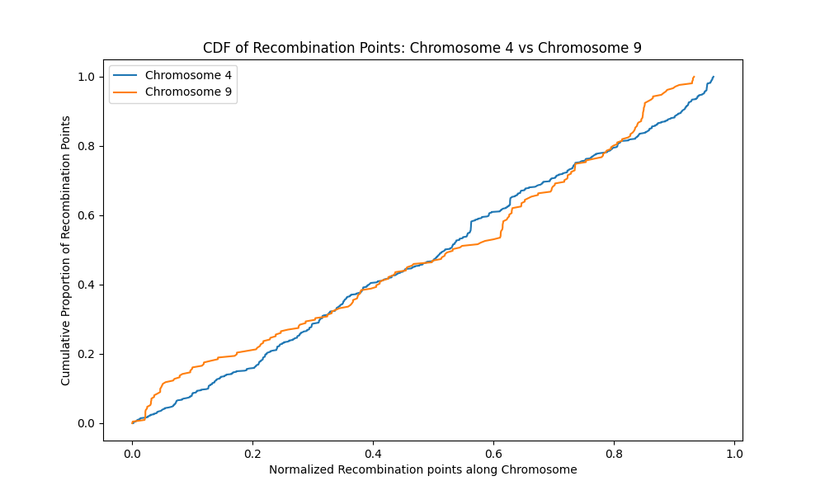

**Figure 119**. The plot shows chromosomes 4 (blue) and 9 (yellow) have similar distribution of recombination points. Both chromosomes have a gradual rise indicating an evenly distributed recombination points pattern.

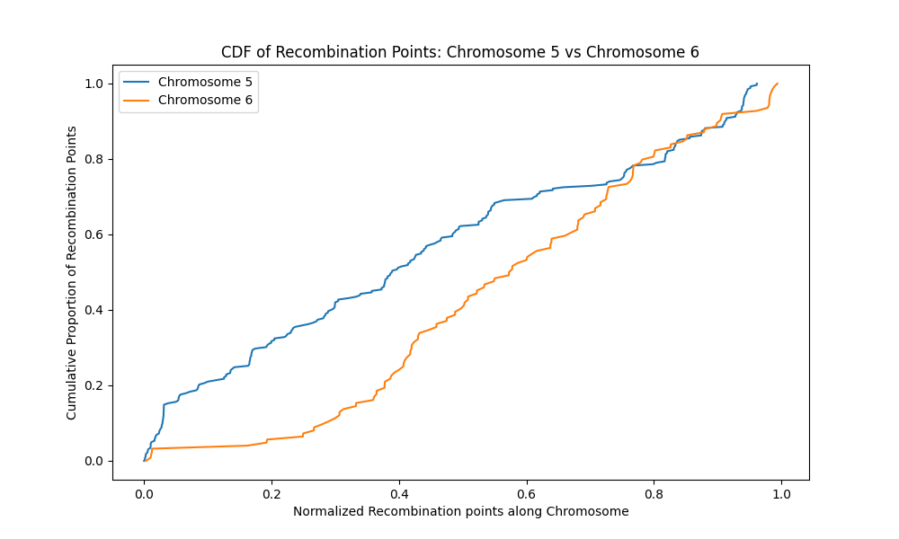

**Figure 120**. The plot shows chromosome 5 (blue) and chromosome 6 (yellow) have sparsely distributed recombination points along their lengths. The flat sections are areas low of recombination points on the chromosomes.

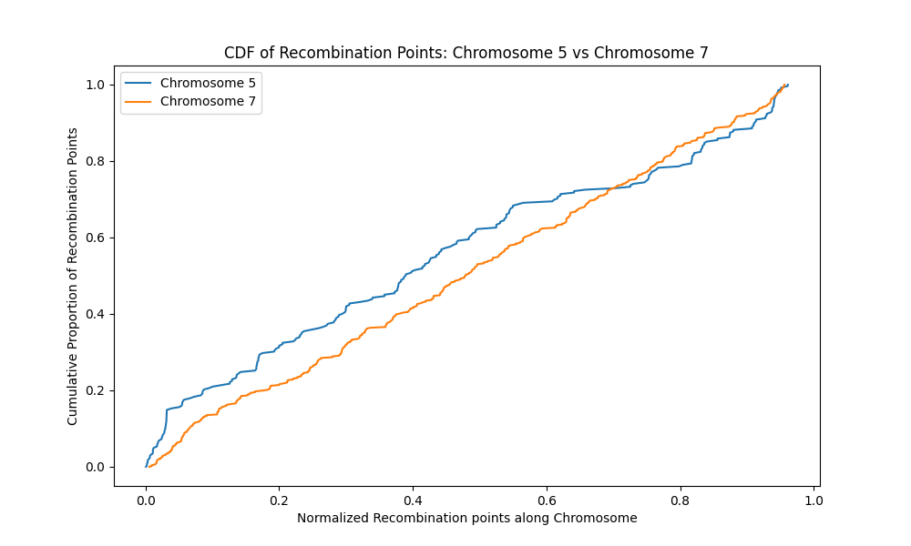

**Figure 121**. The plot shows chromosome 7 (blue) has evenly distributed recombination points along its length compared chromosome 5 (yellow). Chromosome 5 has a flatter section than chromosome because there are more areas with no recombination points on the chromosome.

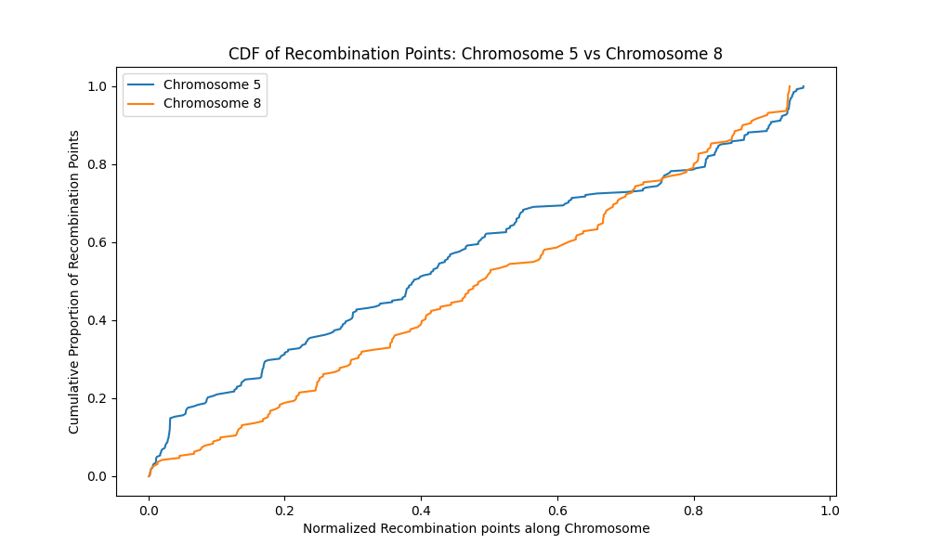

**Figure 122.** The plot shows chromosome 5 (blue) and chromosome 8 (yellow) have sparsely distributed recombination points along their lengths. The flat sections are areas of low recombination points on the chromosomes.

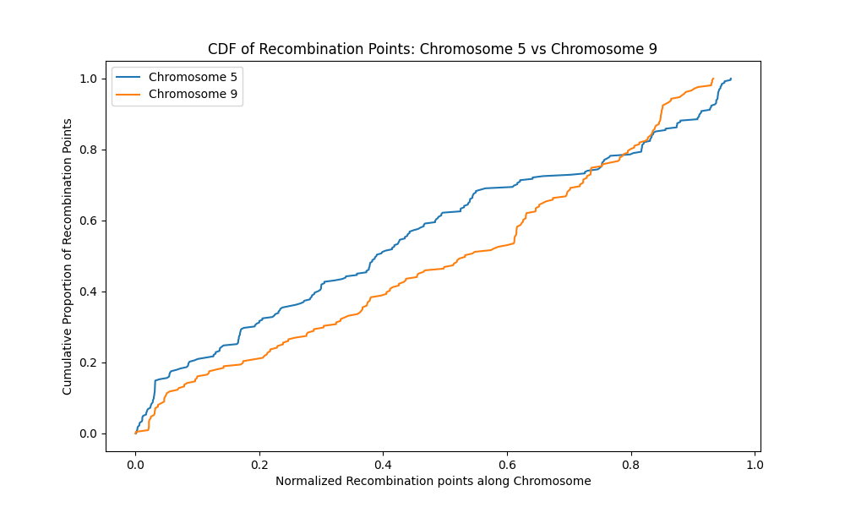

**Figure 123**. The plot shows chromosome 5 (blue) and chromosome 9 (yellow) have sparsely distributed recombination points along their lengths. The flat sections are areas of low recombination points on the chromosomes.

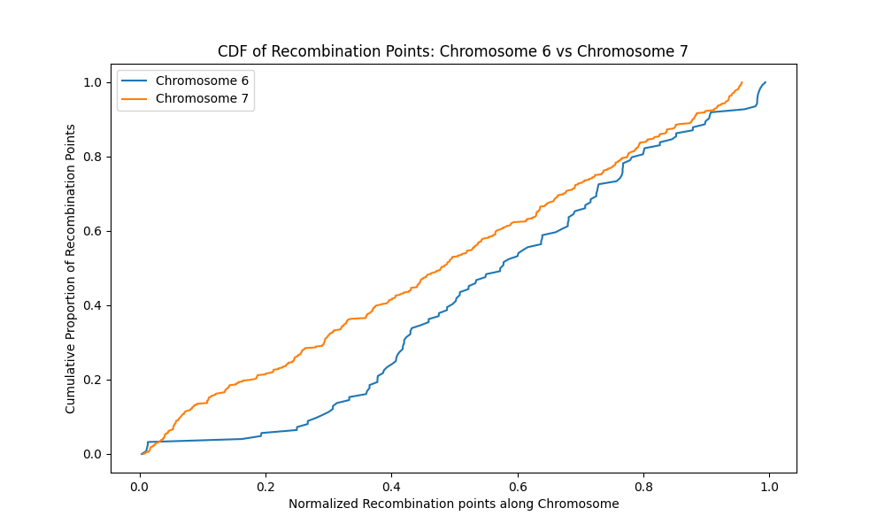

**Figure 124**. The plot shows chromosome 6 (blue) and chromosome 7 (yellow) have sparsely distributed recombination points over their lengths. The flat sections are areas of low recombination points on the chromosomes.

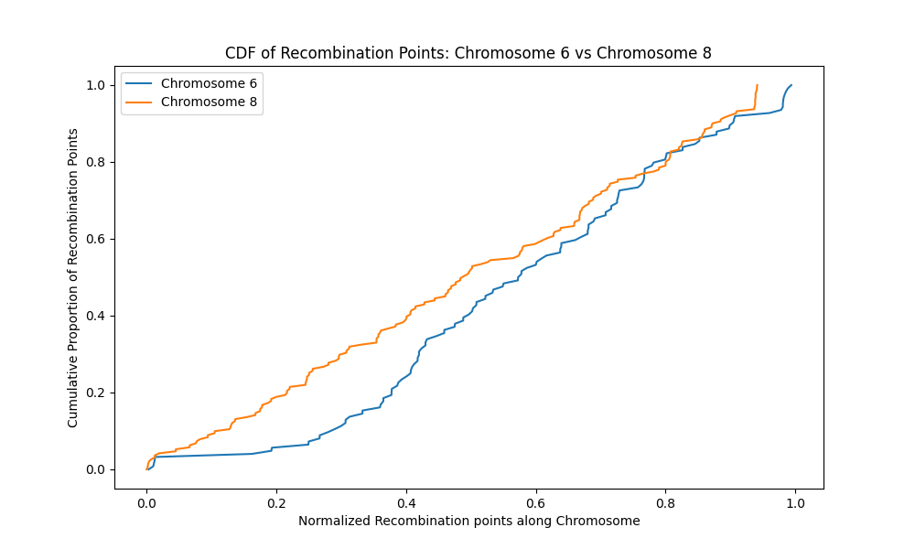

**Figure 125**. The plot shows chromosome 6 (blue) and chromosome 8 (yellow) have sparsely distributed recombination points along their lengths. The flat sections are areas of low recombination points on the chromosomes.

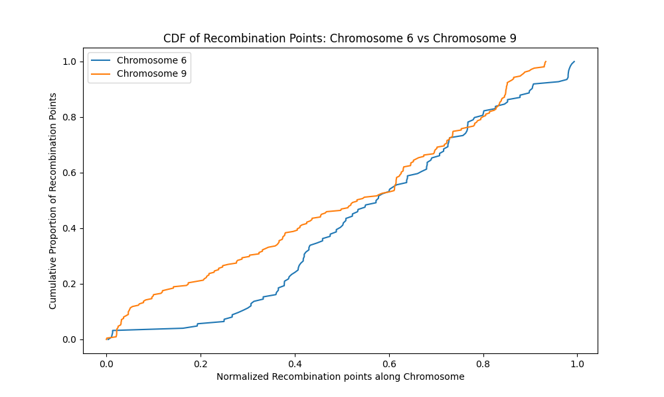

**Figure 126**. The plot shows chromosome 6 (blue) and chromosome 9 (yellow) have sparsely distributed recombination points along their lengths. The flat sections are areas of low recombination points on the chromosomes.

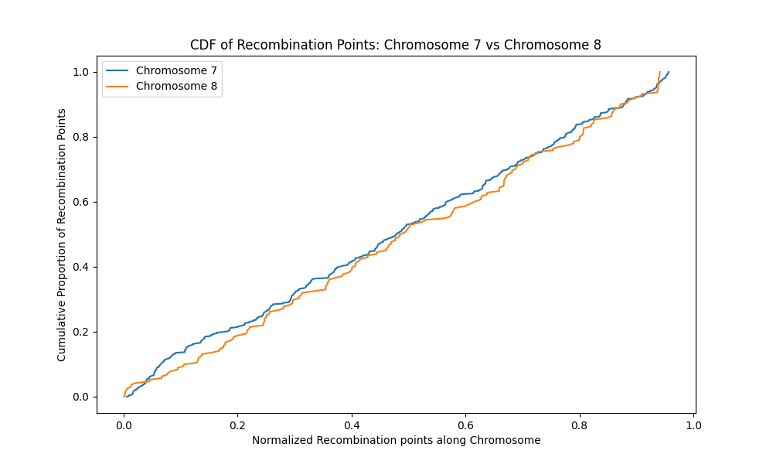

**Figure 127**. The plot shows chromosome 7 (blue) have more evenly distributed recombination points along their lengths compared to chromosome 8. The flat sections on chromosome 8 are areas of low recombination points. The probability of overlap of recombination points and regions of spatial proximity is low in these areas.

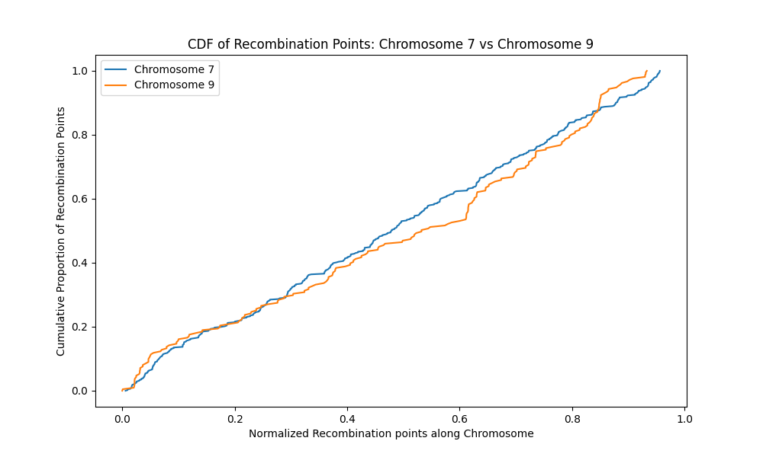

**Figure 128**. The plot shows chromosome 7 (blue) have more evenly distributed recombination points along their lengths compared to chromosome 9. The flat sections on chromosome 9 are areas of low recombination points. The probability of overlap of recombination points and regions of spatial proximity is low in these areas.

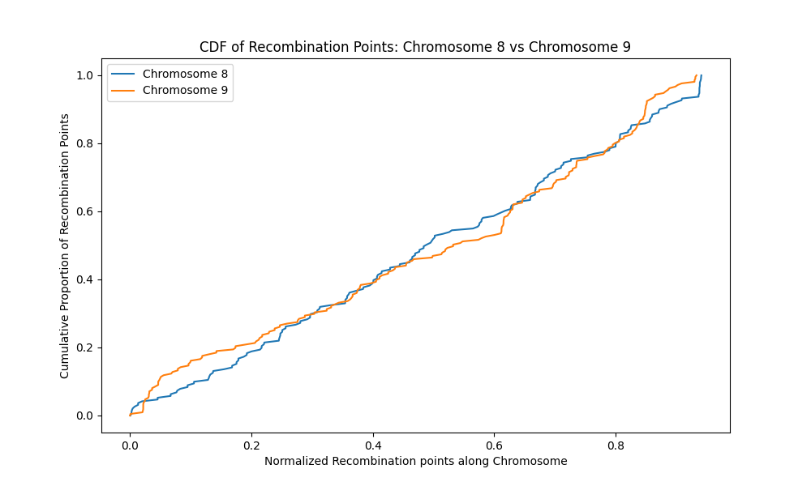

**Figure 129**. The plot shows chromosome 8 (blue) have more evenly distributed recombination points along their lengths compared to chromosome 9. The flat sections on chromosome 9 are areas of low recombination points. The probability of overlap of recombination points and regions of spatial proximity is low in these areas.

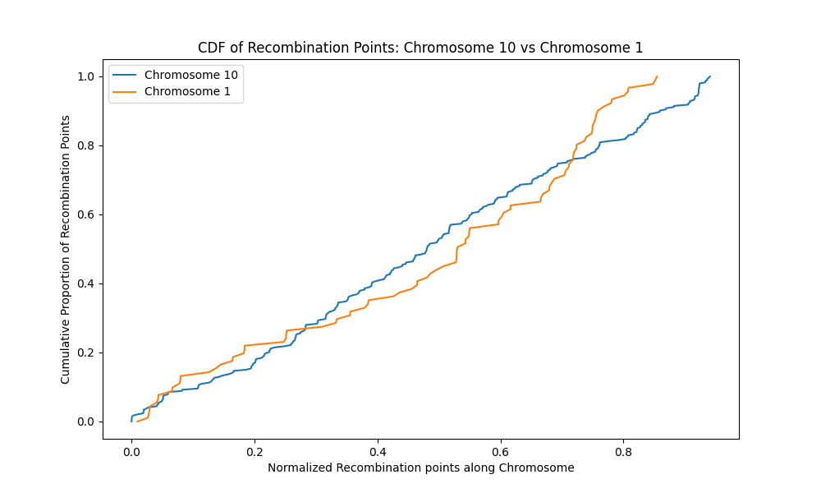

**Figure 130**. The plot shows chromosome 10 (blue) have more evenly distributed recombination points along its length compared to chromosome 1. The flat sections on chromosome 1 are areas of low recombination points. The probability of overlap of recombination points and regions of spatial proximity is low in these areas.

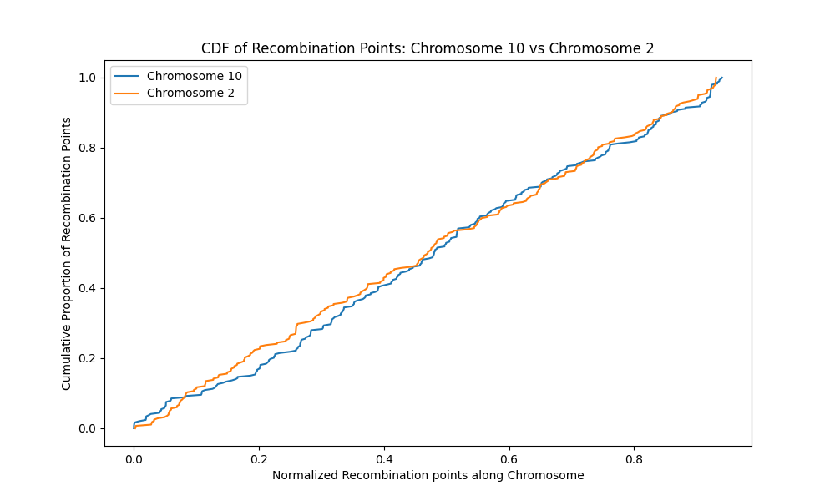

**Figure 131**. The plot shows chromosomes 10 (blue) and 2 (yellow) have similar distribution of recombination points. Both chromosomes have a gradual rise indicating an evenly distributed recombination points pattern

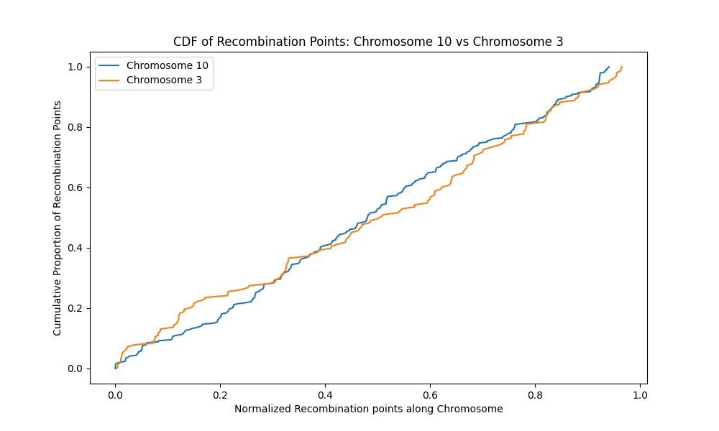

**Figure 132**. The plot shows chromosomes 10 (blue) and 3 (yellow) have similar distribution of recombination points. Both chromosomes have a gradual rise indicating an evenly distributed recombination points pattern.

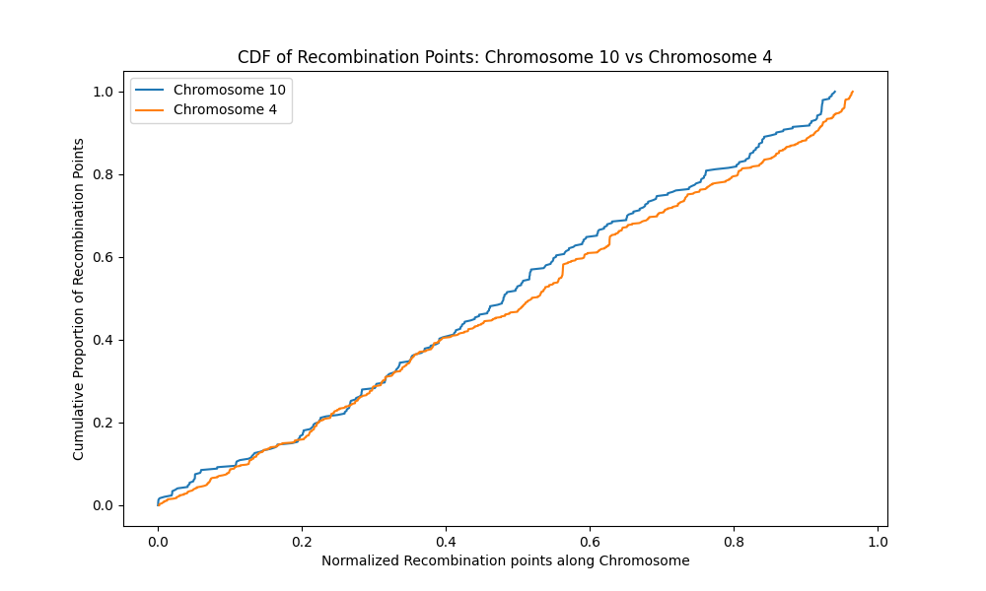

**Figure 133**. The plot shows chromosomes 10 (blue) and 4 (yellow) have similar distribution of recombination points. Both chromosomes have a gradual rise indicating an evenly distributed recombination points pattern.

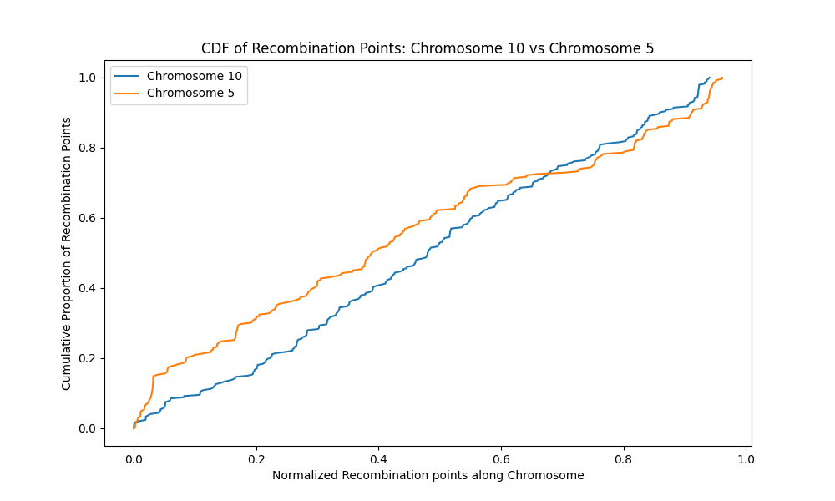

**Figure 134**. The plot shows chromosomes 10 (blue) and 5 (yellow) have similar distribution of recombination points. Both chromosomes have a gradual rise indicating an evenly distributed recombination points pattern.

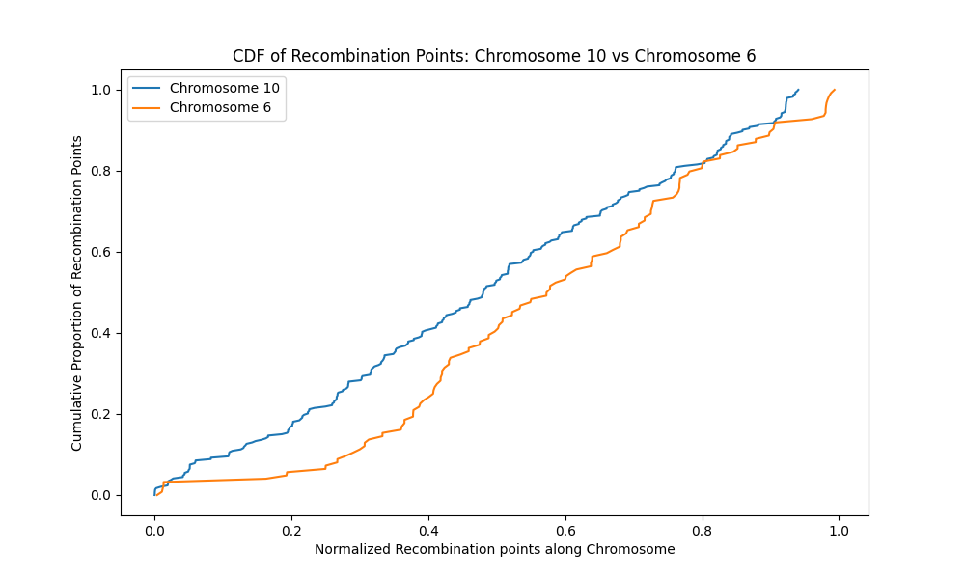

**Figure 135.** The plot shows chromosome 10 (blue) have more evenly distributed recombination points along their lengths compared to chromosome 6. The flat sections on chromosome 6 are areas of low recombination points. The probability of overlap of recombination points and regions of spatial proximity is low in these areas.

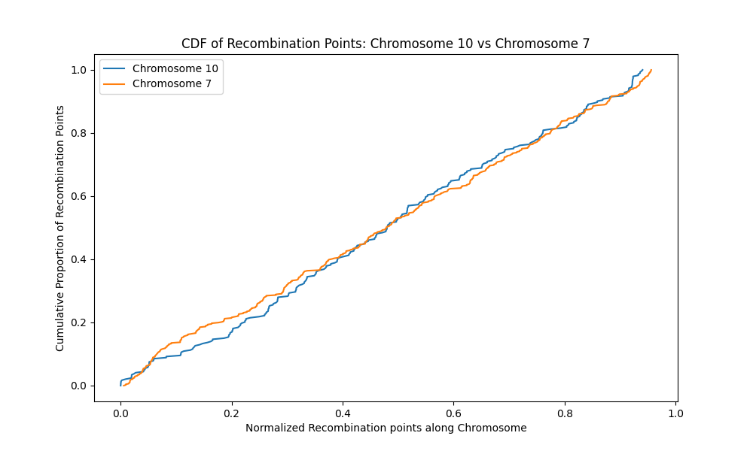

**Figure 136**. The plot shows both chromosome 10 (blue) and chromosome 7 (yellow) have evenly distributed recombination points along their lengths. There are areas with no recombination points as indicated by flat sections on the graph for each chromosome. The probability of overlap of recombination points and regions of spatial proximity is low in these areas.

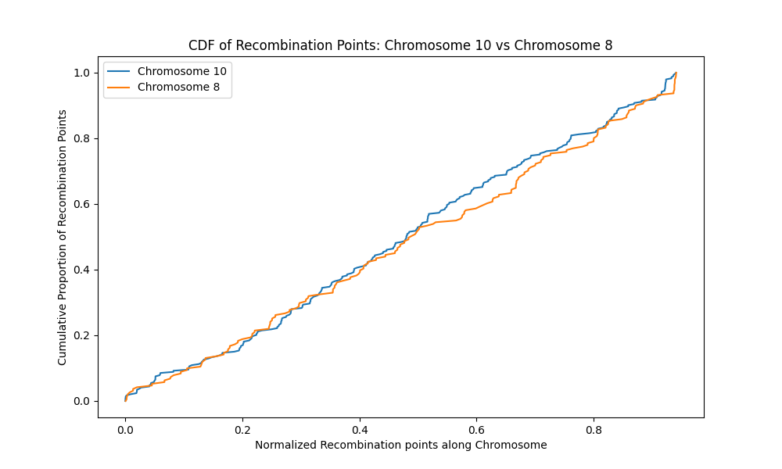

**Figure 137**. The plot shows both chromosome 10 (blue) and chromosome 8 (yellow) have evenly distributed recombination points along their lengths. There are areas with no recombination points as indicated by flat sections on the graph for each chromosome. The probability of overlap of recombination points and regions of spatial proximity is low in these areas.

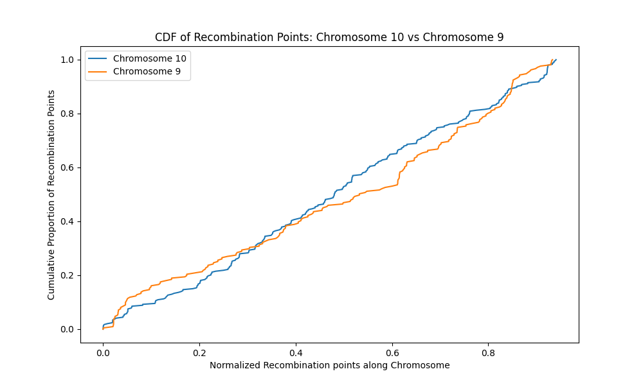

**Figure 138**. A cumulative distribution plot for chromosome 10 (blue) and chromosome 9 (yellow) shows the distribution of recombination points on the two chromosomes is different. Chromosome 9 shows areas of low concentrations more than chromosome 10.

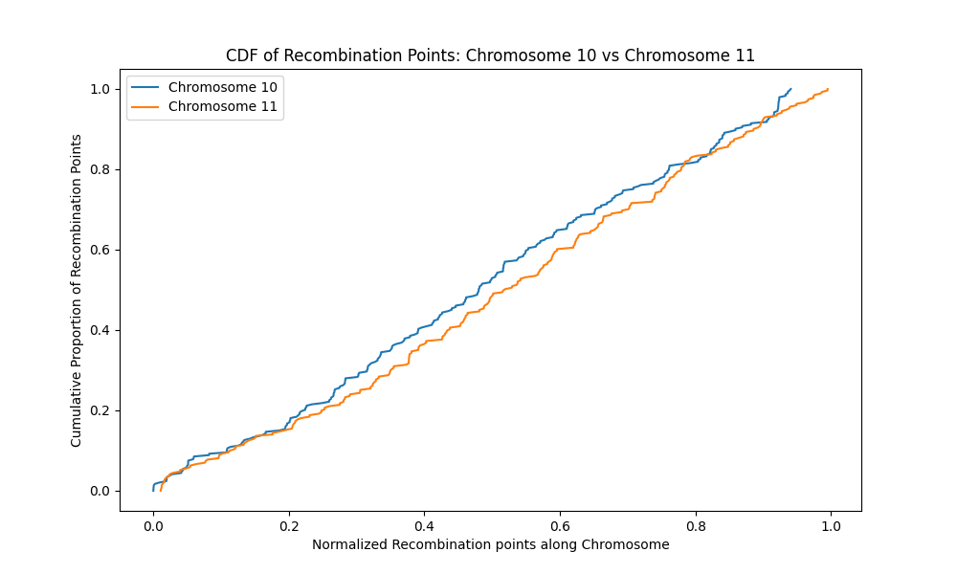

**Figure 139**. The plot shows both chromosome 10 (blue) and chromosome 11 (yellow) have evenly distributed recombination points along their lengths. There are areas with no recombination points as indicated by flat sections on the graph for each chromosome. The probability of overlap of recombination points and regions of spatial proximity is low in these areas.

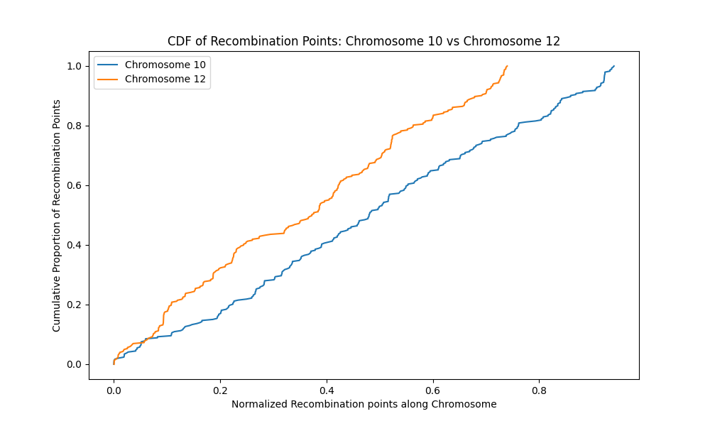

**Figure 140** . The plot shows chromosomes 10 (blue) and 12 (yellow) have similar distribution of recombination points. Both chromosomes have a gradual rise indicating an evenly distributed recombination points pattern.

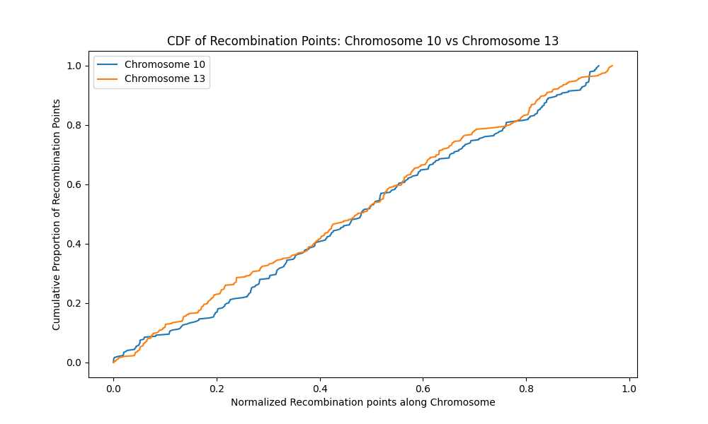

**Figure 141**. The plot shows both chromosome 10 (blue) and chromosome 13 (yellow) have evenly distributed recombination points along their lengths. There are areas with no recombination points as indicated by flat sections on the graph for each chromosome. The probability of overlap of recombination points and regions of spatial proximity is low in these areas.

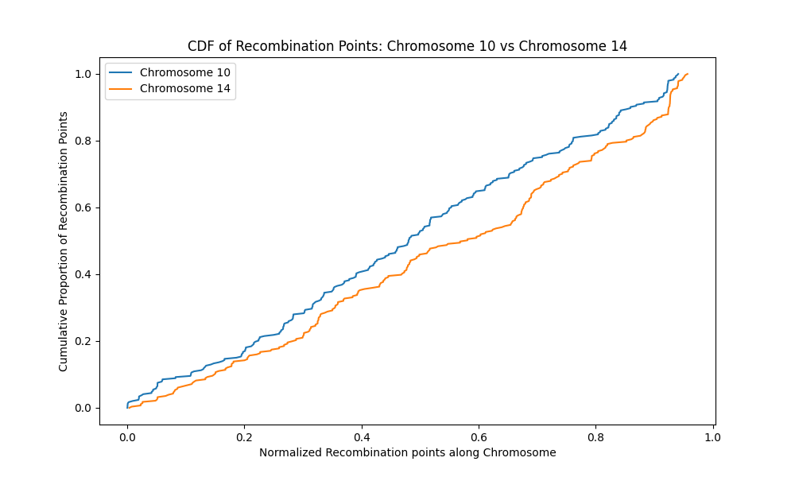

**Figure 142**. The plot shows both chromosome 10 (blue) and chromosome 14 (yellow) have evenly distributed recombination points along their lengths. There are areas with no recombination points as indicated by flat sections on the graph for each chromosome. The probability of overlap of recombination points and regions of spatial proximity is low in these areas.

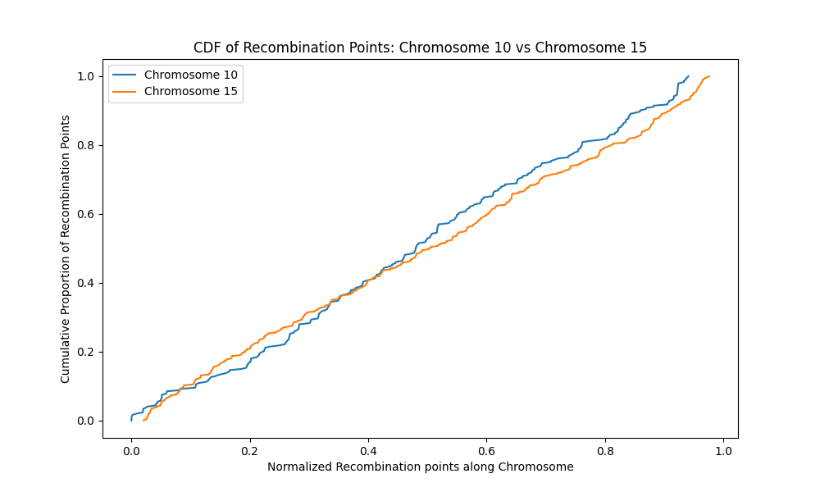

**Figure 143**. The plot shows both chromosome 10 (blue) and chromosome 15 (yellow) have evenly distributed recombination points along their lengths. There are areas with no recombination points as indicated by flat sections on the graph for each chromosome. The probability of overlap of recombination points and regions of spatial proximity is low in these areas.

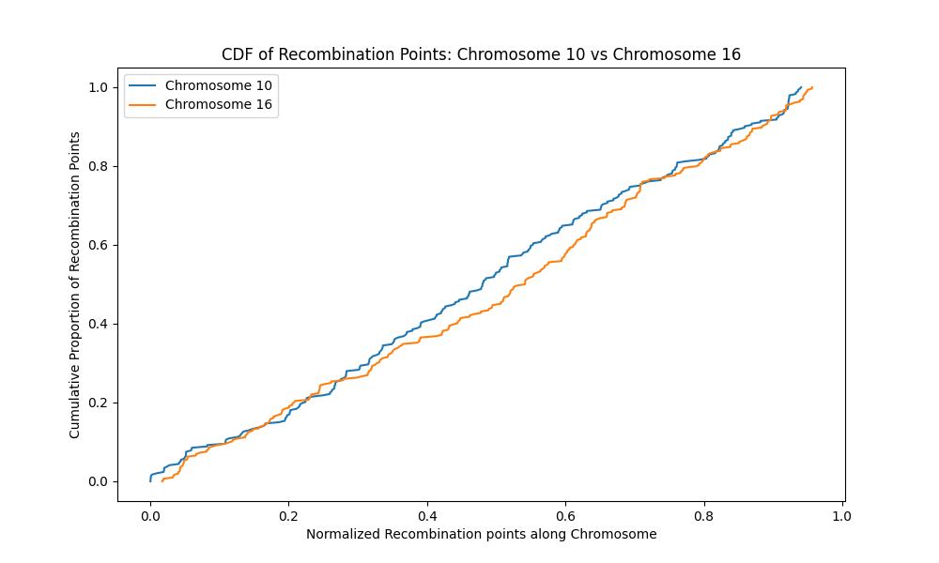

**Figure 144.** The plot shows both chromosome 10 (blue) and chromosome 16 (yellow) have evenly distributed recombination points along their lengths. There are areas with no recombination points as indicated by flat sections on the graph for each chromosome. The probability of overlap of recombination points and regions of spatial proximity is low in these areas.

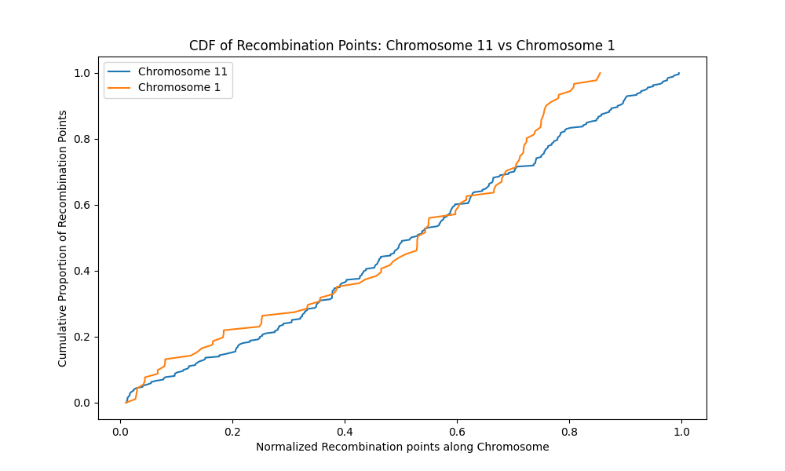

**Figure 145**. The plot shows chromosome 11 (blue) have evenly distributed recombination points along its length compared to chromosome 1. The flat sections on chromosome 1 are areas of low recombination points. The probability of overlap of recombination points and regions of spatial proximity is low in these areas.

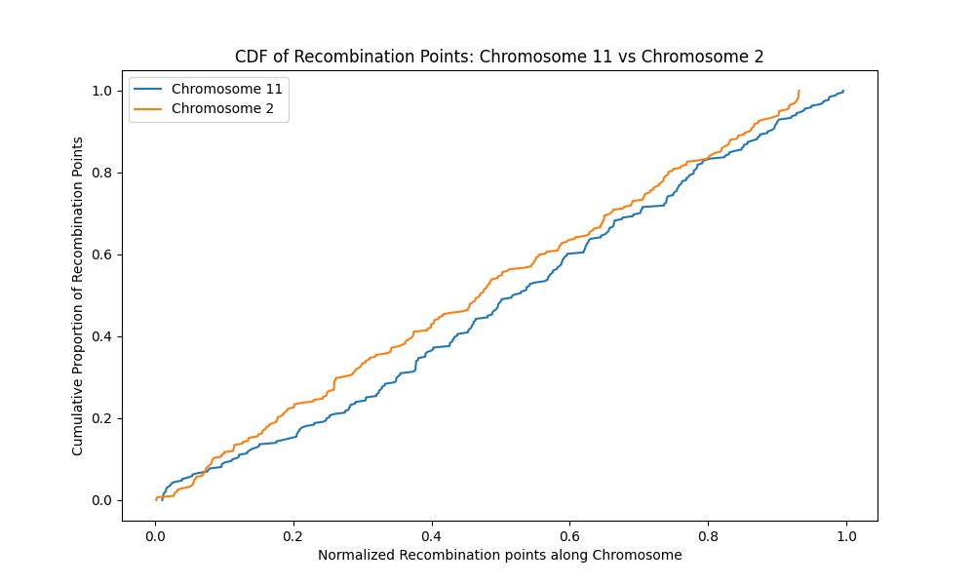

Figure 146. The plot shows chromosome 11 (blue) have evenly distributed recombination points along its length compared to chromosome 2 (yellow). The flat sections on chromosome 2 are areas of low recombination points. The probability of overlap of recombination points and regions of spatial proximity is low in these areas.

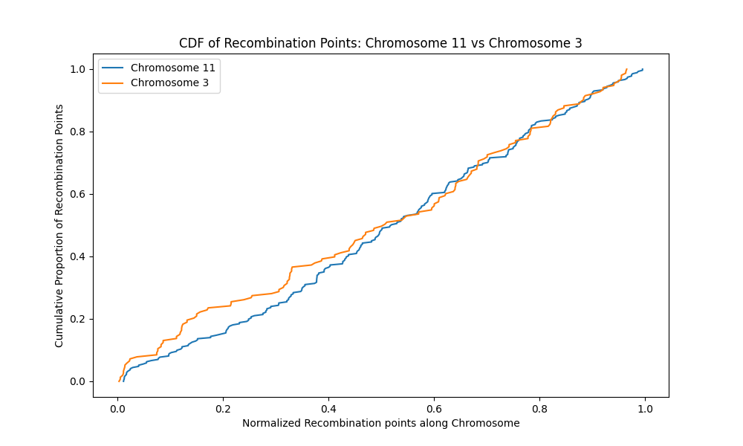

**Figure 147**. The plot shows chromosome 11 (blue) have evenly distributed recombination points along its length compared to chromosome 3. The flat sections on chromosome 3 are areas of low recombination points. The probability of overlap of recombination points and regions of spatial proximity is low in these areas.

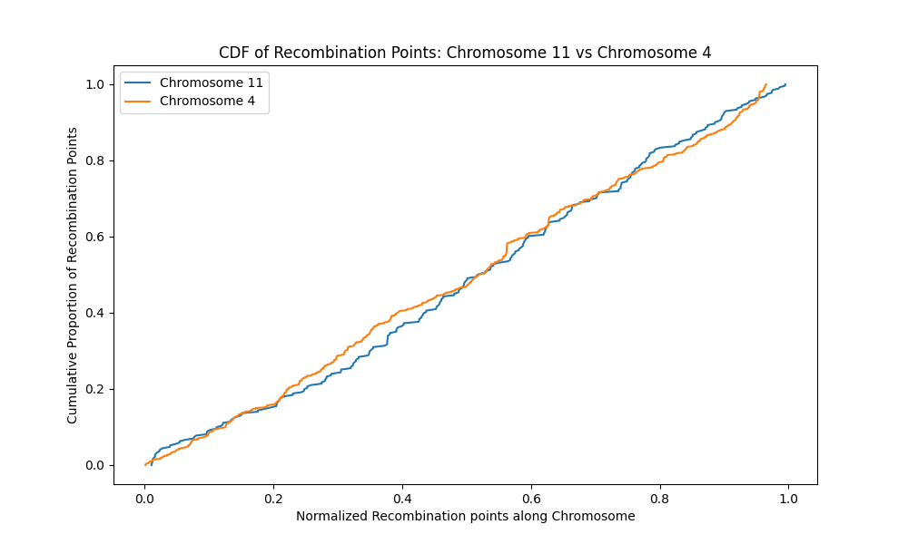

**Figure 148**. The cumulative distribution plot shows both chromosome 11 (blue) and chromosome 4 (yellow) have evenly distributed recombination points along their lengths. There are areas with no recombination points as indicated by flat sections on the graph for each chromosome. The probability of overlap of recombination points and regions of spatial proximity is low in these areas.

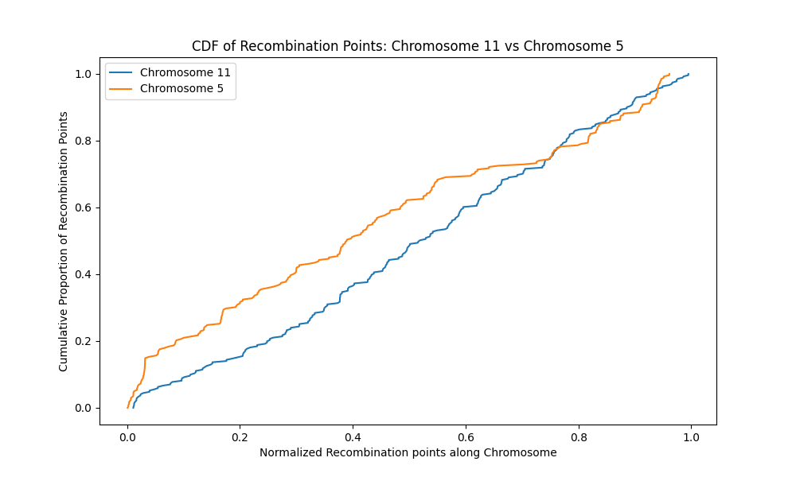

**Figure 149**. The cumulative distribution plot shows both chromosome 11 (blue) and chromosome 5 (yellow) have evenly distributed recombination points along their lengths. There are areas with no recombination points as indicated by flat sections on the graph for each chromosome. The probability of overlap of recombination points and regions of spatial proximity is low in these areas. The initial steep rise of chromosome 5 indicates concentration on recombination points on the chromosome.

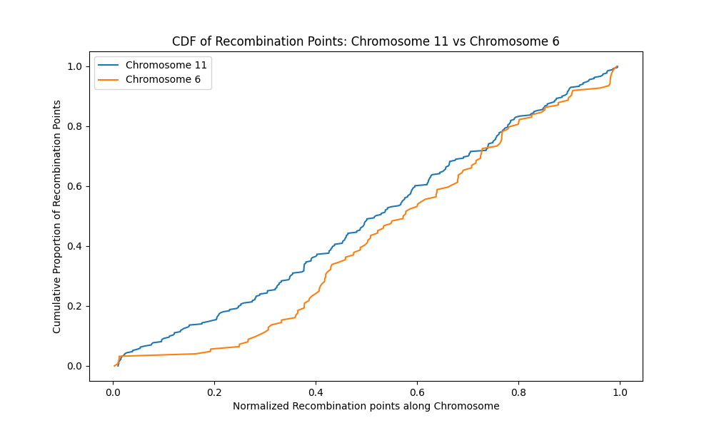

Figure 150 . The cumulative distribution plot shows chromosome 11 (blue) has evenly distributed recombination points compared to chromosome 6 (yellow). There are areas with no recombination points as indicated by flat sections on chromosome 6. The probability of overlap of recombination points and regions of spatial proximity is low in these areas.

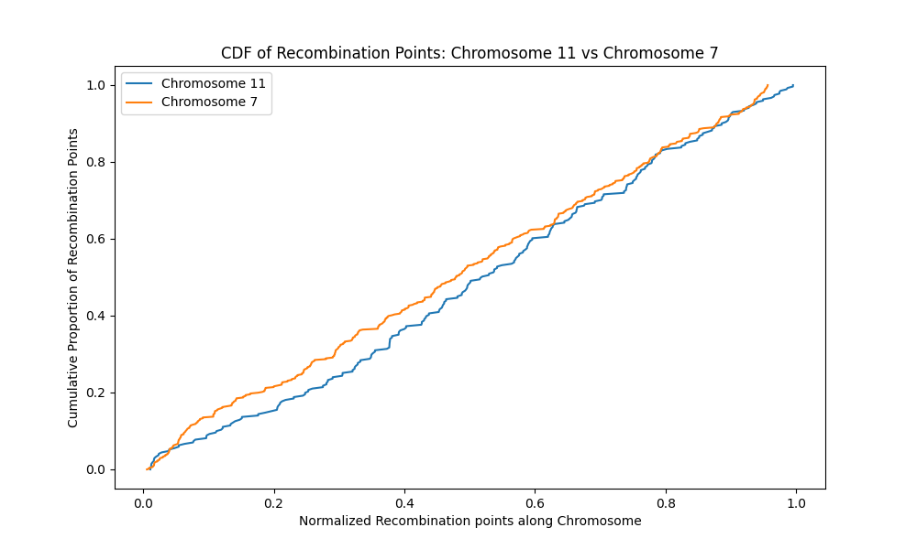

**Figure 151**. The cumulative distribution plot shows both chromosome 11 (blue) and chromosome 7 (yellow) have evenly distributed recombination points along their lengths. There are areas with no recombination points as indicated by flat sections on the graph for each chromosome. The probability of overlap of recombination points and regions of spatial proximity is low in these areas.

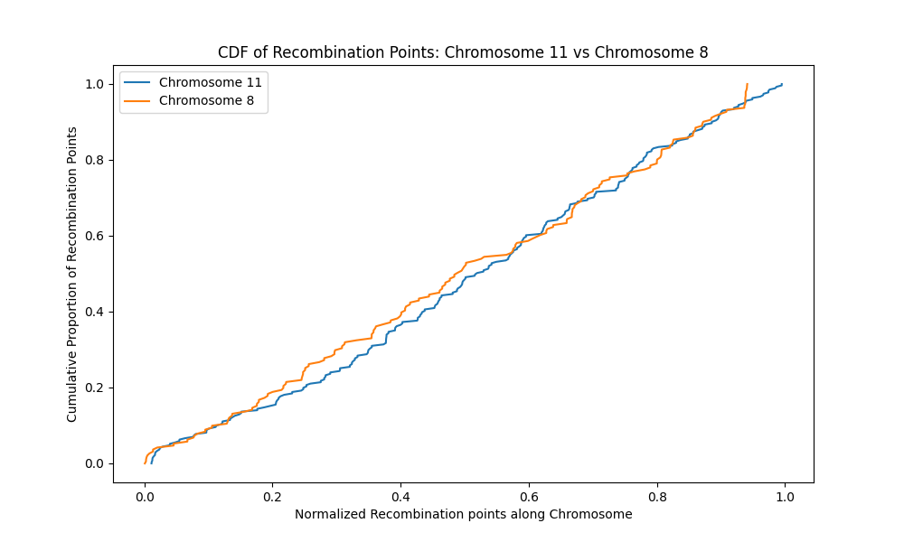

**Figure 152**. The cumulative distribution plot shows both chromosome 11 (blue) and chromosome 8 (yellow) have evenly distributed recombination points along their lengths. There are areas with no recombination points as indicated by flat sections on the graph for each chromosome. The probability of overlap of recombination points and regions of spatial proximity is low in these areas.

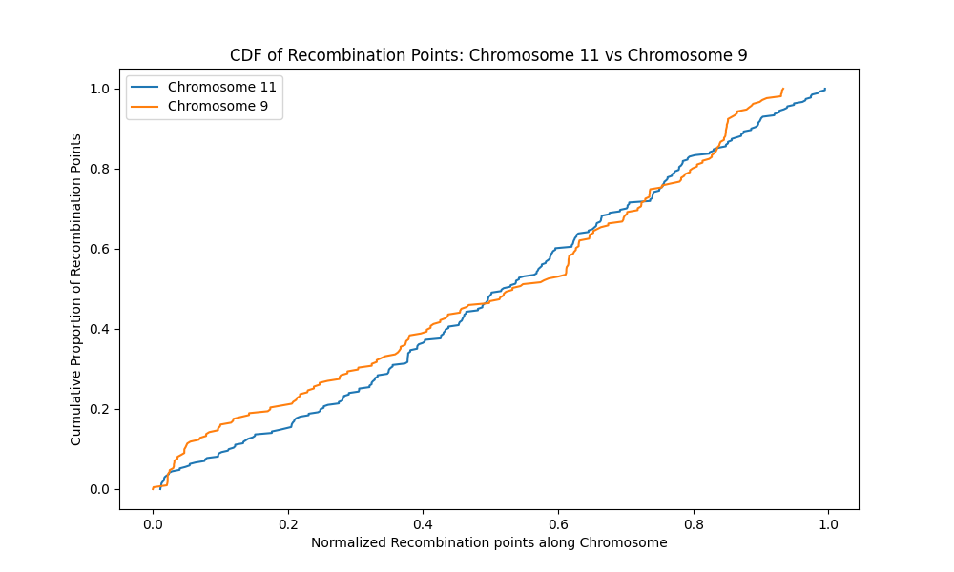

**Figure 153**. The cumulative distribution plot shows both chromosome 11 (blue) and chromosome 9 (yellow) have evenly distributed recombination points along their lengths. There are areas with no recombination points as indicated by flat sections on the graph for each chromosome. The probability of overlap of recombination points and regions of spatial proximity is low in these areas.

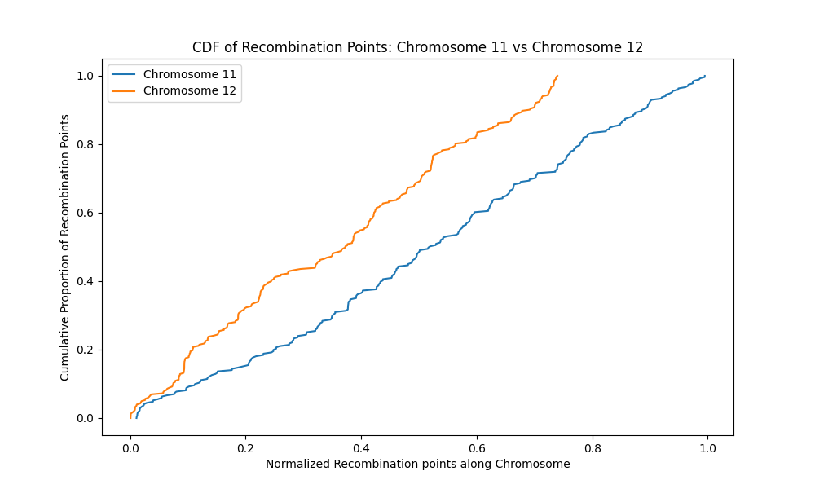

**Figure 154**. The cumulative distribution plot shows both chromosome 11 (blue) and chromosome 12 (yellow) have evenly distributed recombination points along their lengths. There are areas with no recombination points as indicated by flat sections on the graph for each chromosome. The probability of overlap of recombination points and regions of spatial proximity is low in these areas. The steep rise of chromosome 12 indicates concentration on recombination points on chromosome 12 compared with chromosome 11.

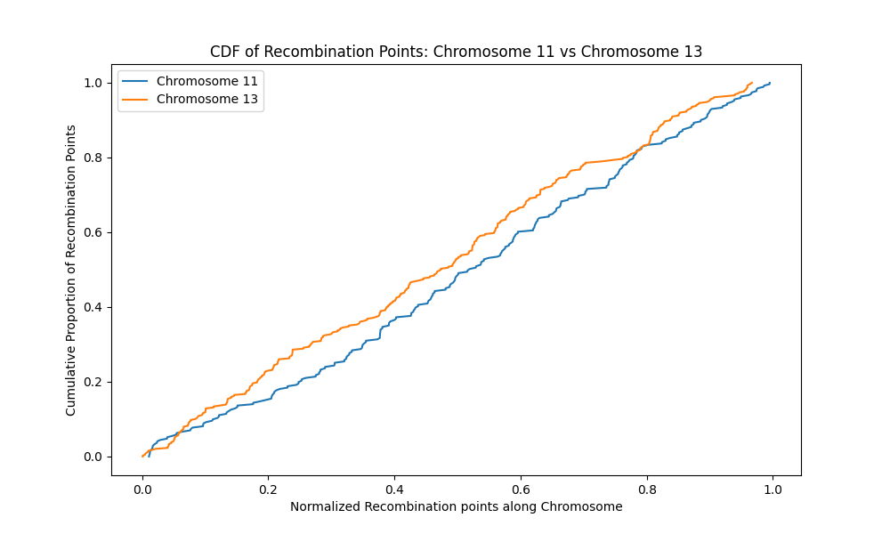

**Figure 155**. The cumulative distribution plot shows both chromosomes 11 and 13 have areas of no recombination points (flat sections on graph). The medium steep rise of both chromosomes indicates that recombination points are evenly distributed across the length of the chromosomes.

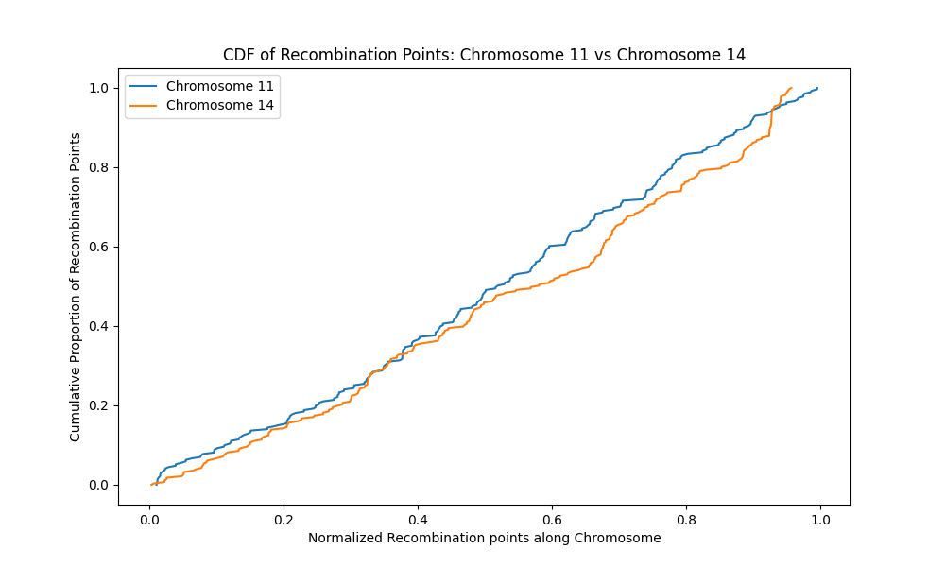

**Figure 156**. The cumulative distribution plot shows both chromosomes 11 and 14 have areas of no recombination points (flat sections on graph). The medium steep rise of both chromosomes indicates that recombination points are evenly distributed across the length of the chromosomes.

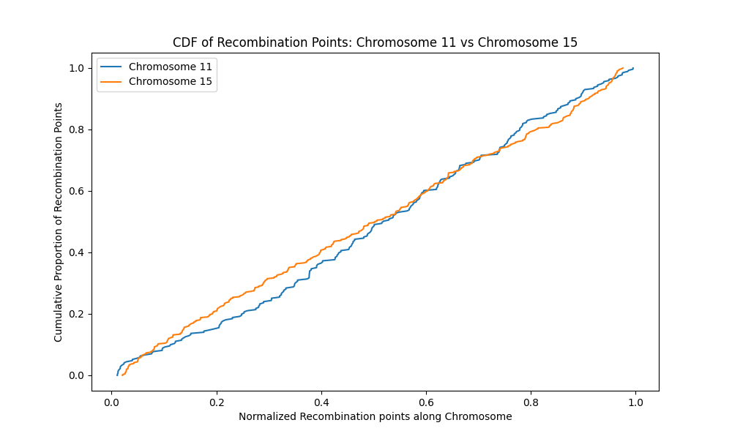

**Figure 157**. The plot shows both chromosome 11 (blue) and chromosome 15 (yellow) have evenly distributed recombination points along their lengths. There are areas with no recombination points as indicated by flat sections on the graph for each chromosome. The probability of overlap of recombination points and regions of spatial proximity is low in these areas.

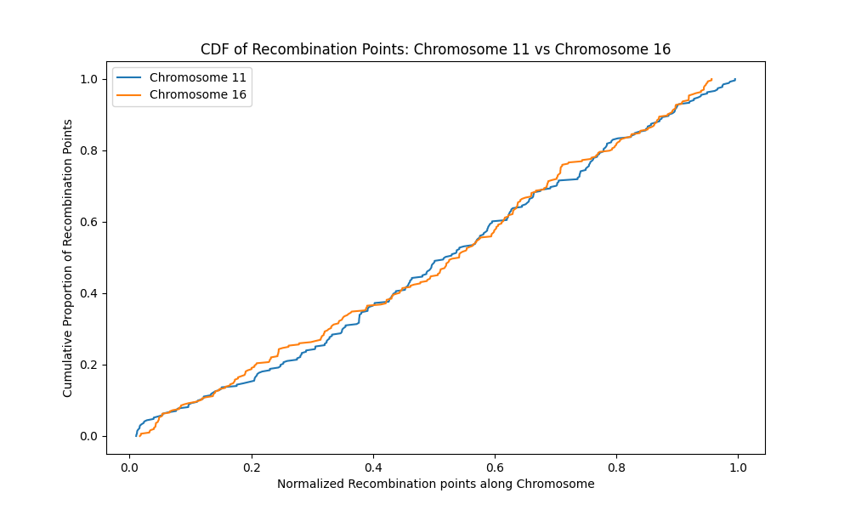

**Figure 158.** The plot shows both chromosome 11 (blue) and chromosome 16 (yellow) have evenly distributed recombination points along their lengths. There are areas with no recombination points as indicated by flat sections on the graph for each chromosome. The probability of overlap of recombination points and regions of spatial proximity is low in these areas.

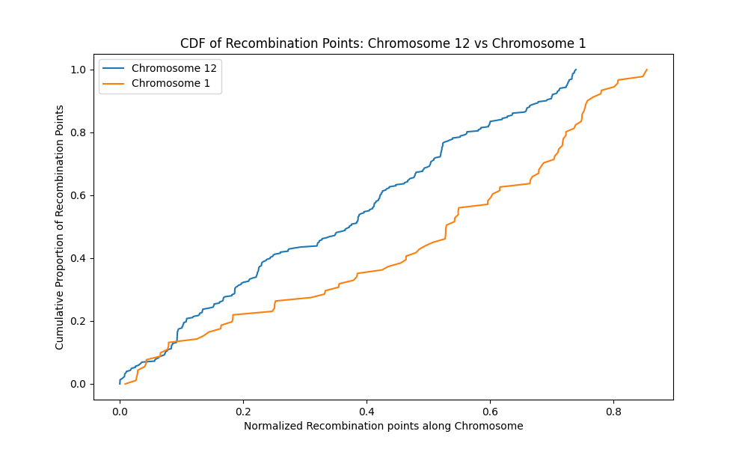

Figure 159. The cumulative distribution plot shows both chromosome 12 (blue) and chromosome 1 (yellow) have evenly distributed recombination points along their lengths. There are areas with no recombination points as indicated by flat sections on the graph for each chromosome. The probability of overlap of recombination points and regions of spatial proximity is low in these areas.

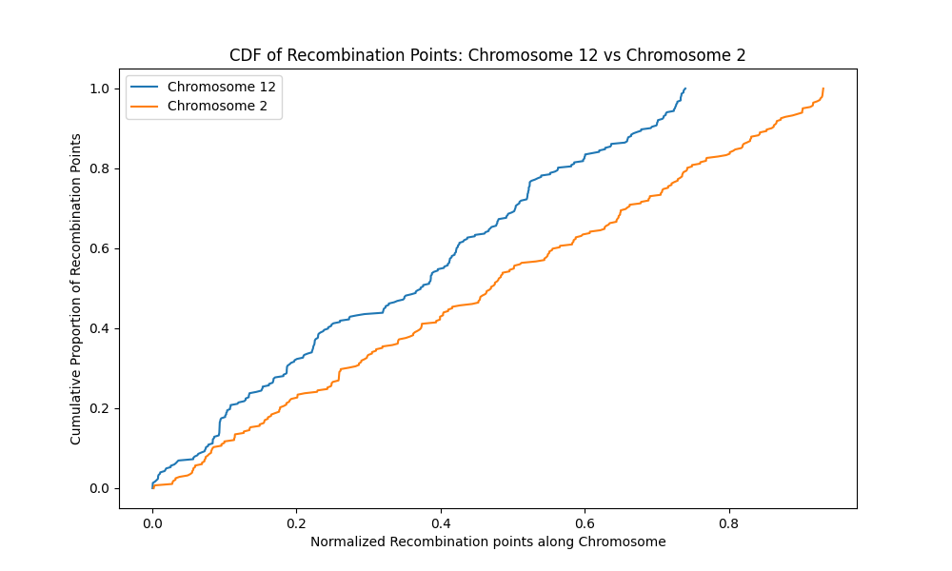

**Figure 160**. The cumulative distribution plot shows both chromosome 12 (blue) and chromosome 2 (yellow) have evenly distributed recombination points along their lengths. There are areas with no recombination points as indicated by flat sections on the graph for each chromosome. The probability of overlap of recombination points and regions of spatial proximity is low in these areas. The initial steep rise of both chromosomes indicates concentration on recombination points on both chromosomes.

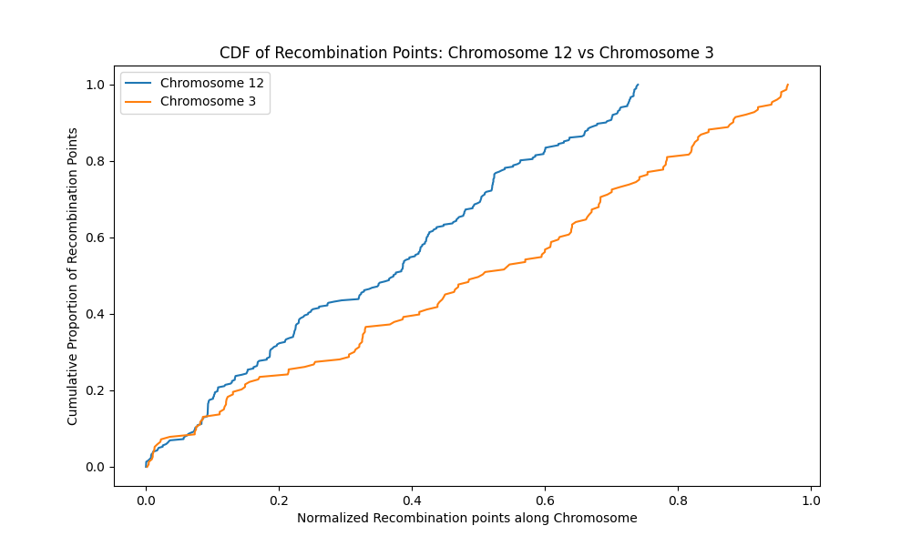

**Figure 161**. The cumulative distribution plot shows both chromosome 12 (blue) and chromosome 3 (yellow) have evenly distributed recombination points along their lengths. There are areas with no recombination points as indicated by flat sections on the graph for each chromosome. The probability of overlap of recombination points and regions of spatial proximity is low in these areas.

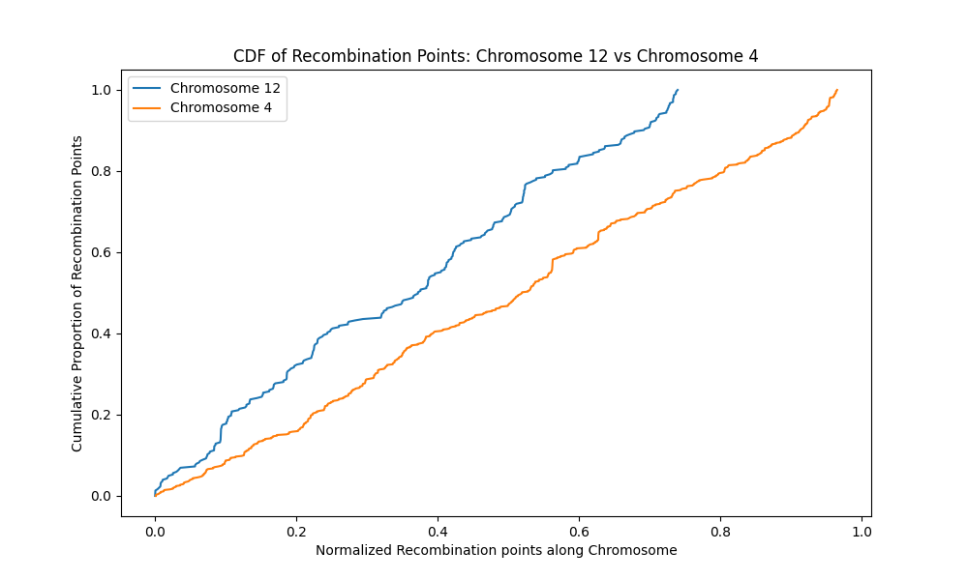

**Figure 162**. The cumulative distribution plot shows both chromosome 12 (blue) and chromosome 4 (yellow) have evenly distributed recombination points along their lengths. There are few areas with no recombination points as indicated by flat sections on the graph for each chromosome. The probability of overlap of recombination points and regions of spatial proximity is low in these areas.

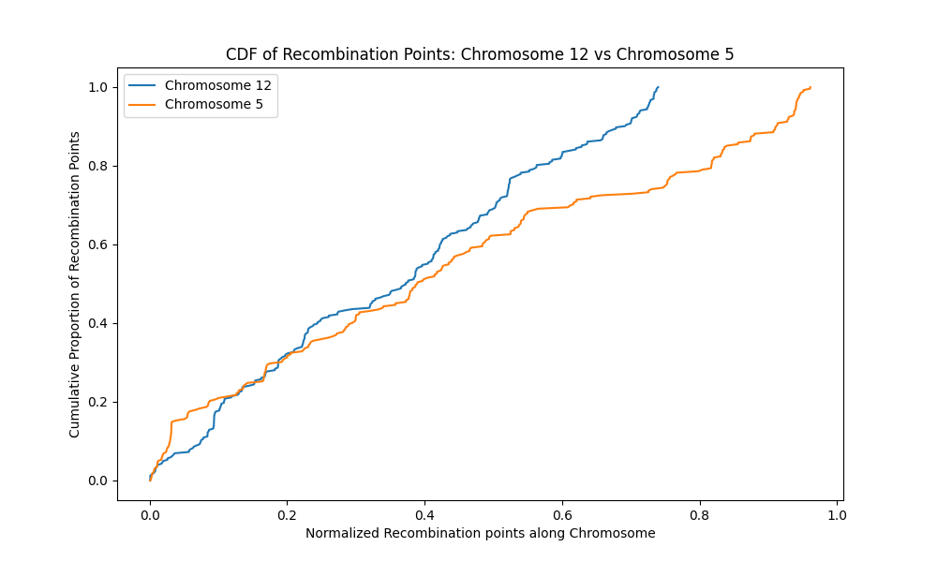

**Figure 163.** The cumulative distribution plot shows both chromosome 12 (blue) and chromosome 5 (yellow) have evenly distributed recombination points along their lengths. There are areas with no recombination points as indicated by flat sections on the graph for each chromosome. The probability of overlap of recombination points and regions of spatial proximity is low in these areas. The initial steep rise of chromosome 5 indicates concentration on recombination points at the part of the chromosome compared to the rest of it.

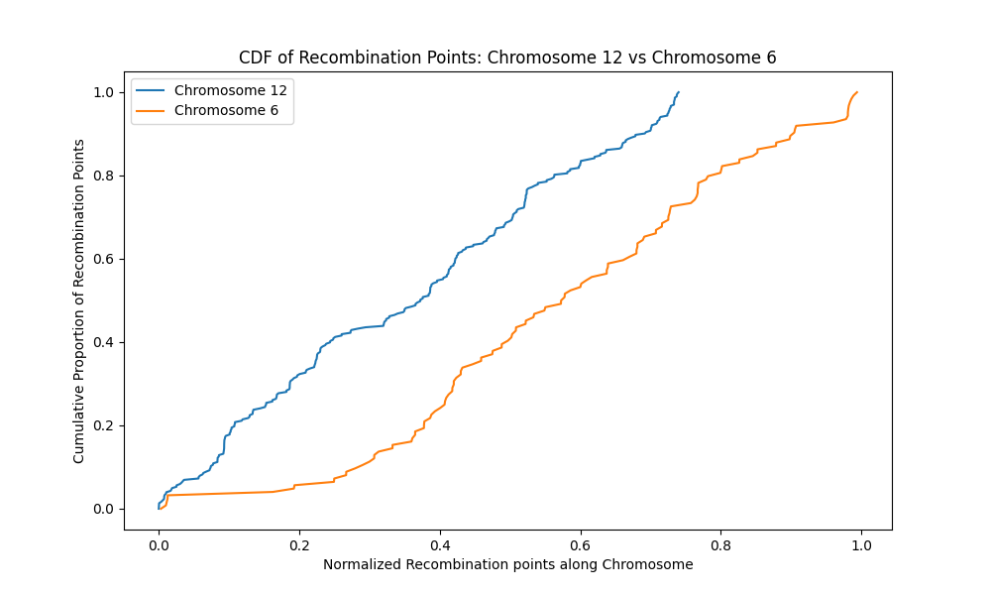

**Figure 164**. The cumulative distribution plot shows both chromosome 12 (blue) and chromosome 6 (yellow) have evenly distributed recombination points along their lengths. There are areas with no recombination points as indicated by flat sections on the graph for each chromosome. The probability of overlap of recombination points and regions of spatial proximity is low in these areas.

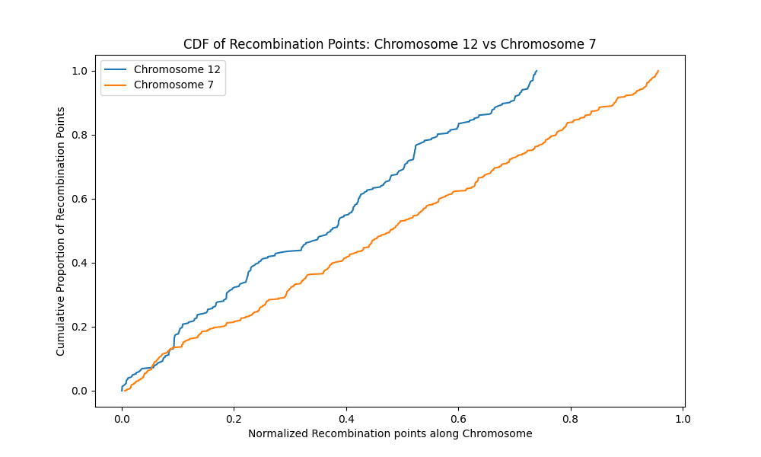

**Figure 165**. The cumulative distribution plot shows both chromosome 12 (blue) and chromosome 7 (yellow) have evenly distributed recombination points along their lengths. There are areas with no recombination points as indicated by flat sections on the graph for each chromosome. The probability of overlap of recombination points and regions of spatial proximity is low in these areas. The initial steep rise of both chromosomes indicates concentration on recombination points on both chromosomes

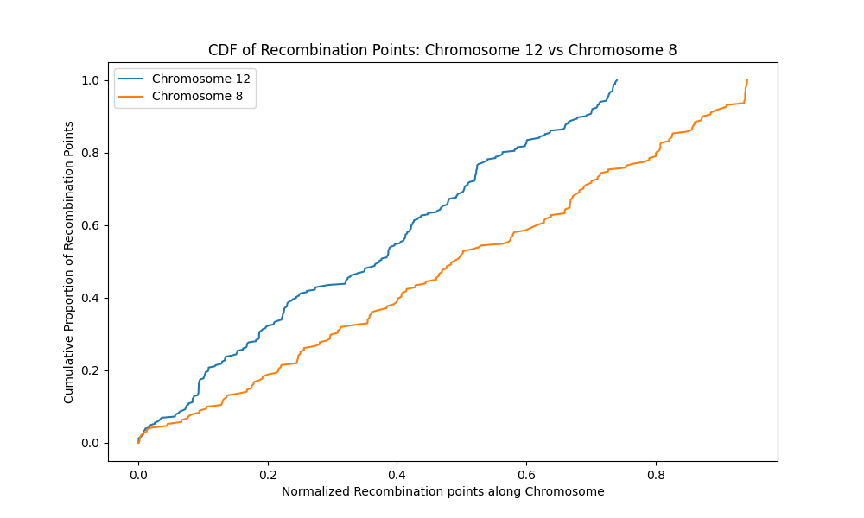

**Figure 166**. The cumulative distribution plot shows both chromosome 12 (blue) and chromosome 8 (yellow) have evenly distributed recombination points along their lengths. There are areas with no recombination points as indicated by flat sections on the graph for each chromosome. The probability of overlap of recombination points and regions of spatial proximity is low in these areas.

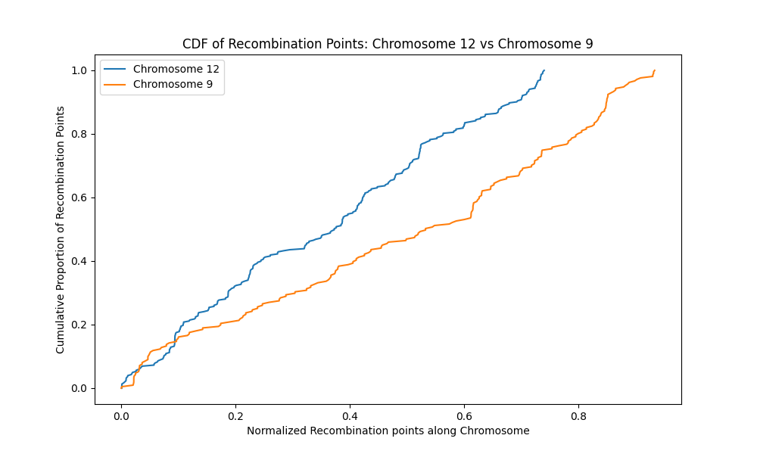

**Figure 167**. The cumulative distribution plot shows both chromosome 12 (blue) and chromosome 9 (yellow) have evenly distributed recombination points along their lengths. There are areas with no recombination points as indicated by flat sections on the graph for each chromosome. The probability of overlap of recombination points and regions of spatial proximity is low in these areas.

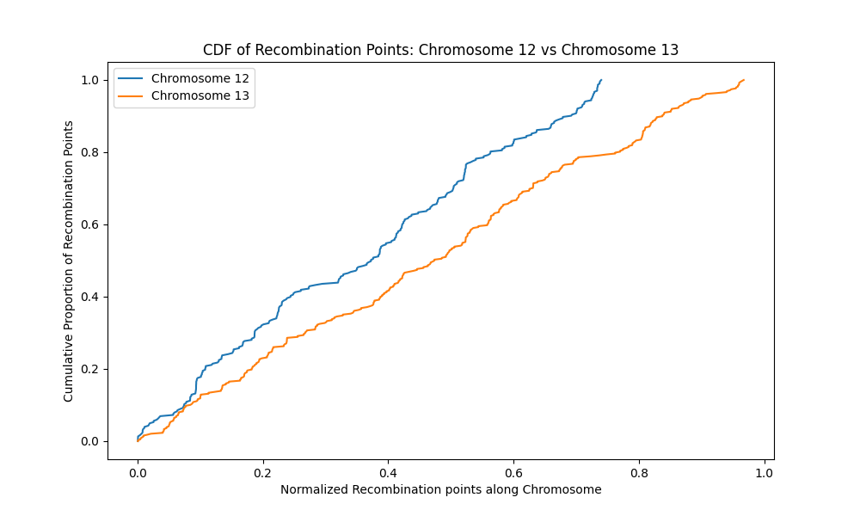

**Figure 168 .** The cumulative distribution plot shows both chromosome 12 (blue) and chromosome 13 (yellow) have evenly distributed recombination points along their lengths. There are areas with no recombination points as indicated by flat sections on the graph for each chromosome. The probability of overlap of recombination points and regions of spatial proximity is low in these areas.

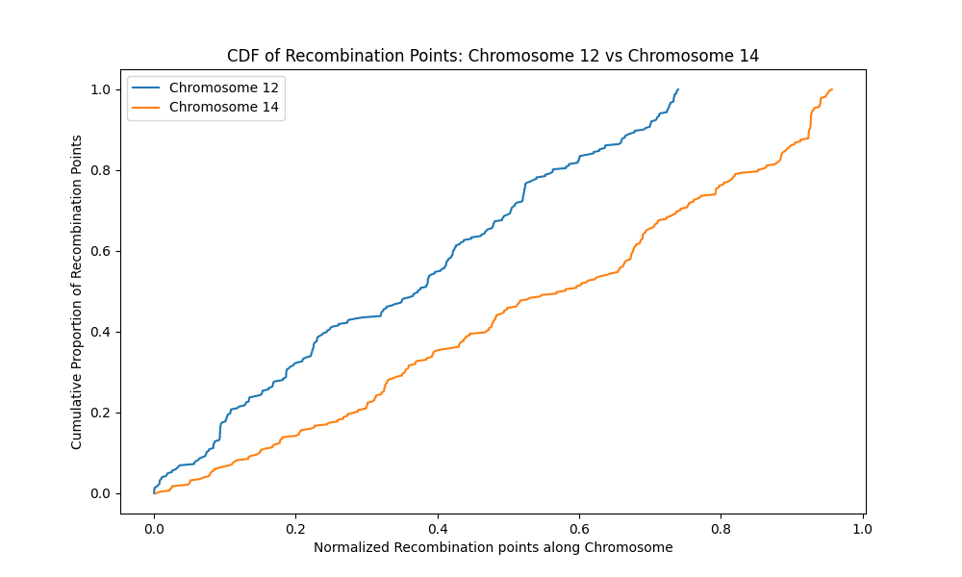

**Figure 169.** The cumulative distribution plot shows both chromosome 12 (blue) and chromosome 14 (yellow) have evenly distributed recombination points along their lengths. There are areas with no recombination points as indicated by flat sections on the graph for each chromosome. The probability of overlap of recombination points and regions of spatial proximity is low in these areas.

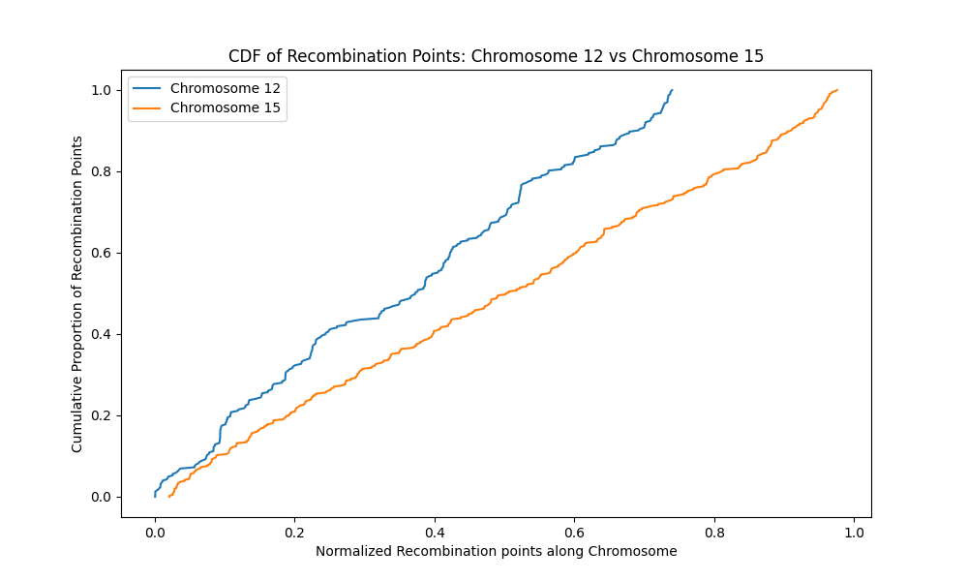

**Figure 170**. The cumulative distribution plot shows both chromosome 12 (blue) and chromosome 15 (yellow) have evenly distributed recombination points along their lengths. There are areas with no recombination points as indicated by flat sections on the graph for each chromosome. The probability of overlap of recombination points and regions of spatial proximity is low in these areas.

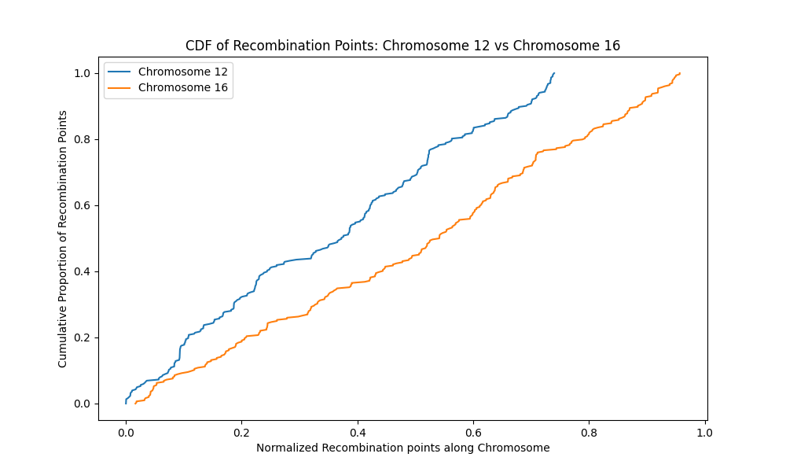

**Figure 171**. The cumulative distribution plot shows both chromosome 12 (blue) and chromosome 16 (yellow) have evenly distributed recombination points along their lengths. There are areas with no recombination points as indicated by flat sections on the graph for each chromosome. The probability of overlap of recombination points and regions of spatial proximity is low in these areas.

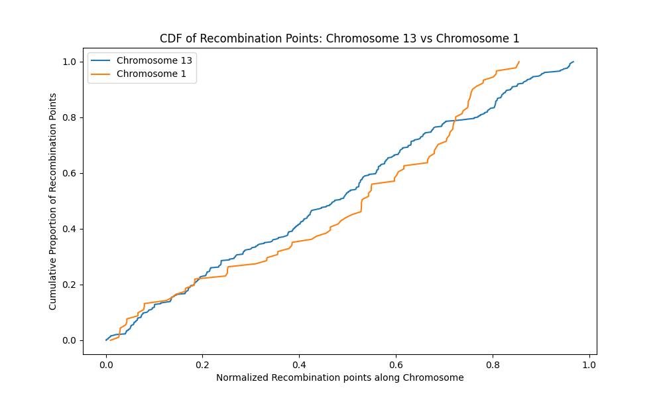

**Figure 172.** The cumulative distribution plot shows both chromosome 13 (blue) and chromosome 1 (yellow) have evenly distributed recombination points along their lengths. There are areas with no recombination points as indicated by flat sections on the graph for each chromosome. Chromosome 1 has more areas without recombination points than chromosome 13. The probability of overlap of recombination points and regions of spatial proximity is low in these areas.

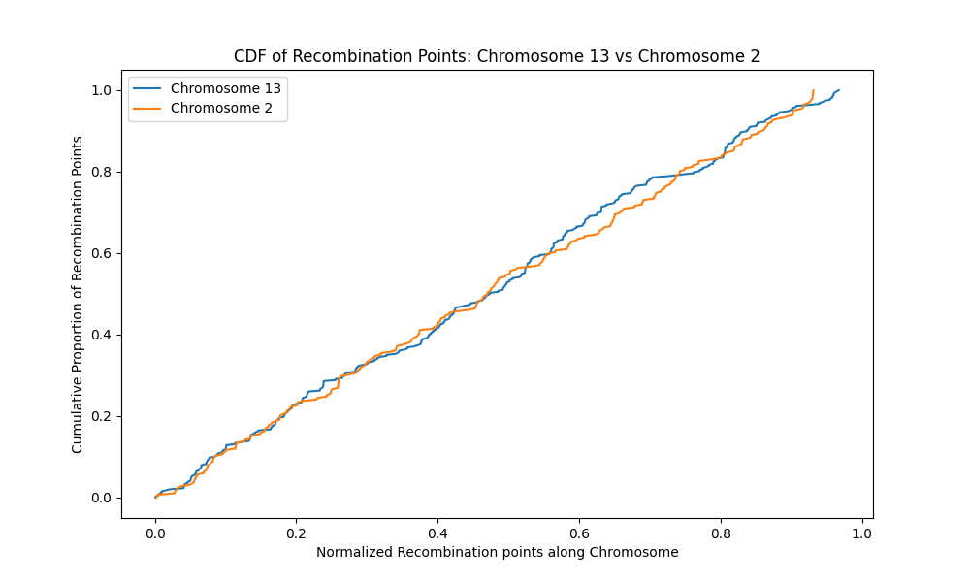

**Figure 173**. The cumulative distribution plot shows both chromosome 13 (blue) and chromosome 2 (yellow) have similar distribution of recombination points along their lengths. There are areas with no recombination points as indicated by flat sections on the graph for each chromosome. The probability of overlap of recombination points and regions of spatial proximity is low in these areas.

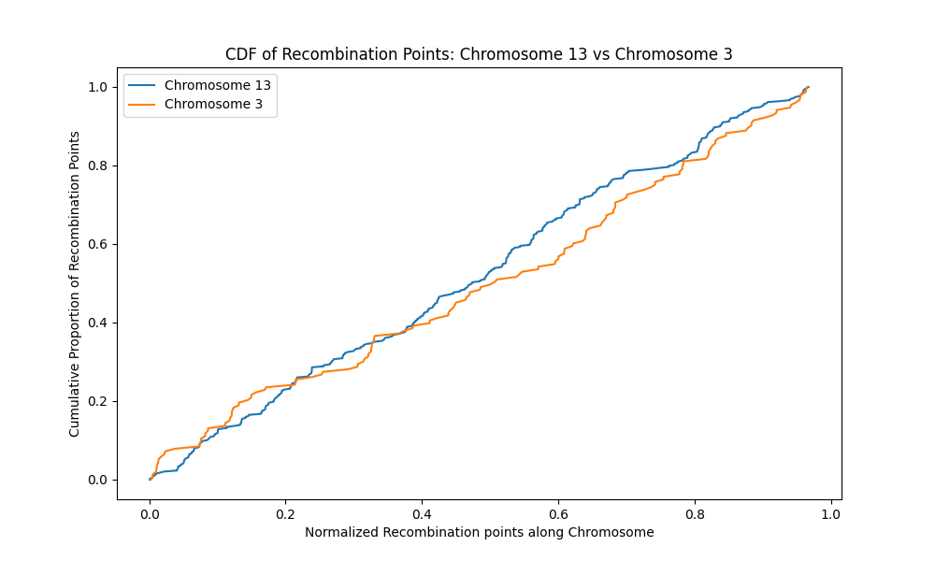

**Figure 174**. The cumulative distribution plot shows both chromosome 13 (blue) and chromosome 3 (yellow) have similar distribution of recombination points along their lengths. There are areas with no recombination points as indicated by flat sections on the graph for each chromosome. The probability of overlap of recombination points and regions of spatial proximity is low in these areas.

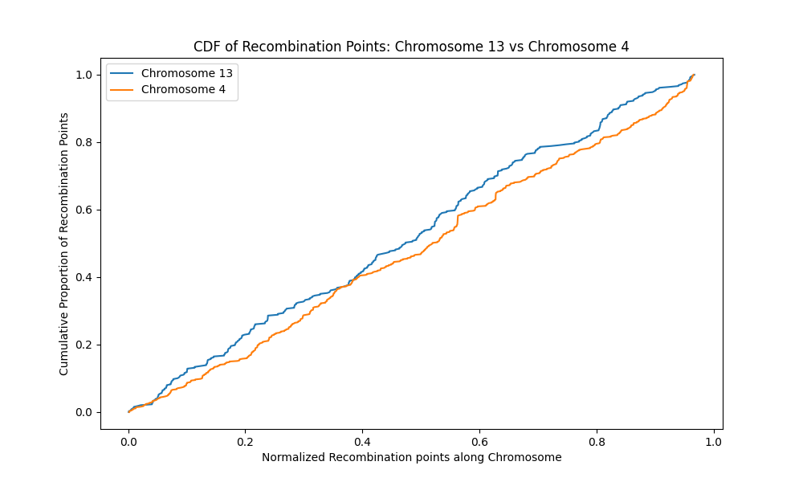

**Figure 175**. The cumulative distribution plot shows both chromosome 13 (blue) and chromosome 4 (yellow) have similarly distributed recombination points along their lengths. There are areas with no recombination points as indicated by flat sections on the graph for each chromosome. The probability of overlap of recombination points and regions of spatial proximity is low in these areas.

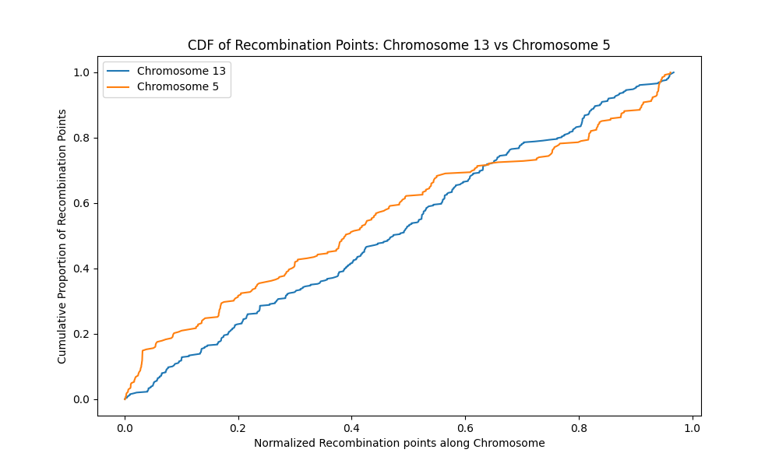

**Figure 176**. The cumulative distribution plot shows both chromosome 13 (blue) and chromosome 5 (yellow) have similarly distributed recombination points along their lengths. There are areas with no recombination points as indicated by flat sections on the graph for each chromosome. The probability of overlap of recombination points and regions of spatial proximity is low in these areas.

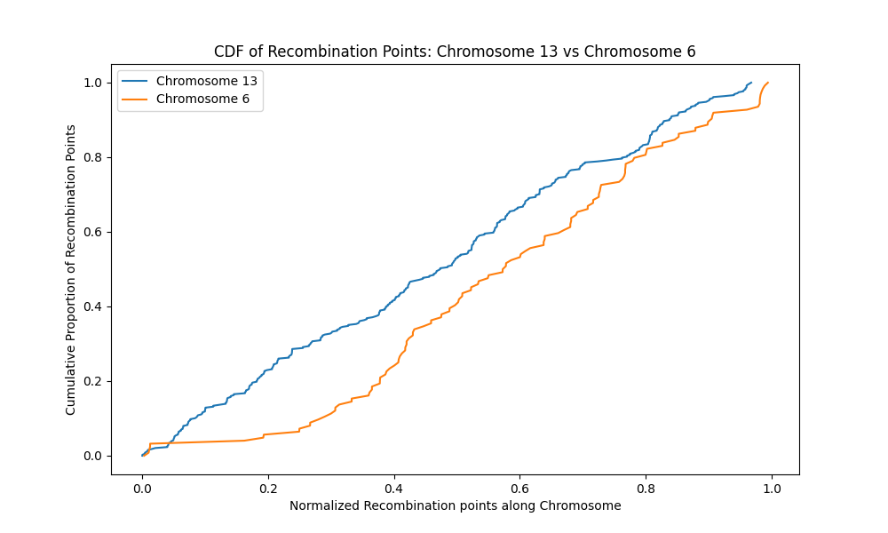

**Figure 177**. The cumulative distribution plot shows both chromosome 13 (blue) and chromosome 6 (yellow) have evenly distributed recombination points along their lengths. There are areas with no recombination points as indicated by flat sections on the graph for each chromosome. The probability of overlap of recombination points and regions of spatial proximity is low in these areas. The beginning of chromosome 6 has no recombination points as shown by a flat surface.

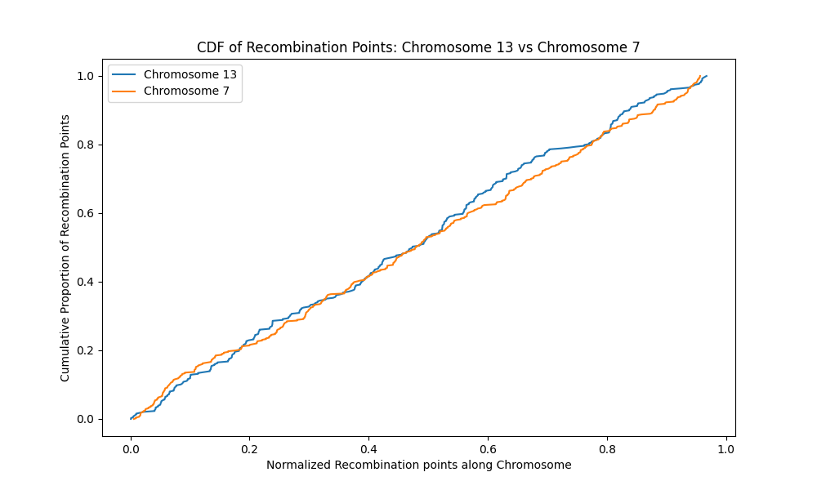

**Figure 178**. The cumulative distribution plot shows both chromosome 13 (blue) and chromosome 7 (yellow) have evenly distributed recombination points along their lengths. There are areas with no recombination points as indicated by flat sections on the graph for each chromosome. The probability of overlap of recombination points and regions of spatial proximity is low in these areas.

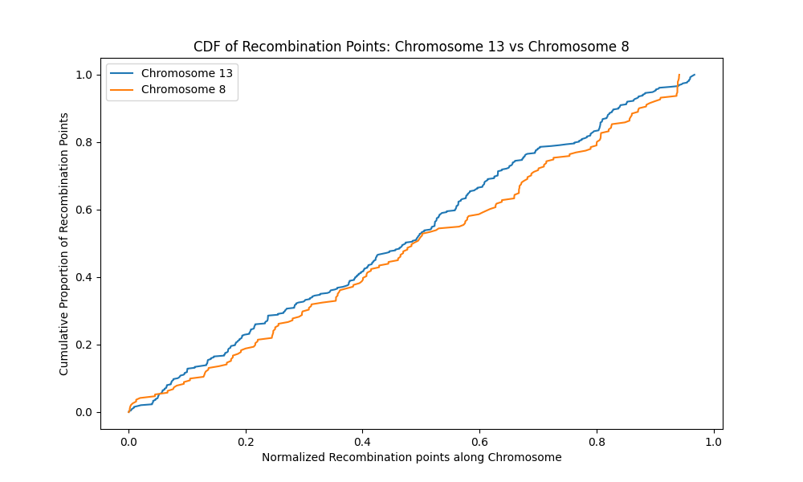

**Figure 179**. The cumulative distribution plot shows both chromosome 13 (blue) and chromosome 8 (yellow) have evenly distributed recombination points along their lengths. There are areas with no recombination points as indicated by flat sections on the graph for each chromosome. The probability of overlap of recombination points and regions of spatial proximity is low in these areas.

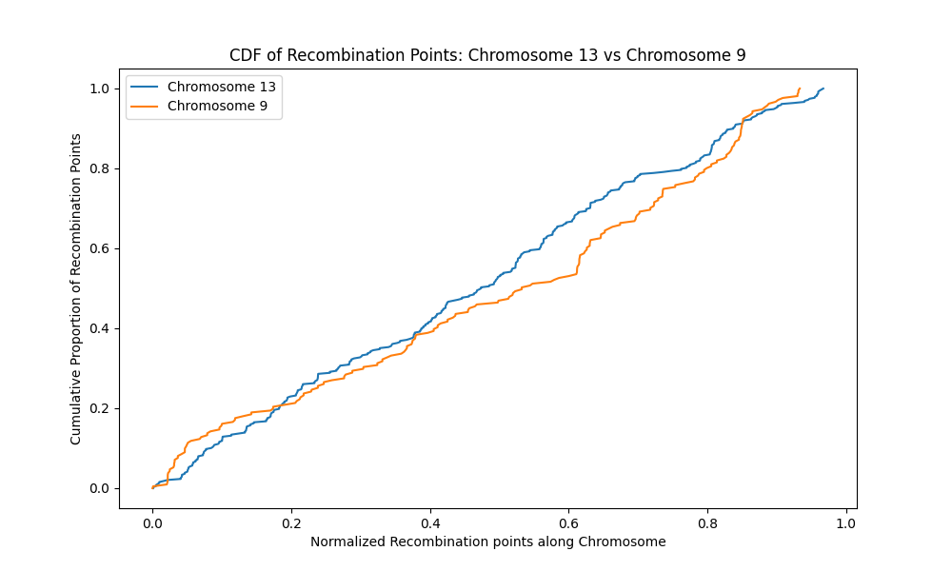

**Figure 180**. The cumulative distribution plot shows both chromosome 13 (blue) and chromosome 9 (yellow) have similarly distributed recombination points along their lengths. There are also areas with no recombination points as indicated by flat sections on the graph for each chromosome. The probability of overlap of recombination points and regions of spatial proximity is low in these areas.

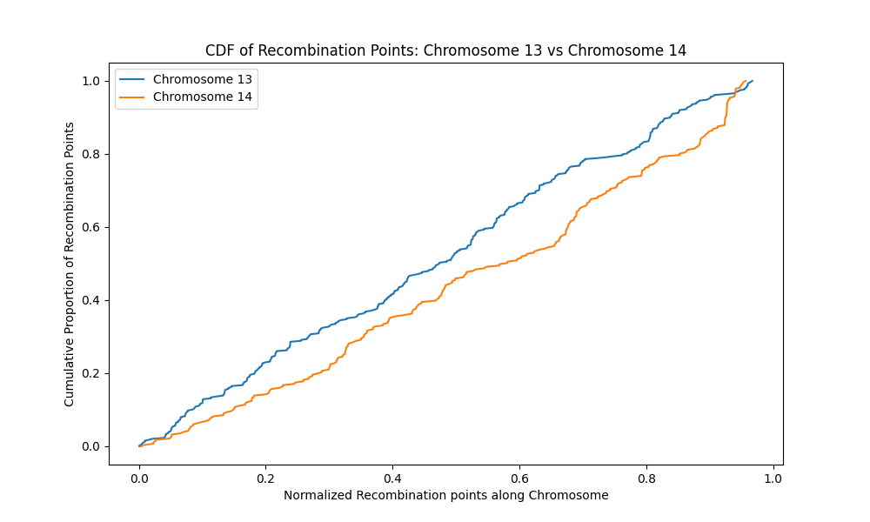

**Figure 181**. The cumulative distribution plot shows both chromosome 13 (blue) and chromosome 14 (yellow) have similarly distributed recombination points along their lengths. There are also areas with no recombination points as indicated by flat sections on the graph for each chromosome. The probability of overlap of recombination points and regions of spatial proximity is low in these areas.

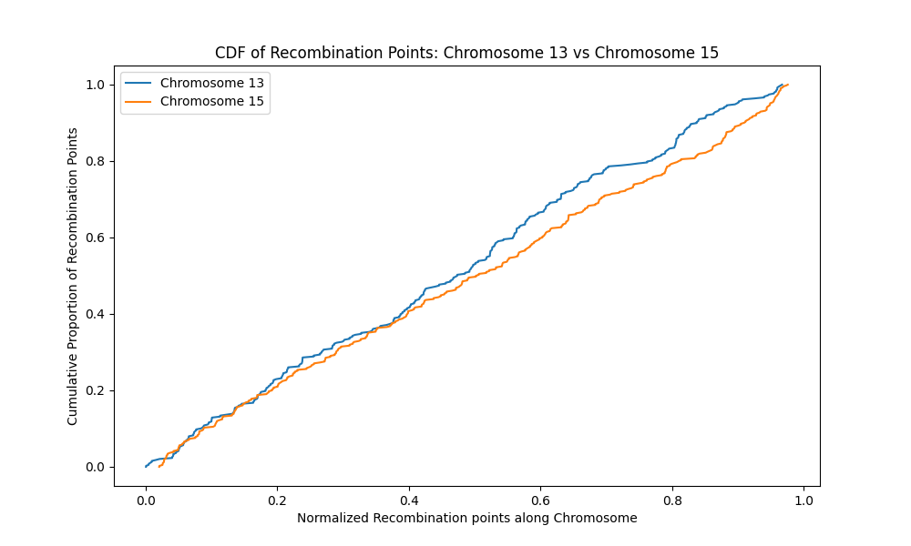

**Figure 182**. The cumulative distribution plot shows both chromosome 13 (blue) and chromosome 15 (yellow) have similarly distributed recombination points along their lengths. There are also areas with no recombination points as indicated by flat sections on the graph for each chromosome. The probability of overlap of recombination points and regions of spatial proximity is low in these areas.

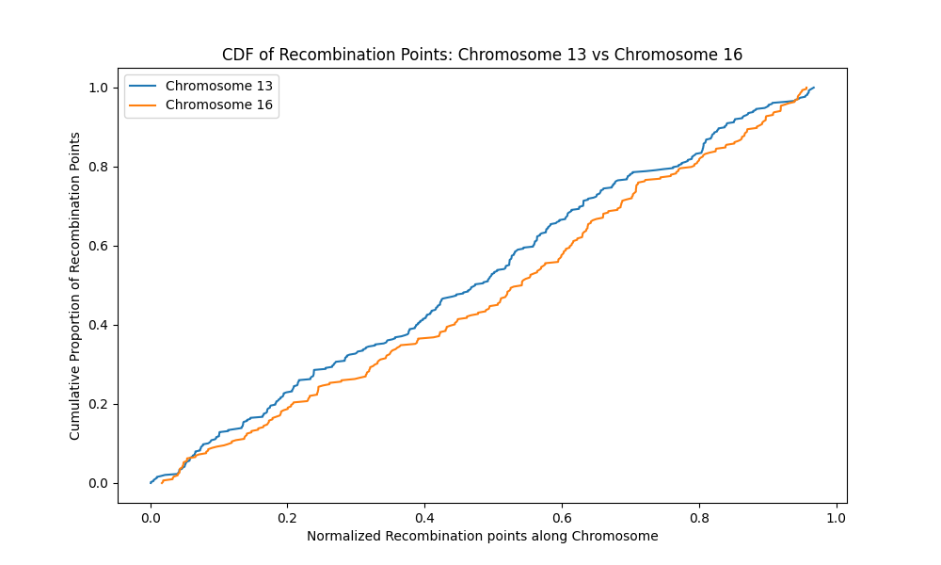

**Figure 183.** The cumulative distribution plot shows both chromosome 13 (blue) and chromosome 16 (yellow) have similarly distributed recombination points along their lengths. There are also areas with no recombination points as indicated by flat sections on the graph for each chromosome. The probability of overlap of recombination points and regions of spatial proximity is low in these areas.

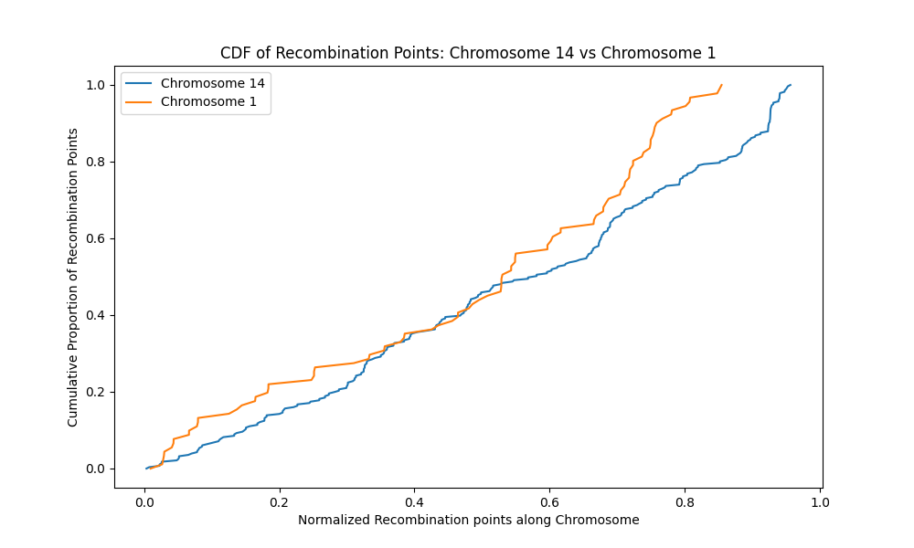

**Figure 184**. The cumulative distribution plot shows both chromosome 14 (blue) and chromosome 1 (yellow) have differently distributed recombination points along their lengths. Chromosome 1 has many areas with no recombination points as indicated by flat sections on the graph. The probability of overlap of recombination points and regions of spatial proximity is low in these areas.

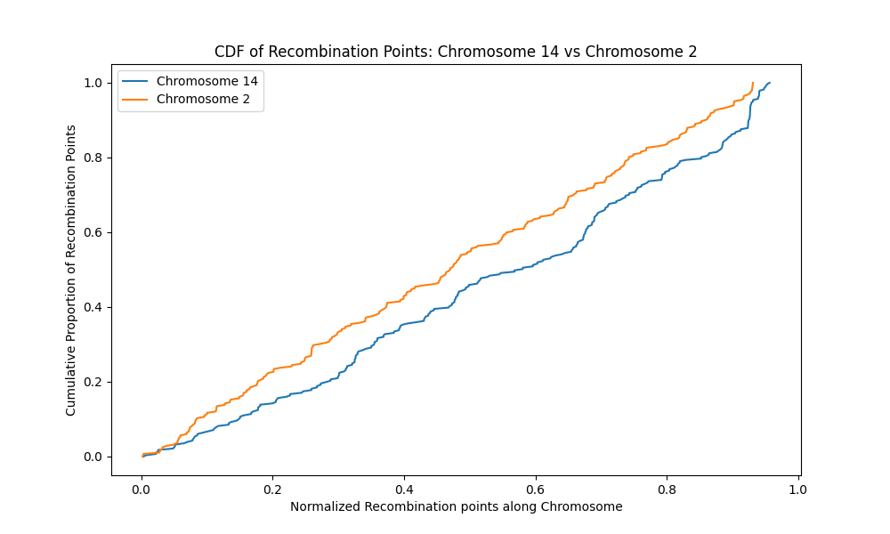

**Figure 185**. The cumulative distribution plot shows both chromosome 14 (blue) and chromosome 2 (yellow) have similarly distributed recombination points along their lengths. There are also areas with no recombination points as indicated by flat sections on the graph for each chromosome. The probability of overlap of recombination points and regions of spatial proximity is low in these areas.

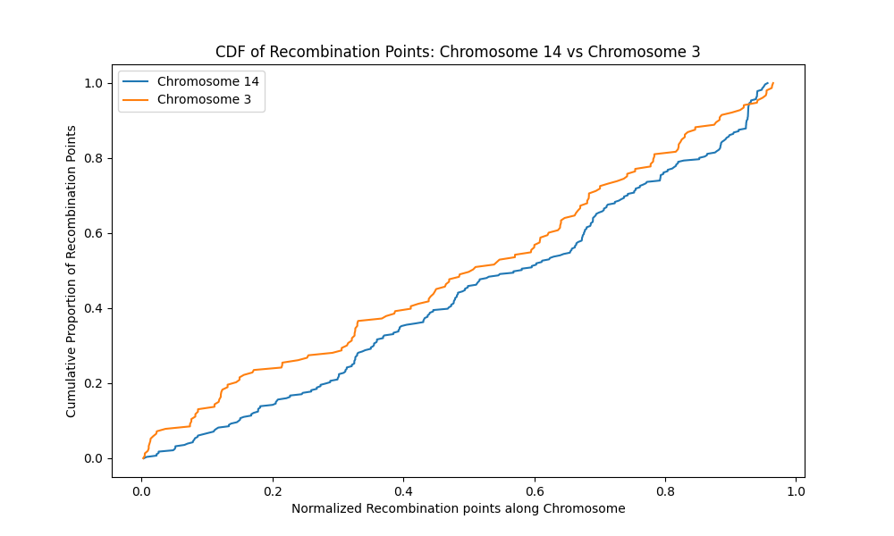

**Figure 186**. The cumulative distribution plot shows both chromosome 14 (blue) and chromosome3 (yellow) have similarly distributed recombination points along their lengths. There are also areas with no recombination points as indicated by flat sections on the graph for each chromosome. The probability of overlap of recombination points and regions of spatial proximity is low in these areas.

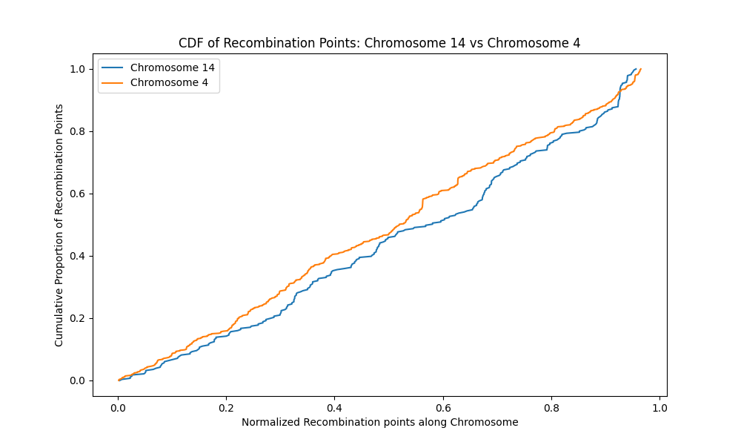

**Figure 187**. The cumulative distribution plot shows both chromosome 14 (blue) and chromosome 4 (yellow) have similarly distributed recombination points along their lengths. There are also areas with no recombination points as indicated by flat sections on the graph for each chromosome. The probability of overlap of recombination points and regions of spatial proximity is low in these areas.

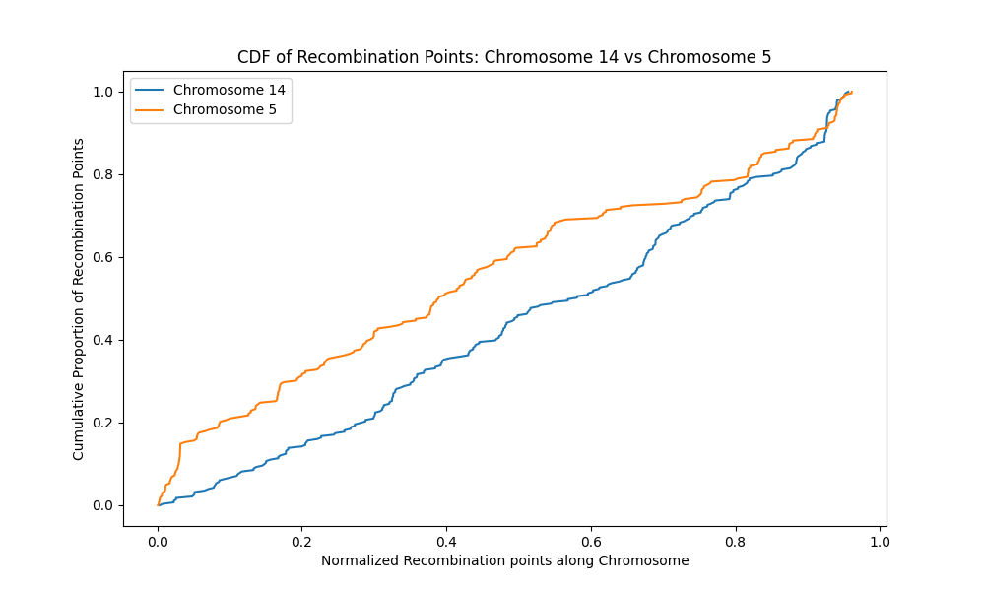

**Figure 188.** The cumulative distribution plot shows both chromosome 14 (blue) and chromosome 5 (yellow) have similarly distributed recombination points along their lengths. There are also areas with no recombination points as indicated by flat sections on the graph for each chromosome. The probability of overlap of recombination points and regions of spatial proximity is low in these areas.

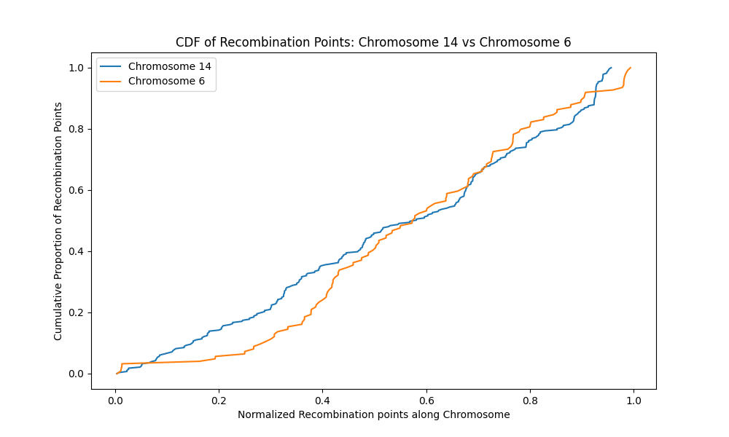

**Figure 189.** The cumulative distribution plot shows both chromosome 14 (blue) and chromosome 6 (yellow) have similarly distributed recombination points along their lengths. There are also areas with no recombination points as indicated by flat sections on the graph for each chromosome. The probability of overlap of recombination points and regions of spatial proximity is low in these areas.

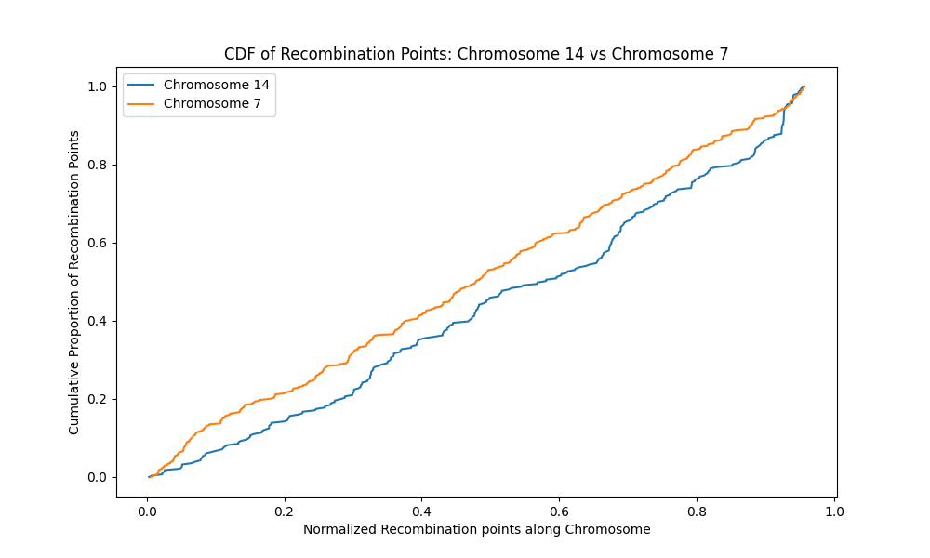

**Figure 190**. The cumulative distribution plot shows both chromosome 14 (blue) and chromosome 7 (yellow) have differently distributed recombination points along their lengths. There are also areas with no recombination points as indicated by flat sections on the graph for each chromosome. The probability of overlap of recombination points and regions of spatial proximity is low in these areas.

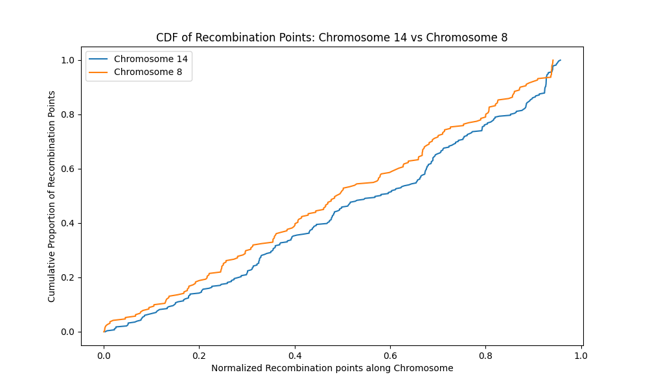

**Figure 191**. The cumulative distribution plot shows both chromosome 14 (blue) and chromosome 8 (yellow) have similarly distributed recombination points along their lengths. There are also areas with no recombination points as indicated by flat sections on the graph for each chromosome. The probability of overlap of recombination points and regions of spatial proximity is low in these areas.

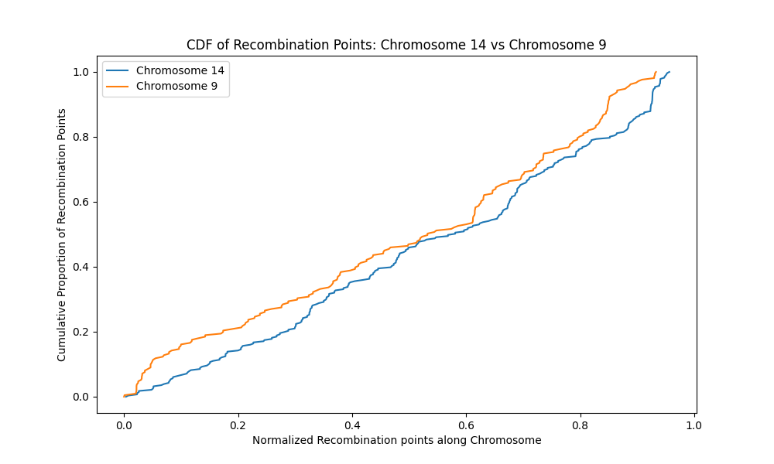

**Figure 192**. The cumulative distribution plot shows both chromosome 14 (blue) and chromosome 9 (yellow) have differently distributed recombination points along their lengths. There are also areas with no recombination points as indicated by flat sections on the graph for each chromosome. The probability of overlap of recombination points and regions of spatial proximity is low in these areas.

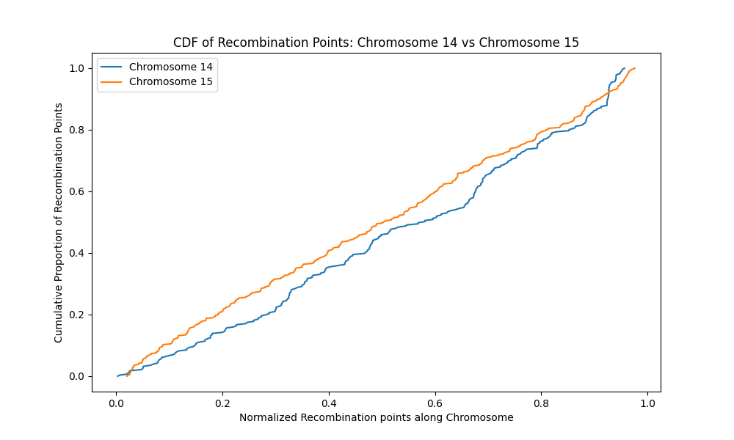

**Figure 193**. The cumulative distribution plot shows both chromosome 14 (blue) and chromosome 15 (yellow) have differently distributed recombination points along their lengths. There are also areas with no recombination points as indicated by flat sections on the graph for each chromosome. The probability of overlap of recombination points and regions of spatial proximity is low in these areas.

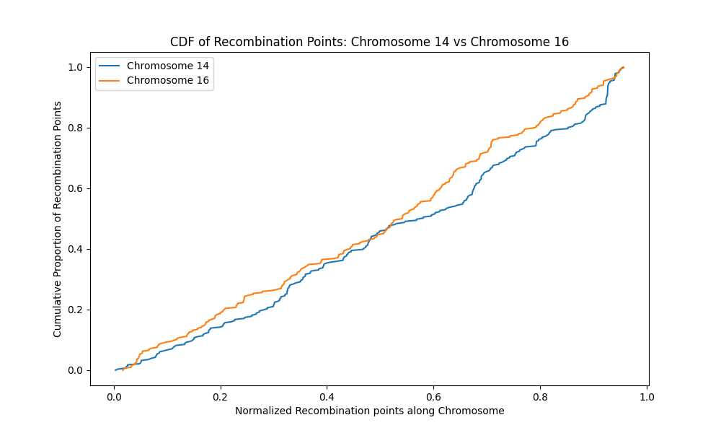

**Figure 194**. The cumulative distribution plot shows both chromosome 14 (blue) and chromosome 16 (yellow) have differently distributed recombination points along their lengths. There are also areas with no recombination points as indicated by flat sections on the graph for each chromosome. The probability of overlap of recombination points and regions of spatial proximity is low in these areas.

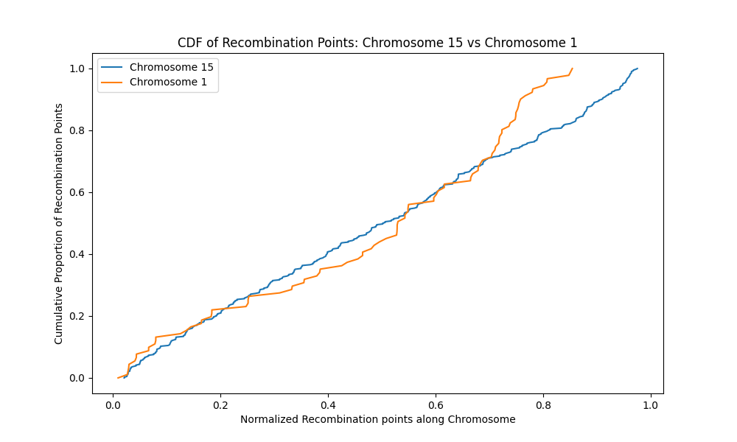

**Figure 195**. The cumulative distribution plot shows both chromosome 15 (blue) and chromosome 1 (yellow) have differently distributed recombination points along their lengths. There are also areas with no recombination points as indicated by flat sections on the graph for each chromosome. The probability of overlap of recombination points and regions of spatial proximity is low in these areas.

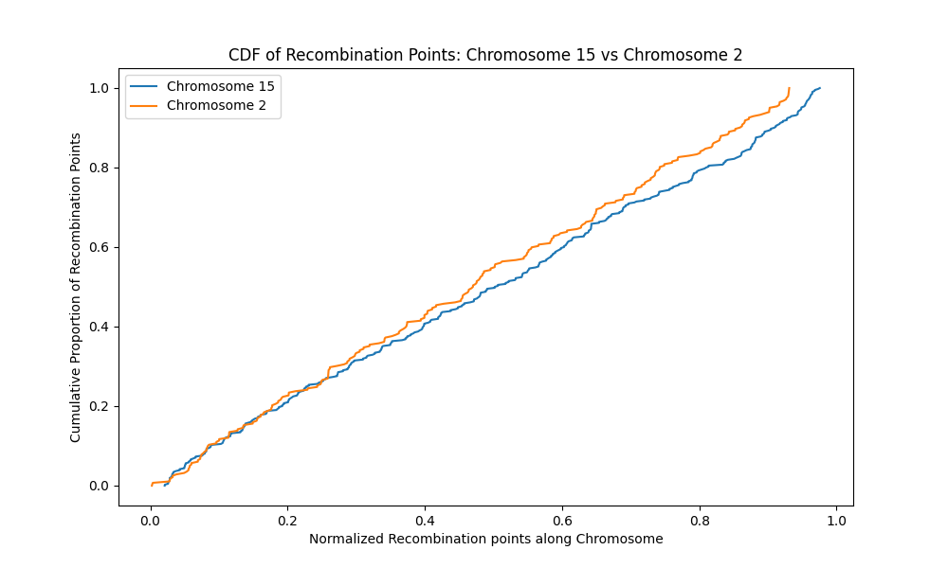

**Figure 196**. The cumulative distribution plot shows that both chromosome 15 (blue) and chromosome 2 (yellow) have similarly distributed recombination points along their lengths. There are also areas with no recombination points as indicated by flat sections on the graph for each chromosome. The probability of overlap of recombination points and regions of spatial proximity is low in these areas.

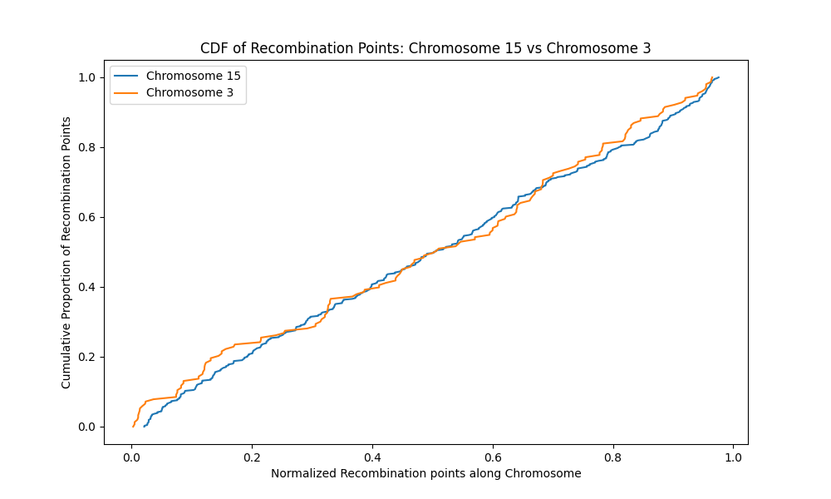

**Figure 197**. The cumulative distribution plot shows both chromosome 15 (blue) and chromosome 3 (yellow) have differently distributed recombination points along their lengths. There are also areas with no recombination points as indicated by flat sections on the graph for each chromosome. The probability of overlap of recombination points and regions of spatial proximity is low in these areas.

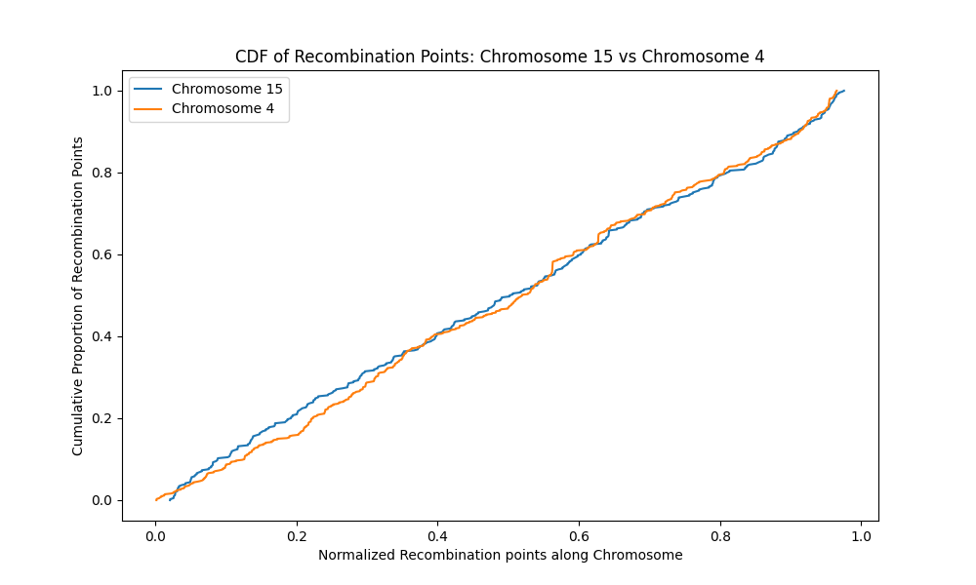

**Figure 198**. The cumulative distribution plot shows both chromosome 15 (blue) and chromosome 4 (yellow) have differently distributed recombination points along their lengths. There are also areas with no recombination points as indicated by flat sections on the graph for each chromosome. The probability of overlap of recombination points and regions of spatial proximity is low in these areas.

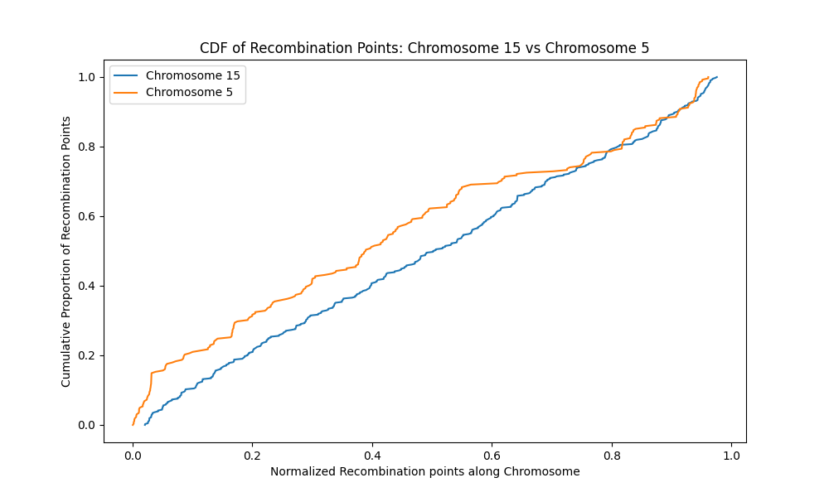

**Figure 199**. The cumulative distribution plot shows both chromosome 15 (blue) and chromosome 6 (yellow) have differently distributed recombination points along their lengths. There are also areas with no recombination points as indicated by flat sections on the graph for each chromosome. The probability of overlap of recombination points and regions of spatial proximity is low in these areas.

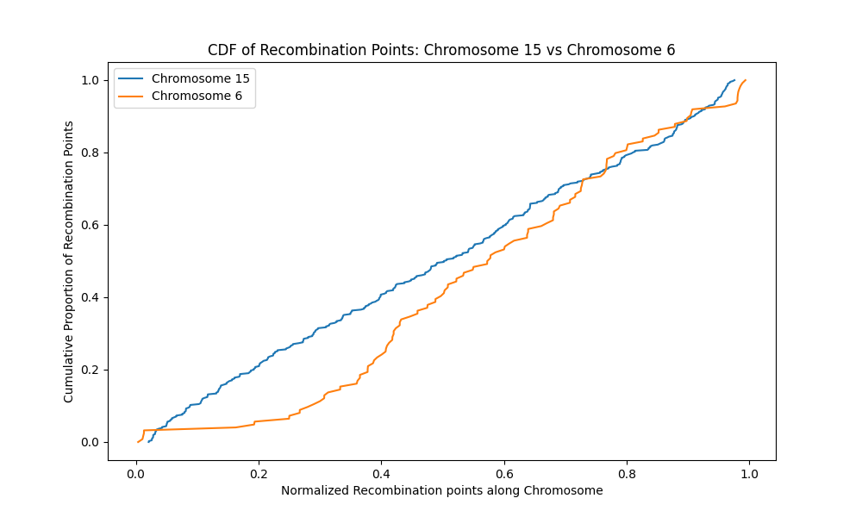

**Figure 200.** The cumulative distribution plot shows both chromosome 15 (blue) and chromosome 6 (yellow) have differently distributed recombination points along their lengths. Chromosome 6 has an initial flat section which indicates no recombination points at that point. Such an area could be a telomeric region. The probability of overlap of recombination points and regions of spatial proximity is low in these areas.

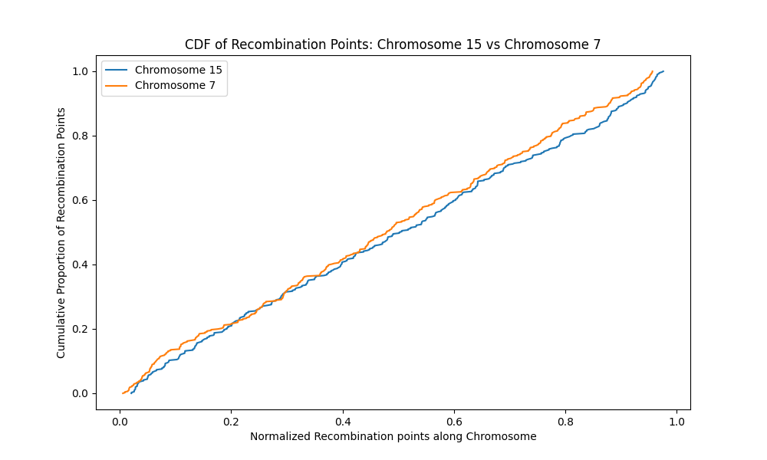

**Figure 201**. The cumulative distribution plot shows both chromosome 15 (blue) and chromosome 7 (yellow) have similarly distributed recombination points along their lengths. There are also areas with no recombination points as indicated by flat sections on the graph for each chromosome. The probability of overlap of recombination points and regions of spatial proximity is low in these areas.

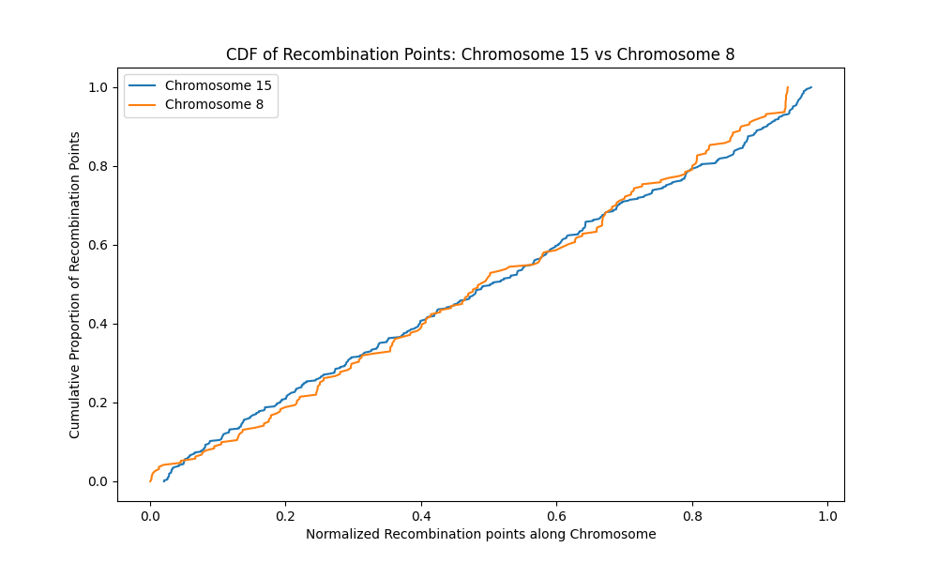

**Figure 202**. The cumulative distribution plot shows both chromosome 15 (blue) and chromosome 8 (yellow) have differently distributed recombination points along their lengths. There are also areas with no recombination points as indicated by flat sections on the graph for each chromosome. The probability of overlap of recombination points and regions of spatial proximity is low in these areas.

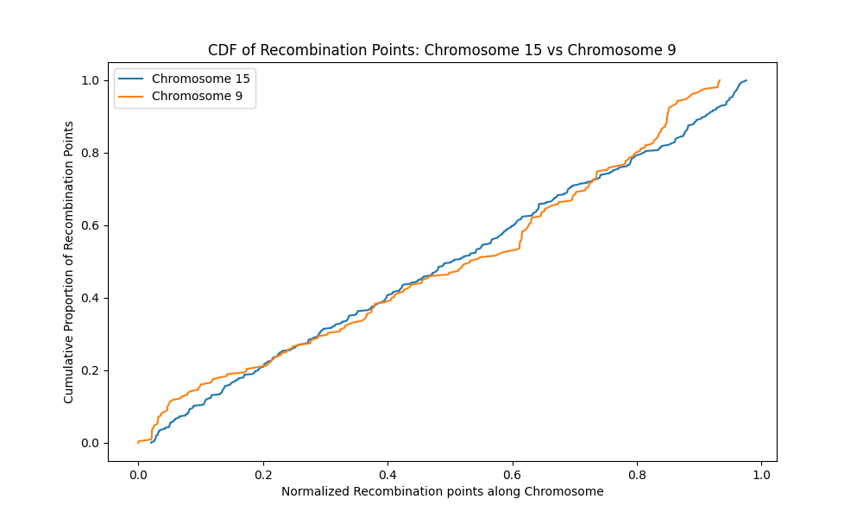

**Figure 203**. The cumulative distribution plot shows both chromosome 15 (blue) and chromosome 9 (yellow) have differently distributed recombination points along their lengths. There are also areas with no recombination points as indicated by flat sections on the graph for each chromosome. The probability of overlap of recombination points and regions of spatial proximity is low in these areas

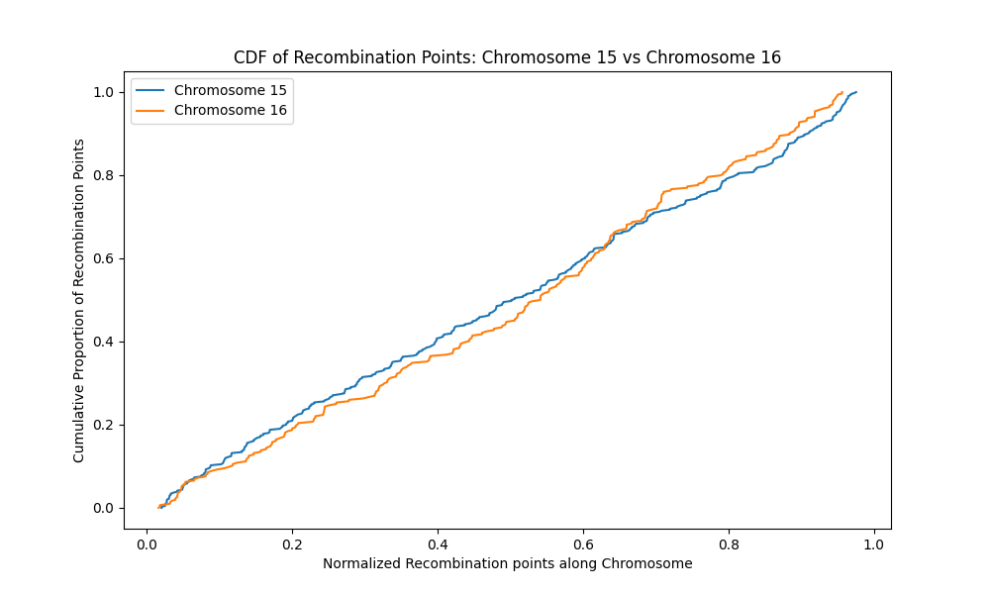

**Figure 204**. The cumulative distribution plot shows both chromosome 15 (blue) and chromosome 16 (yellow) have differently distributed recombination points along their lengths. There are also areas with no recombination points as indicated by flat sections on the graph for each chromosome. The probability of overlap of recombination points and regions of spatial proximity is low in these areas

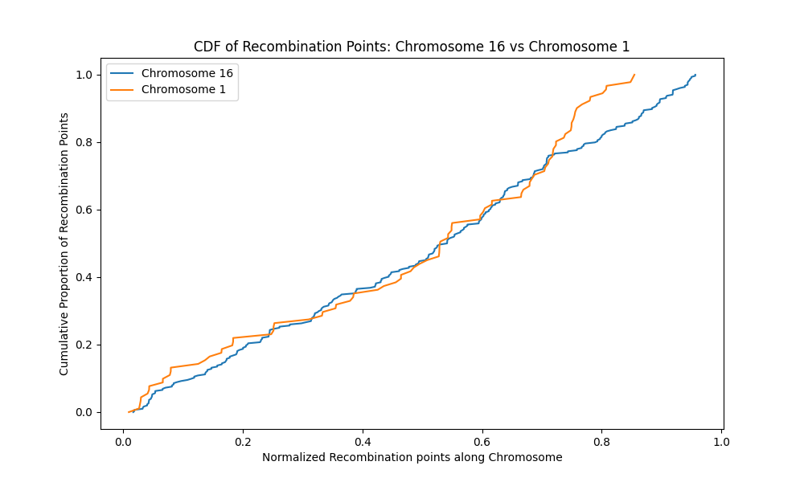

**Figure 205.** The cumulative distribution plot shows both chromosome 16 (blue) and chromosome 1 (yellow) have differently distributed recombination points along their lengths. There are also areas with no recombination points as indicated by flat sections on the graph for each chromosome. The probability of overlap of recombination points and regions of spatial proximity is low in these areas.

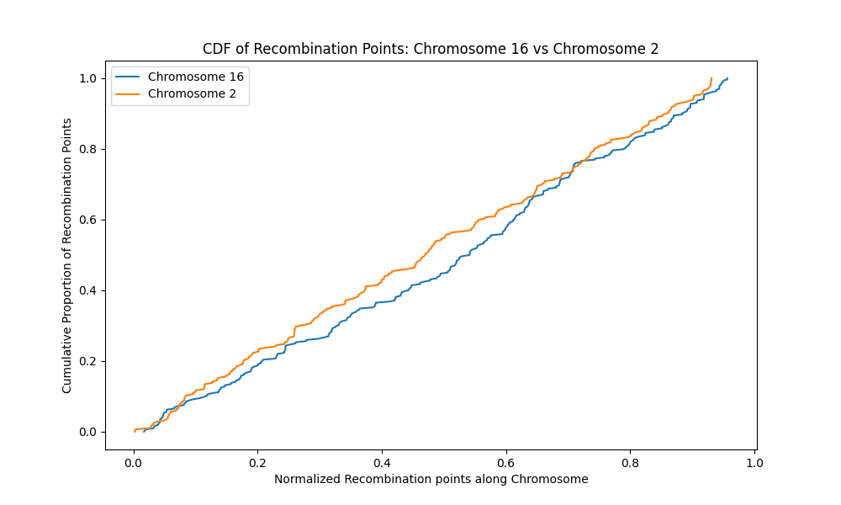

**Figure 206**. The cumulative distribution plot shows both chromosome 16 (blue) and chromosome 2 (yellow) have differently distributed recombination points along their lengths. There are also areas with no recombination points as indicated by flat sections on the graph for each chromosome. The probability of overlap of recombination points and regions of spatial proximity is low in these areas.

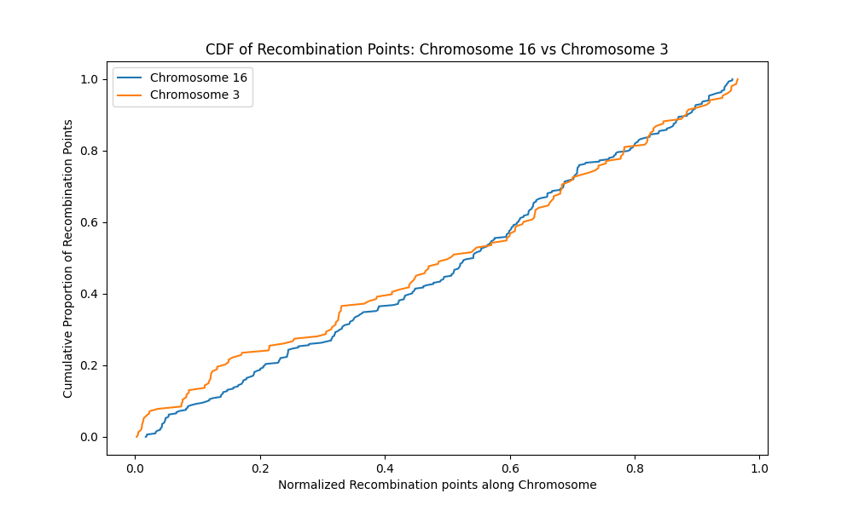

**Figure 207**. The cumulative distribution plot shows both chromosome 16 (blue) and chromosome 3 (yellow) have differently distributed recombination points along their lengths. There are also areas with no recombination points as indicated by flat sections on the graph for each chromosome. The probability of overlap of recombination points and regions of spatial proximity is low in these areas.

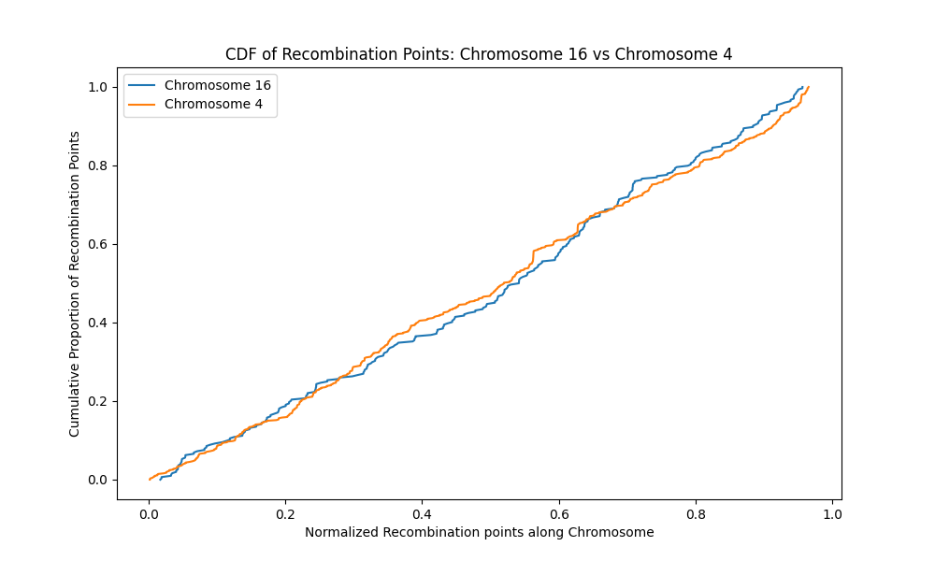

**Figure 208**. The cumulative distribution plot shows both chromosome 16 (blue) and chromosome 4 (yellow) have differently distributed recombination points along their lengths. There are also areas with no recombination points as indicated by flat sections on the graph for each chromosome. The probability of overlap of recombination points and regions of spatial proximity is low in these areas.

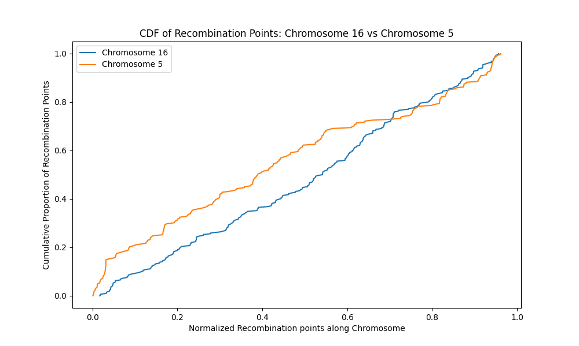

**Figure 209**. The cumulative distribution plot shows both chromosome 16 (blue) and chromosome 5 (yellow) have differently distributed recombination points along their lengths. There are also areas with no recombination points as indicated by flat sections on the graph for each chromosome. The probability of overlap of recombination points and regions of spatial proximity is low in these areas.

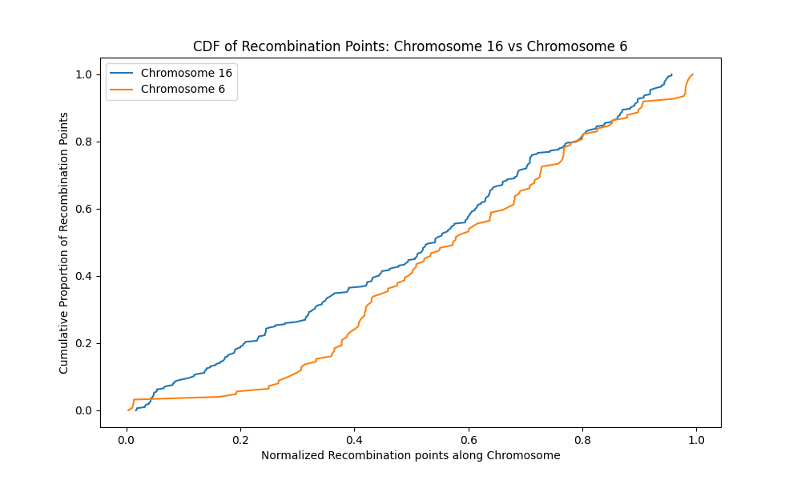

**Figure 210**. The cumulative distribution plot shows both chromosome 16 (blue) and chromosome 6 (yellow) have differently distributed recombination points along their lengths. Chromosome 6 has an initial flat section which indicates no recombination points at that point. Such an area could be a telomeric region. The probability of overlap of recombination points and regions of spatial proximity is low in these areas

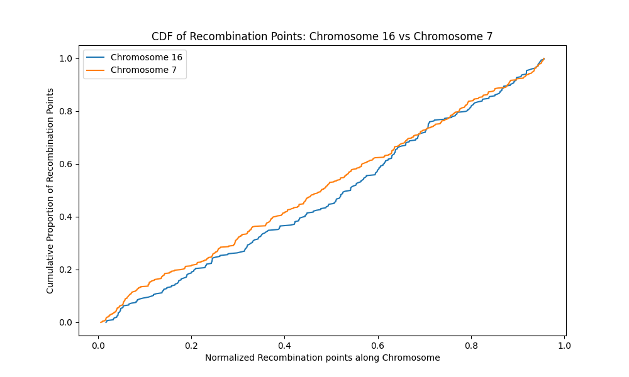

**Figure 211.** The cumulative distribution plot shows both chromosome 16 (blue) and chromosome 7 (yellow) have similarly distributed recombination points along their lengths. Regions with no recombination points are indicated with flat sections on the graph. The probability of overlap of recombination points and regions of spatial proximity is low in these areas

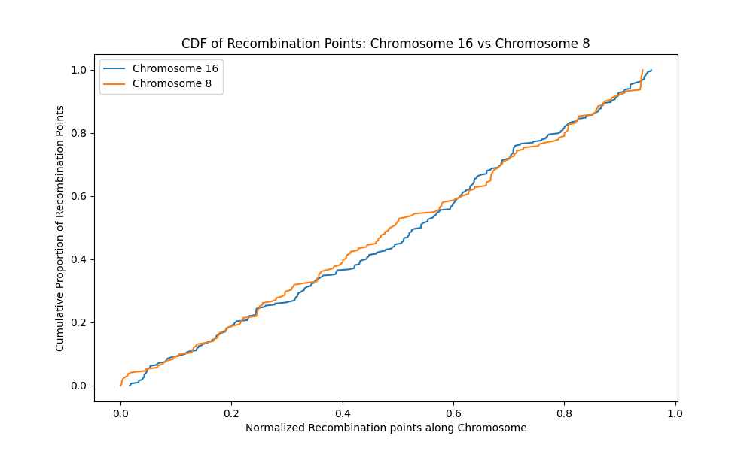

**Figure 212**. The cumulative distribution plot shows both chromosome 16 (blue) and chromosome 8 (yellow) have differently distributed recombination points along their lengths. There are also areas with no recombination points as indicated by flat sections on the graph for each chromosome. The probability of overlap of recombination points and regions of spatial proximity is low in these areas

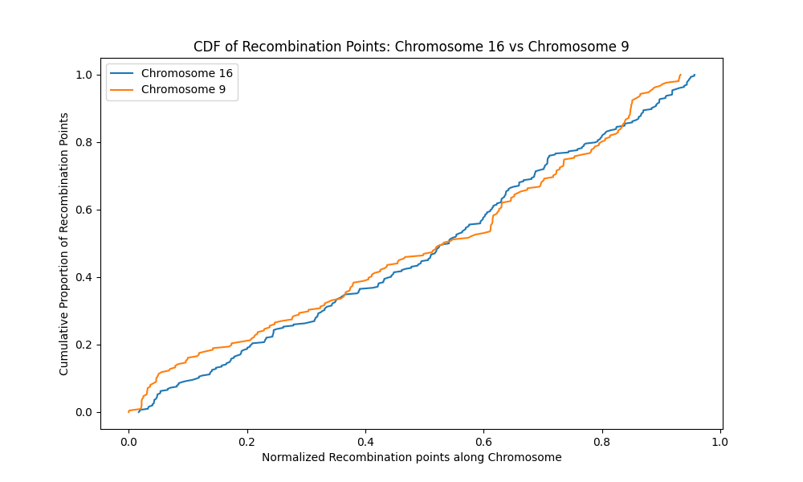

Figure 213. The cumulative distribution plot shows both chromosome 16 (blue) and chromosome 9 (yellow) have differently distributed recombination points along their lengths. There are also areas with no recombination points as indicated by flat sections on the graph for each chromosome. The probability of overlap of recombination points and regions of spatial proximity is low in these areas.

**Linear Regression Analysis**.

To understand the relationship between recombination hotspots and regions of spatial proximity (Hi-C contact points), linear regression analysis was done on all 16 chromosomes. The strength of the relationship was determined using the Spearman Rank-order coefficient and p-values. A strong positive monotonic relationship existed between the data points on all chromosomes except chromosome 16. The graphs for the analysis are shown below.

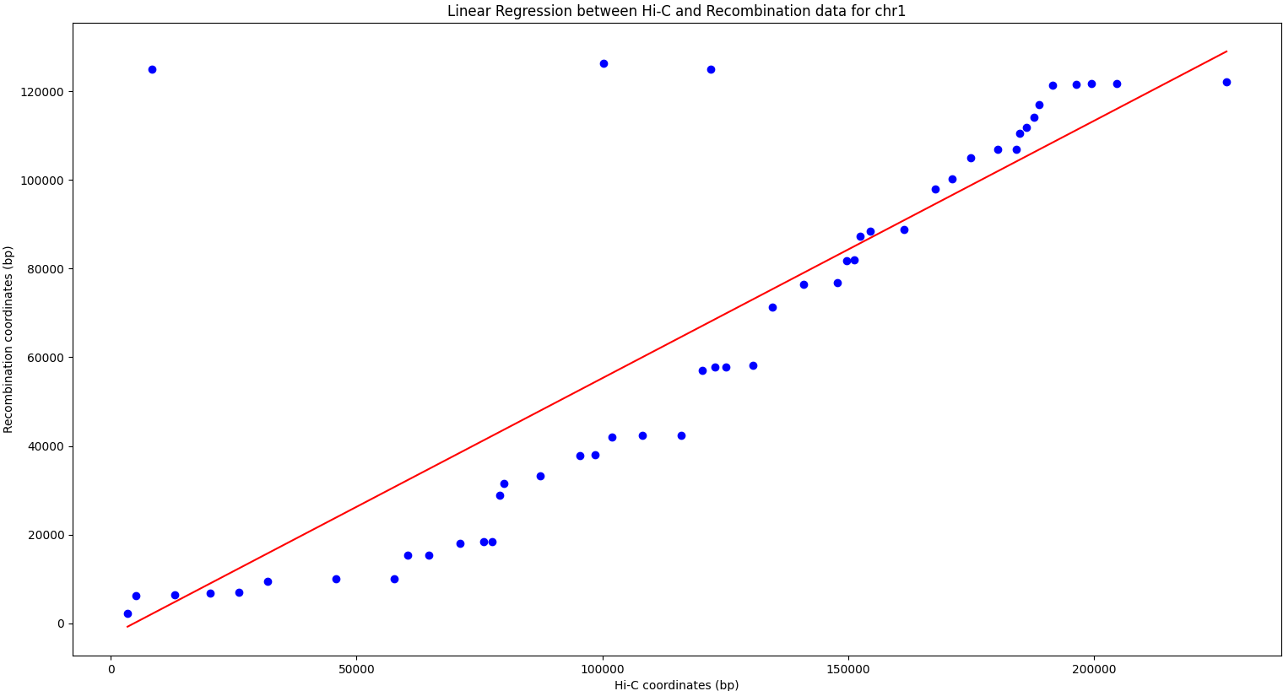

**Figure 214**. A strong correlation was observed between Recombination Hotspots and regions of spatial proximity on chromosome 1 (Spearman's ρ = 0.82, p<0.001)

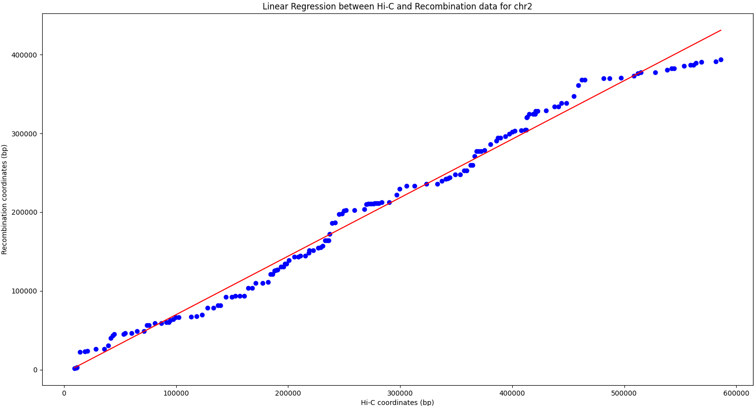

**Figure 215**. A scatterplot of Recombination Hotspots and regions of spatial proximity on chromosome 2 demonstrating a strong positive correlation (Spearman's ρ = 0.98, p<0.001)

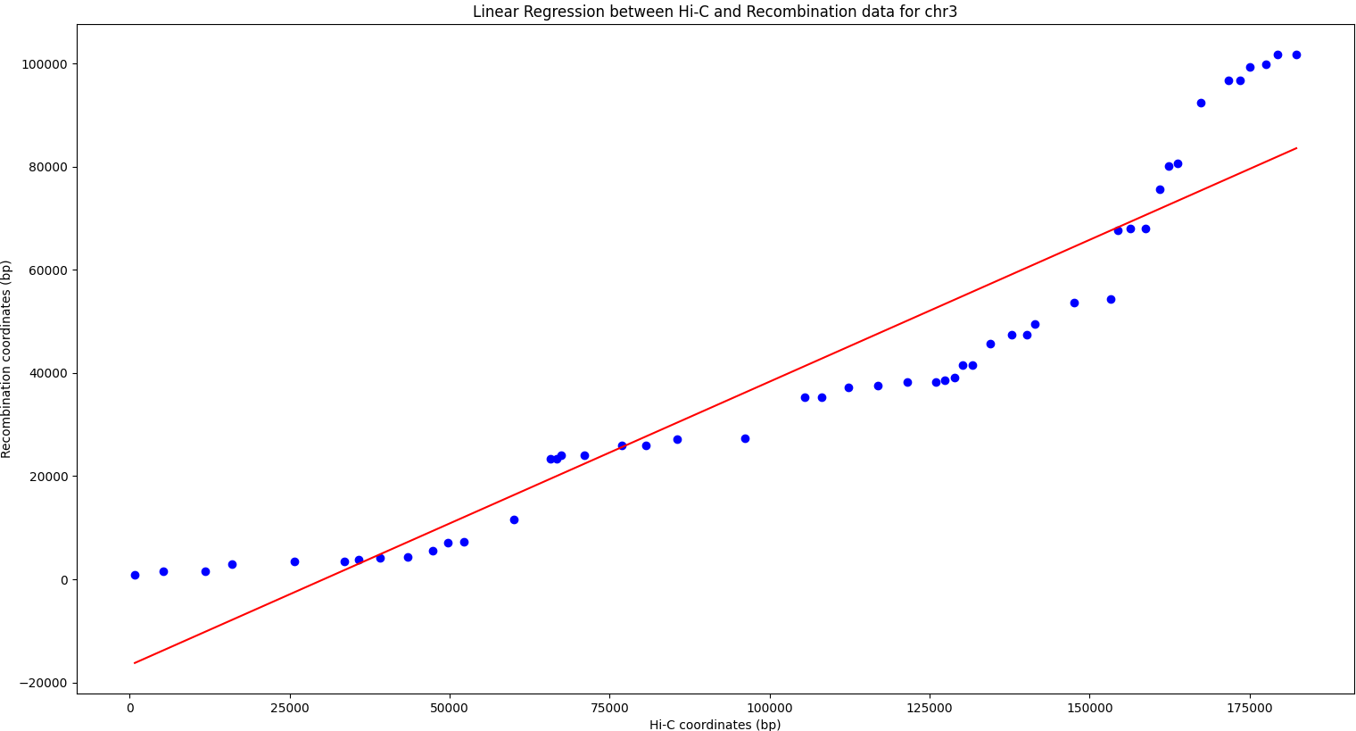

**Figure 216** . A significant positive correlation observed between Recombination Hotspots and regions of spatial proximity frequencies on chromosome 3 (Spearman's ρ = 0.0.99, p<0.001)

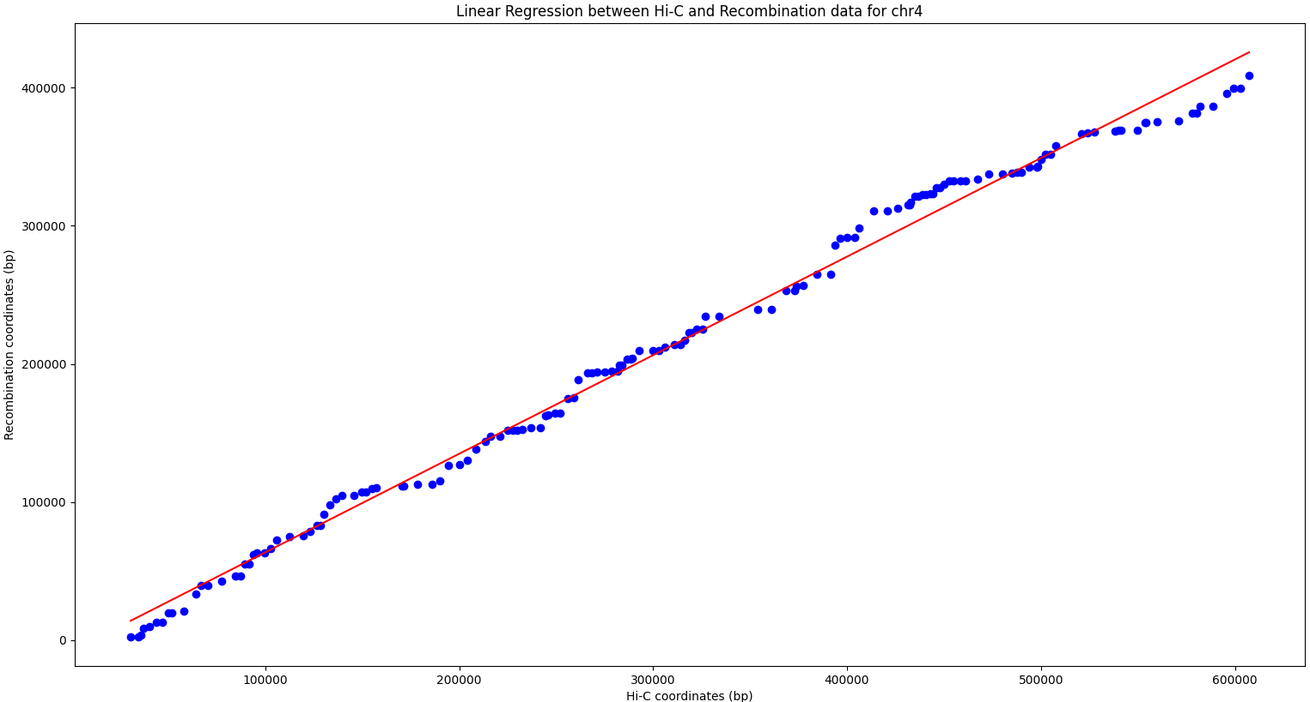

**Figure 217.** Recombination hotspots are strongly correlated with regions of spatial proximity across chromosome 4 (Spearman Correlation Coefficient ρ = 0.99, p<0.001)

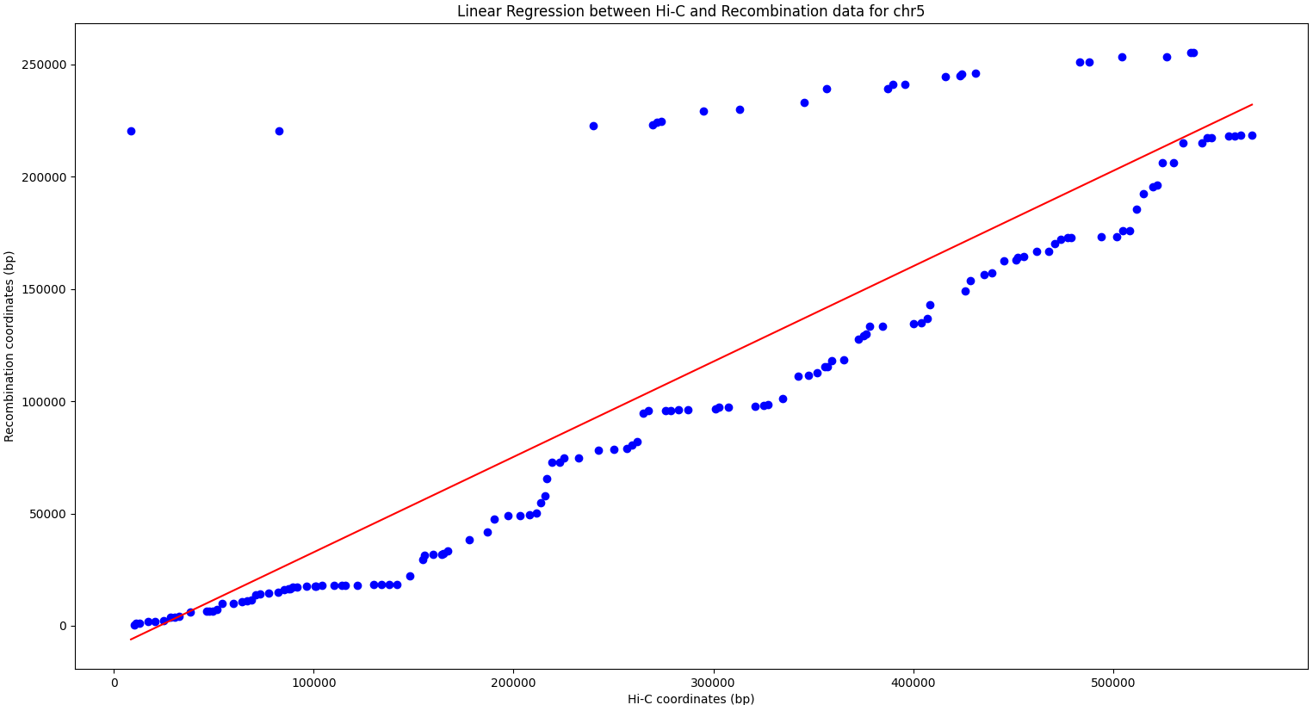

**Figure 218**. Recombination hotspots are strongly correlated with regions of spatial proximity points across chromosome 5 (Spearman Correlation Coefficient ρ = 0.86, p<0.001)

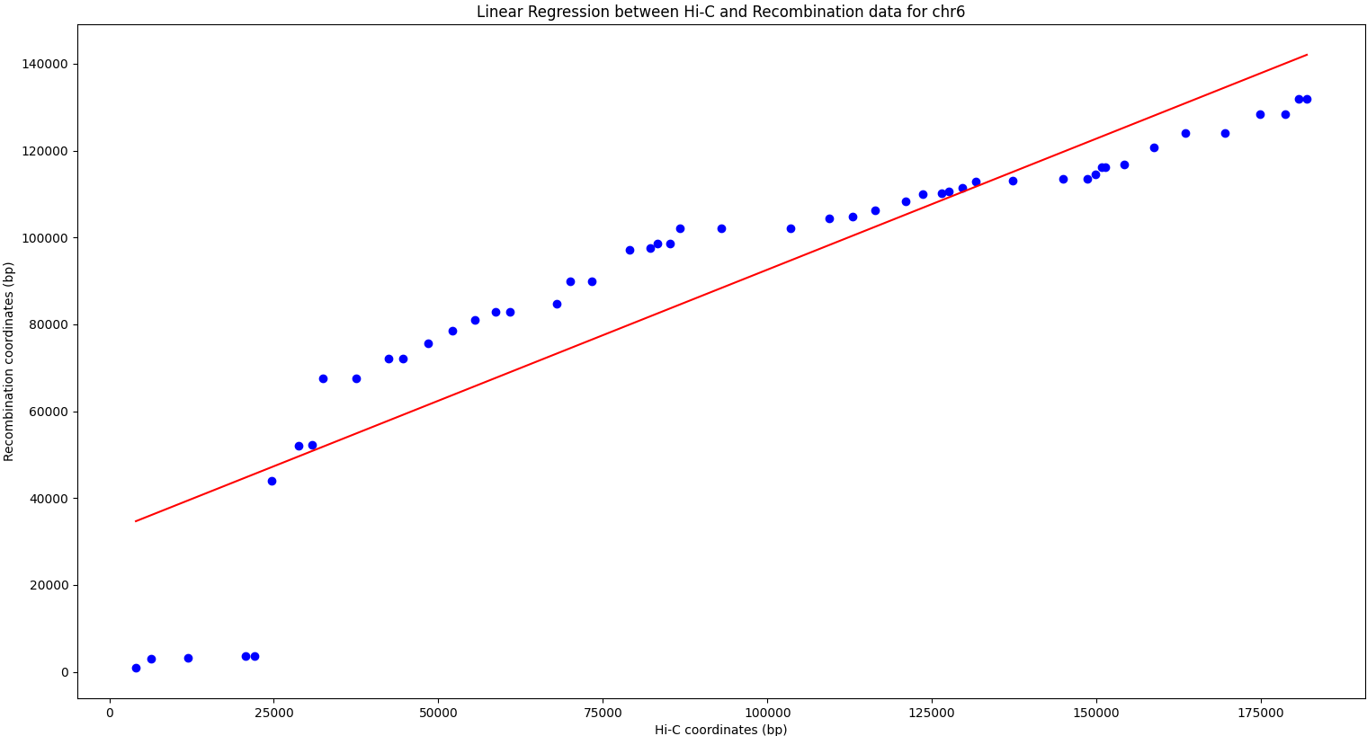

**Figure 219**. A significant positive correlation was observed between Recombination Hotspots and regions of spatial proximity on chromosome 6 (Spearman's ρ = 0.99, p<0.001)

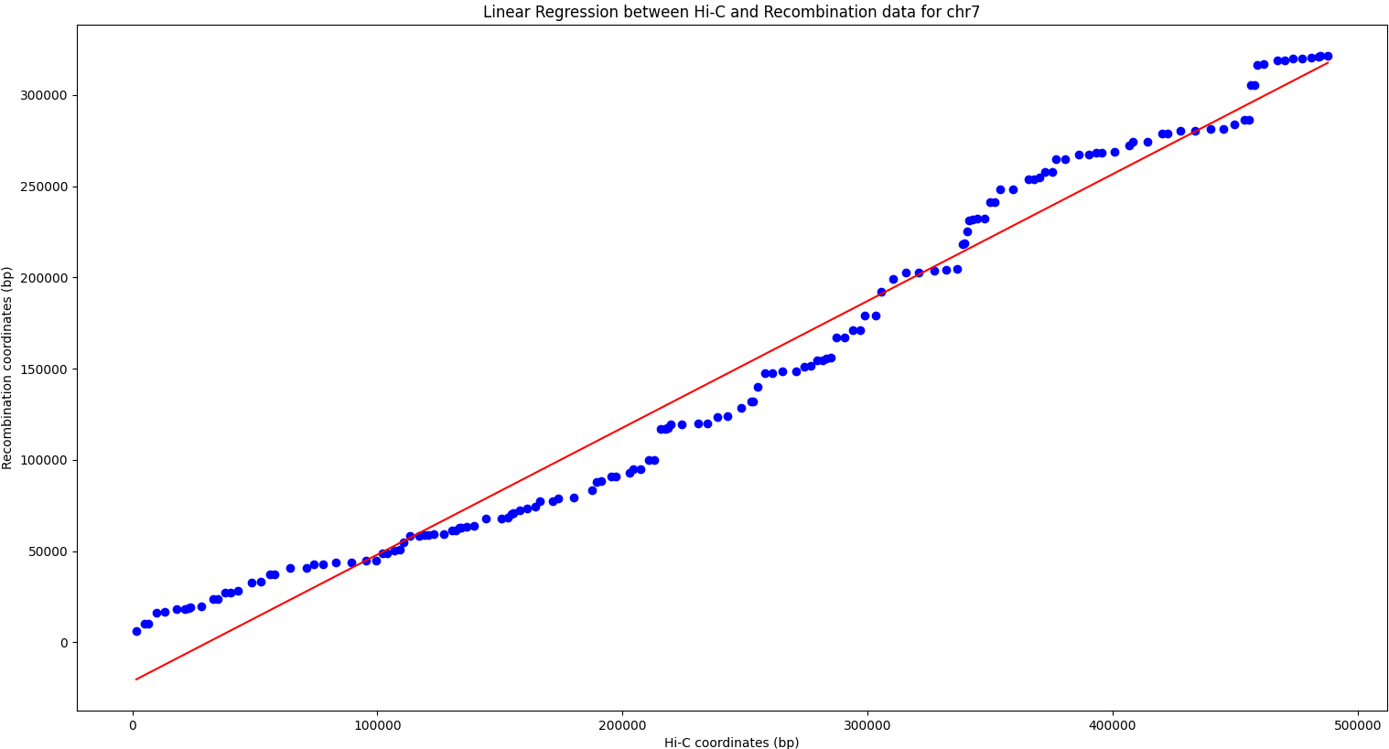

**Figure 220**. Strong Correlation between Recombination Hotspots and regions of spatial proximity on chromosome 7 (Spearman's ρ = 0.99, p<0.001).

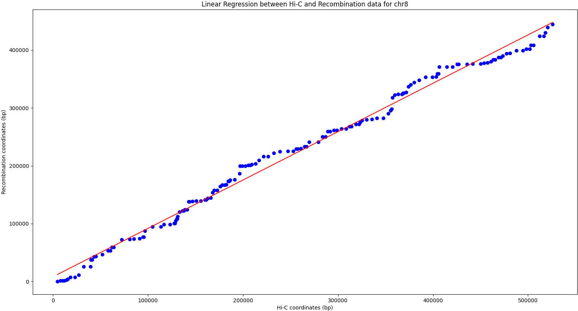

**Figure 221**. Spearman Correlation analysis reveals a strong association between Recombination Hotspots and regions of spatial proximity on chromosome 8 (ρ = 0.99, p<0.001)

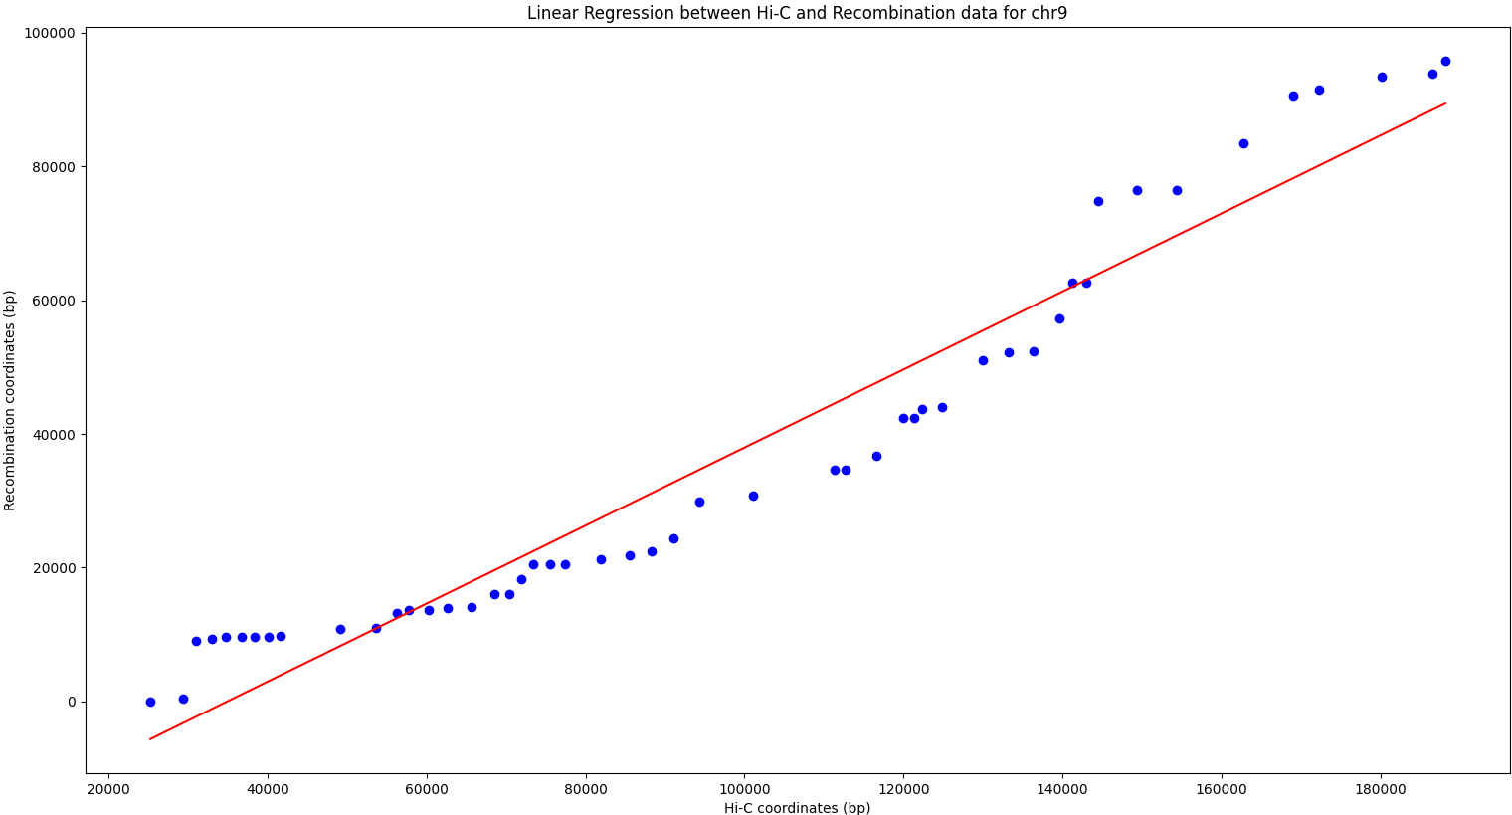

**Figure 222**. A Spearman Correlation Analysis reveals a strong association between Recombination Hotspots and regions of spatial proximity on chromosome 9 (ρ = 0.9, p<0.001)

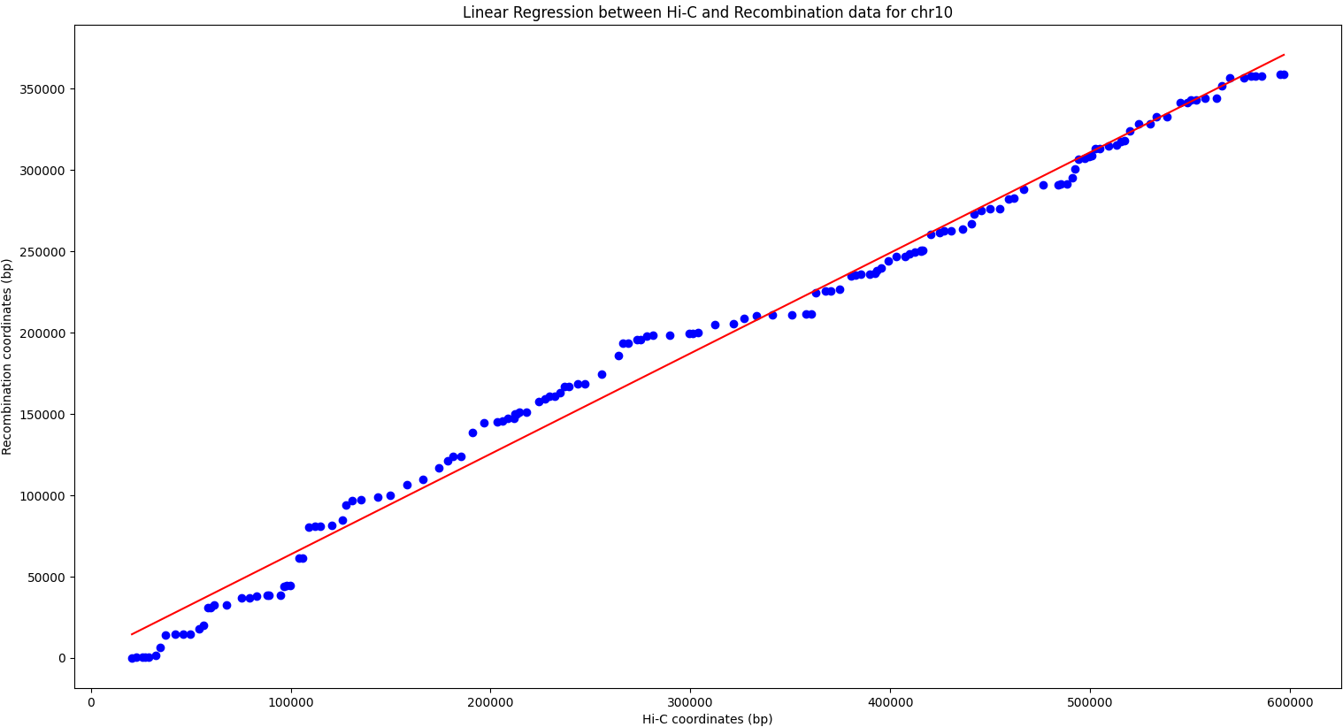

**Figure 223**. Recombination Hotspots are strongly correlated with regions of spatial proximity across chromosome 10 (Spearman Correlation Coefficient ρ = 0.99, p<0.001)

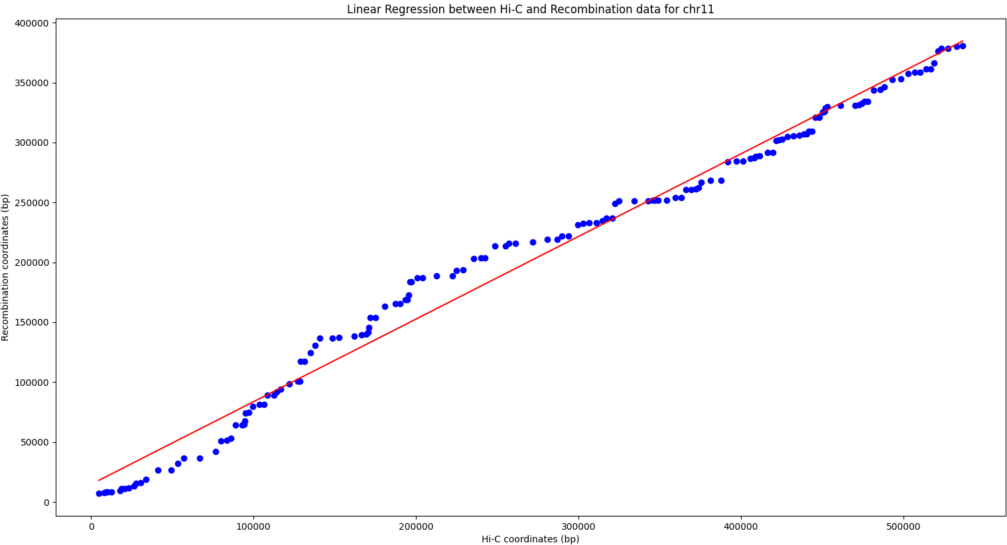

**Figure 224**. Recombination Hotspots are also strongly correlated with regions of spatial proximity across chromosome 11 (Spearman Correlation Coefficient ρ = 0.99, p<0.001)

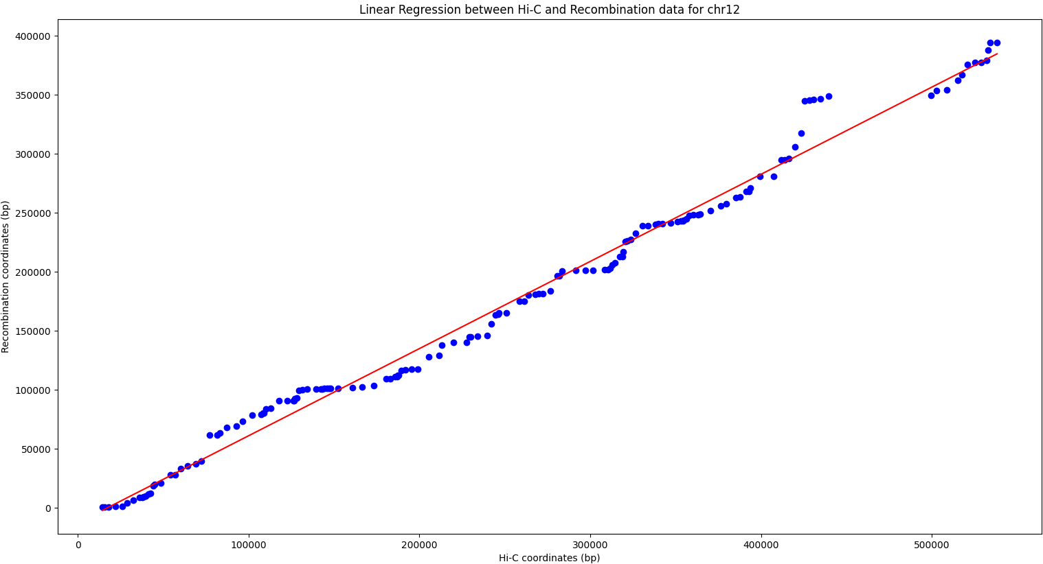

**Figure 225**. Recombination Hotspots are strongly correlated with regions of spatial proximity across chromosome 12 (Spearman Correlation Coefficient ρ = 0.99, p<0.001)

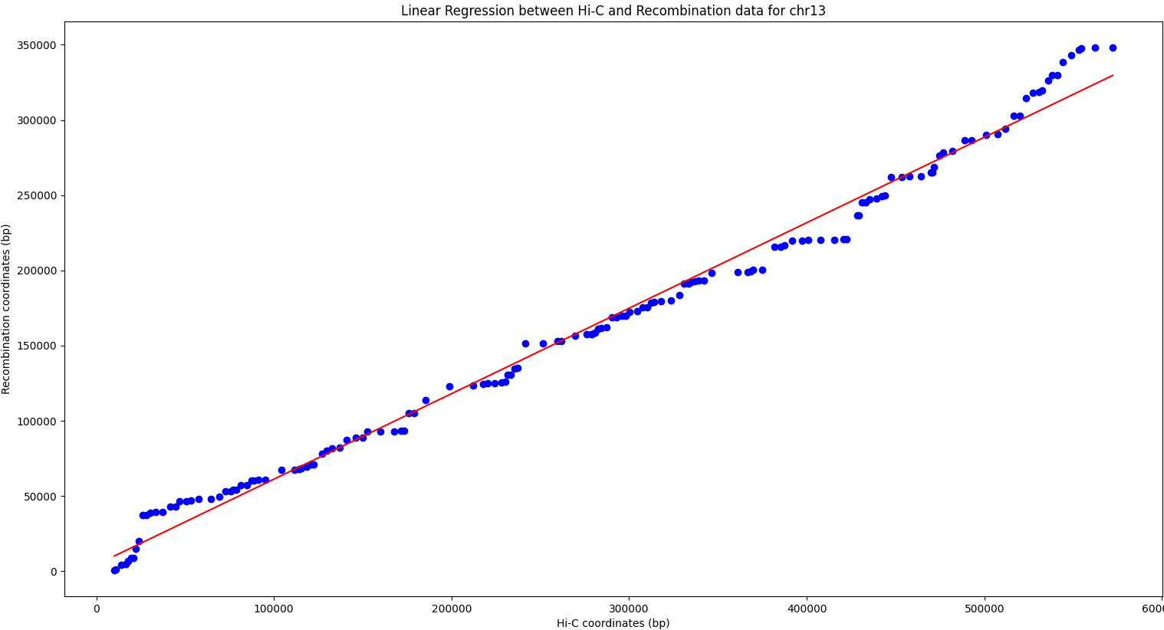

**Figure 226.** Recombination Hotspots are strongly correlated with Hi-C contact points Across chromosome 13 (Spearman Correlation Coefficient ρ = 0.99, p<0.001)

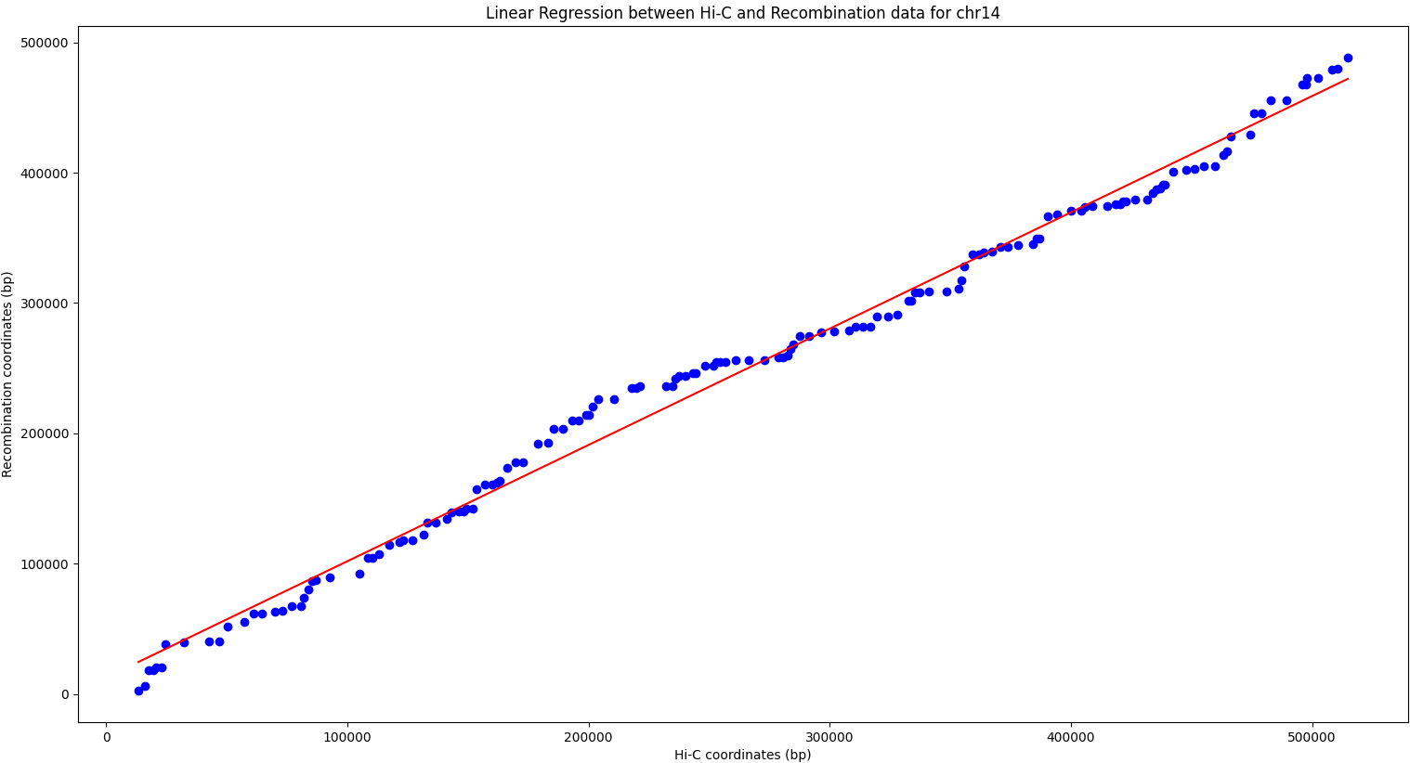

**Figure 227**. A Scatterplot of Recombination Hotspots and regions of spatial proximity on chromosome 14 demonstrating a strong positive correlation (Spearman's ρ = 0.99, p<0.001)

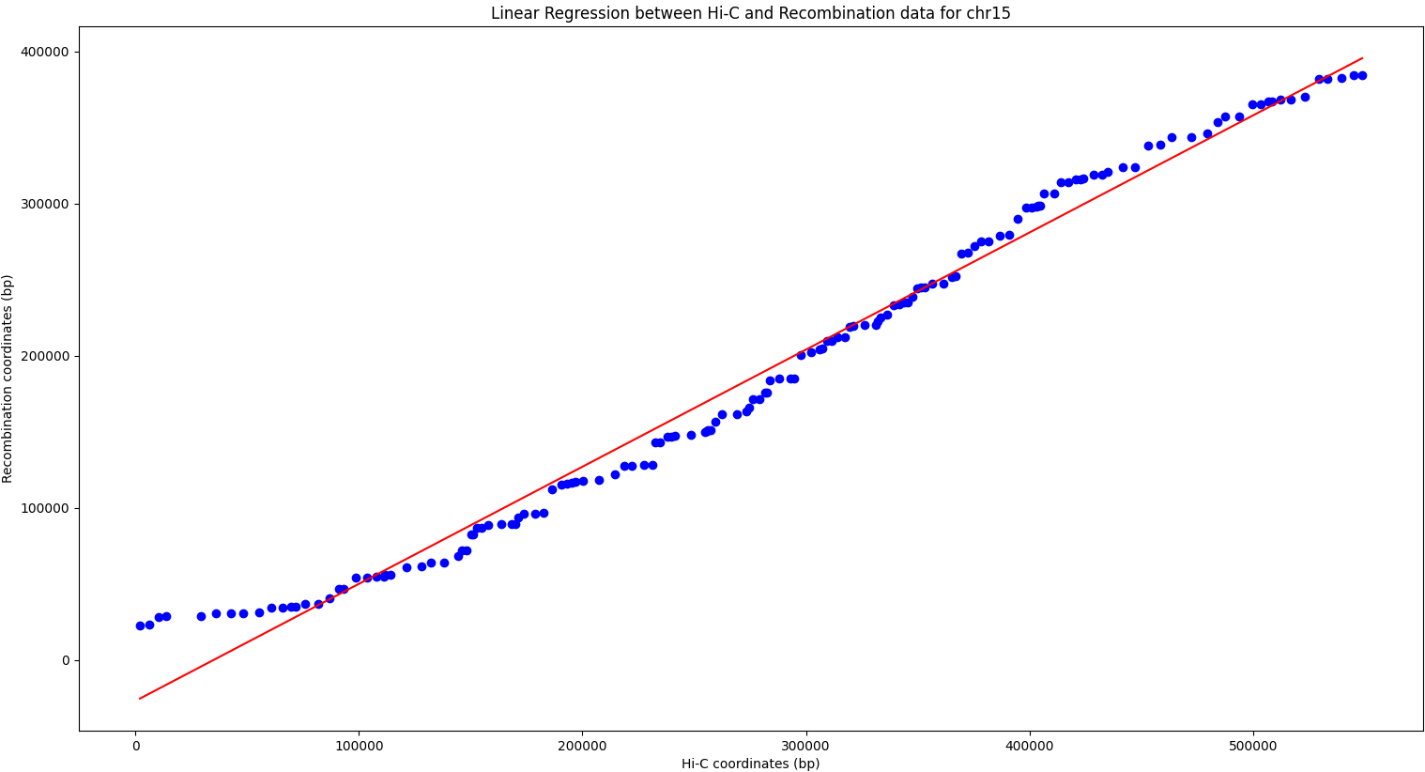

**Figure 228.** A Scatterplot of Recombination Hotspots and regions of spatial proximity on chromosome 15 demonstrating a strong positive correlation (Spearman's ρ = 0.98, p<0.001)

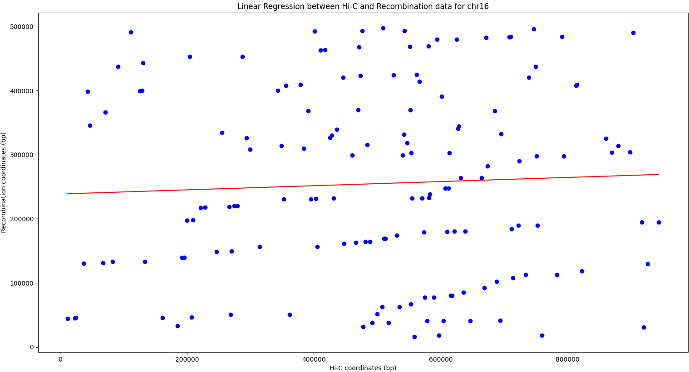

**Figure 229**. A Scatterplot of Recombination Hotspots and regions of spatial proximity on chromosome 16 demonstrating a weak Positive non-significant Correlation (Spearman's ρ = 0.02, p=0.74)

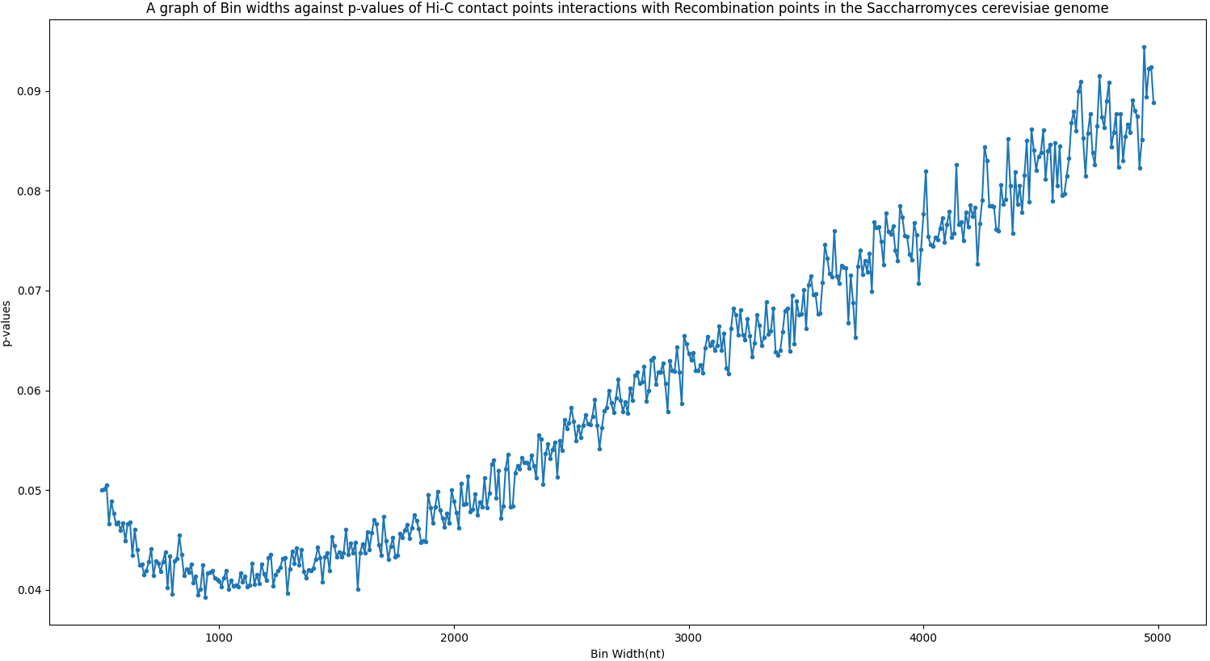

**Figure 230**. A graph of bin width against p-values for Hi-C contact points cross-linkages with recombination points. The optimal bin width for the hypergeometric distribution is 1000bp. Most overlaps were not significant after 1000bp

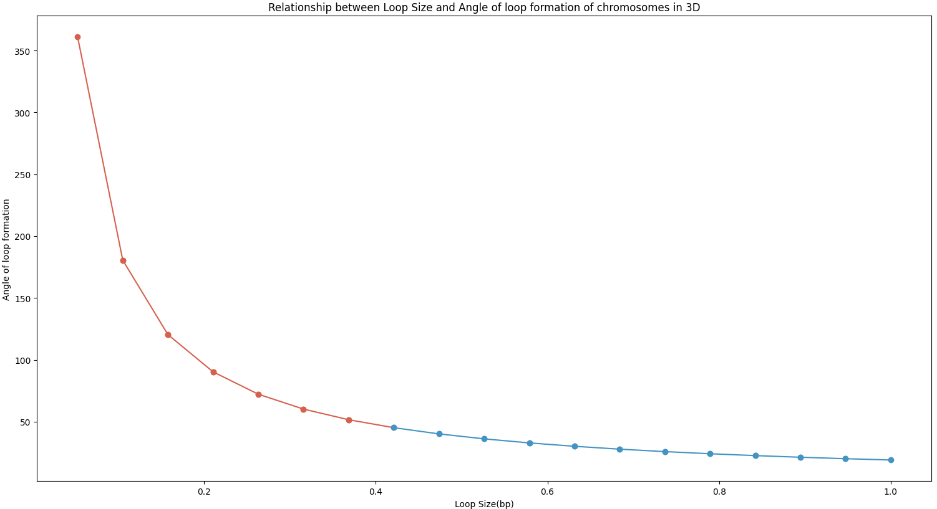

**Figure 232.** A graph of loop size against the loop angle of formation of chromosomes in proximity. As the loop size increases, the distance between loops (angle of formation) decreases. Increase in loop size increases the chances of overlap and interaction between recombination hotspots, regions of spatial proximity and other genomic features.

**Statistical Analysis**

The overlap of regions of spatial proximity and recombination hotspots have important implications for evolutionary genomics. The overlap of these regions could indicate conserved genomic features over evolutionary distance. The significance of these overlaps in the current was investigated by a hypergeometric distribution function. **Table 1** shows the probabilities of overlap at α=0.05, and **Table 2** shows the probabilities of overlap at α=0.003 (after Bonferroni correction for multiple testing)

**Table 1.** Probabilities of overlap of regions of spatial proximity (Hi-C) and recombination hotspots before Bonferroni correction (α=0.05)

|  |  |  |  |  |  |  |
| --- | --- | --- | --- | --- | --- | --- |
| Hi-C | Recomb | N | n | K | k | Probability |
| 1 | 1 | 231 | 49 | 56 | 13 | 0.13344313163462285 |
| 1 | 2 | 814 | 49 | 178 | 10 | 0.1396826018700716 |
| 1 | 3 | 317 | 49 | 96 | 18 | 0.07423368107554103 |
| 1 | 4 | 1532 | 49 | 366 | 11 | 0.13364216026831932 |
| 1 | 5 | 577 | 49 | 153 | 12 | 0.12955133420386408 |
| 1 | 6 | 271 | 49 | 72 | 15 | 0.10741686894572039 |
| 1 | 7 | 1091 | 49 | 298 | 12 | 0.1209564936923011 |
| 1 | 8 | 563 | 49 | 121 | 11 | 0.1399794247589329 |
| 1 | 9 | 440 | 49 | 128 | 17 | 0.08463825225303173 |
| 1 | 10 | 746 | 49 | 175 | 12 | 0.13414702477047638 |
| 1 | 11 | 667 | 49 | 178 | 10 | 0.08258967813127792 |
| 1 | 12 | 1079 | 49 | 196 | 13 | 0.04415918750682274 |
| 1 | 13 | 925 | 49 | 229 | 14 | 0.1061581746731518 |
| 1 | 14 | 785 | 49 | 178 | 10 | 0.1335352536094106 |
| 1 | 15 | 1092 | 49 | 266 | 11 | 0.1314898898695667 |
| 1 | 16 | 949 | 49 | 195 | 10 | 0.1438718034284066 |
| 2 | 2 | 814 | 281 | 178 | 62 | 0.07058201860186139 |
| 2 | 5 | 577 | 281 | 153 | 46 | 3.045728121096802e-08 |
| 2 | 7 | 1091 | 281 | 298 | 78 | 0.060564183419219014 |
| 2 | 8 | 563 | 281 | 121 | 41 | 2.8092296017560238e-05 |
| 2 | 9 | 440 | 281 | 128 | 53 | 3.861797474659712e-10 |
| 2 | 10 | 746 | 281 | 175 | 62 | 0.05608769644177752 |
| 2 | 11 | 667 | 281 | 178 | 61 | 0.0032179179047968558 |
| 2 | 12 | 1079 | 281 | 196 | 72 | 8.109421556372649e-05 |
| 2 | 13 | 925 | 281 | 229 | 76 | 0.037079358822004055 |
| 2 | 14 | 785 | 281 | 178 | 72 | 0.02390600952266448 |
| 2 | 15 | 1092 | 281 | 266 | 67 | 0.06280969147052334 |
| 2 | 16 | 949 | 281 | 195 | 57 | 0.06968629162709059 |
| 3 | 1 | 231 | 93 | 56 | 22 | 0.12281144036082192 |
| 3 | 2 | 814 | 93 | 178 | 20 | 0.10599580421648155 |
| 3 | 3 | 317 | 93 | 96 | 30 | 0.09370627658767283 |
| 3 | 4 | 1532 | 93 | 366 | 15 | 0.01931348556854886 |
| 3 | 5 | 577 | 93 | 153 | 31 | 0.027215570405924764 |
| 3 | 6 | 271 | 93 | 72 | 25 | 0.11445411938084597 |
| 3 | 7 | 1091 | 93 | 298 | 23 | 0.08367215182322424 |
| 3 | 8 | 563 | 93 | 121 | 25 | 0.04138220661611328 |
| 3 | 9 | 440 | 93 | 128 | 19 | 0.011752060405494815 |
| 3 | 10 | 746 | 93 | 175 | 23 | 0.09760930768130924 |
| 3 | 11 | 667 | 93 | 178 | 17 | 0.014013528054993292 |
| 3 | 12 | 1079 | 93 | 196 | 25 | 0.009284979514824284 |
| 3 | 13 | 925 | 93 | 229 | 29 | 0.031715850438705874 |
| 3 | 14 | 785 | 93 | 178 | 24 | 0.07576185818372205 |
| 3 | 15 | 1092 | 93 | 266 | 19 | 0.06832954733965692 |
| 3 | 16 | 949 | 93 | 195 | 20 | 0.10275567132007865 |
| 4 | 2 | 814 | 466 | 178 | 55 | 6.805682110472101e-16 |
| 4 | 5 | 577 | 466 | 153 | 46 | 1.8715076246037033e-73 |
| 4 | 8 | 563 | 466 | 121 | 41 | 6.5324964882629395e-49 |
| 4 | 10 | 746 | 466 | 175 | 51 | 6.415151217038354e-25 |
| 4 | 11 | 667 | 466 | 178 | 50 | 1.3410078211511336e-43 |
| 4 | 13 | 925 | 466 | 229 | 78 | 4.755890675196705e-09 |
| 4 | 14 | 785 | 466 | 178 | 58 | 1.420747765554332e-16 |
| 4 | 16 | 949 | 466 | 195 | 67 | 1.328945204374895e-06 |
| 5 | 1 | 231 | 171 | 56 | 18 | 6.1000522381861995e-15 |
| 5 | 2 | 814 | 171 | 178 | 50 | 0.0029508232299100953 |
| 5 | 3 | 317 | 171 | 96 | 28 | 3.3924656352377475e-09 |
| 5 | 4 | 1532 | 171 | 366 | 45 | 0.05428804983557367 |
| 5 | 5 | 577 | 171 | 153 | 39 | 0.03541712743322544 |
| 5 | 6 | 271 | 171 | 72 | 25 | 7.68741988592947e-09 |
| 5 | 7 | 1091 | 171 | 298 | 47 | 0.07418253068907023 |
| 5 | 8 | 563 | 171 | 121 | 44 | 0.02405023456520459 |
| 5 | 9 | 440 | 171 | 128 | 40 | 0.009457095500934478 |
| 5 | 10 | 746 | 171 | 175 | 46 | 0.038814758831676656 |
| 5 | 11 | 667 | 171 | 178 | 47 | 0.07642988030026346 |
| 5 | 12 | 1079 | 171 | 196 | 40 | 0.013650206050751524 |
| 5 | 13 | 925 | 171 | 229 | 45 | 0.06720018320817173 |
| 5 | 14 | 785 | 171 | 178 | 46 | 0.026826633505706212 |
| 5 | 15 | 1092 | 171 | 266 | 43 | 0.07400749623097265 |
| 5 | 16 | 949 | 171 | 195 | 39 | 0.05873363321263786 |
| 6 | 1 | 231 | 80 | 56 | 14 | 0.028610564264210332 |
| 6 | 2 | 814 | 80 | 178 | 24 | 0.020836371664510807 |
| 6 | 3 | 317 | 80 | 96 | 19 | 0.03874379104561951 |
| 6 | 4 | 1532 | 80 | 366 | 14 | 0.043314281223431714 |
| 6 | 5 | 577 | 80 | 153 | 20 | 0.10422030858565737 |
| 6 | 6 | 271 | 80 | 72 | 19 | 0.09692445575909094 |
| 6 | 7 | 1091 | 80 | 298 | 27 | 0.0413489579588036 |
| 6 | 8 | 563 | 80 | 121 | 11 | 0.022275328063746158 |
| 6 | 9 | 440 | 80 | 128 | 22 | 0.10313507428927345 |
| 6 | 10 | 746 | 80 | 175 | 20 | 0.10263202859503494 |
| 6 | 11 | 667 | 80 | 178 | 15 | 0.02511557057764791 |
| 6 | 12 | 1079 | 80 | 196 | 37 | 1.1451862178533575e-09 |
| 6 | 13 | 925 | 80 | 229 | 20 | 0.10716753308958687 |
| 6 | 14 | 785 | 80 | 178 | 17 | 0.10834931790998478 |
| 6 | 15 | 1092 | 80 | 266 | 20 | 0.1055752997110672 |
| 6 | 16 | 949 | 80 | 195 | 18 | 0.10083687462912432 |
| 7 | 2 | 814 | 359 | 178 | 74 | 0.05085400518918316 |
| 7 | 5 | 577 | 359 | 153 | 51 | 1.4073932005949832e-17 |
| 7 | 7 | 1091 | 359 | 298 | 101 | 0.05242467353498175 |
| 7 | 8 | 563 | 359 | 121 | 48 | 6.479112138495052e-10 |
| 7 | 9 | 440 | 359 | 128 | 48 | 1.5428111988843997e-52 |
| 7 | 10 | 746 | 359 | 175 | 54 | 6.41644496325526e-08 |
| 7 | 11 | 667 | 359 | 178 | 54 | 1.0669355298693684e-13 |
| 7 | 12 | 1079 | 359 | 196 | 66 | 0.06601931850239083 |
| 7 | 13 | 925 | 359 | 229 | 67 | 0.0001624242345296693 |
| 7 | 14 | 785 | 359 | 178 | 60 | 7.748398243396041e-05 |
| 7 | 15 | 1092 | 359 | 266 | 91 | 0.051581960254546484 |
| 7 | 16 | 949 | 359 | 195 | 64 | 0.0179411958782283 |
| 8 | 1 | 231 | 173 | 56 | 17 | 5.872292693956622e-17 |
| 8 | 2 | 814 | 173 | 178 | 34 | 0.06162307281802502 |
| 8 | 3 | 317 | 173 | 96 | 34 | 3.7056336295351457e-06 |
| 8 | 4 | 1532 | 173 | 366 | 45 | 0.058011881836326176 |
| 8 | 5 | 577 | 173 | 153 | 42 | 0.06048132782469537 |
| 8 | 6 | 271 | 173 | 72 | 22 | 1.27166779150713e-11 |
| 8 | 7 | 1091 | 173 | 298 | 46 | 0.07256284608896749 |
| 8 | 8 | 563 | 173 | 121 | 43 | 0.03798661743882038 |
| 8 | 9 | 440 | 173 | 128 | 48 | 0.07587157442662716 |
| 8 | 10 | 746 | 173 | 175 | 46 | 0.04340225644315048 |
| 8 | 11 | 667 | 173 | 178 | 46 | 0.07952274719966601 |
| 8 | 12 | 1079 | 173 | 196 | 44 | 0.0025869207030046653 |
| 8 | 13 | 925 | 173 | 229 | 45 | 0.07026711397996158 |
| 8 | 14 | 785 | 173 | 178 | 35 | 0.057406157652612436 |
| 8 | 15 | 1092 | 173 | 266 | 45 | 0.06498235575665533 |
| 8 | 16 | 949 | 173 | 195 | 40 | 0.0527307746871047 |
| 9 | 1 | 231 | 133 | 56 | 18 | 7.673551676206817e-06 |
| 9 | 2 | 814 | 133 | 178 | 26 | 0.07306959330227683 |
| 9 | 3 | 317 | 133 | 96 | 31 | 0.007000899985355381 |
| 9 | 4 | 1532 | 133 | 366 | 30 | 0.08020007069855718 |
| 9 | 5 | 577 | 133 | 153 | 42 | 0.02848494927357312 |
| 9 | 6 | 271 | 133 | 72 | 23 | 0.00033374911464120397 |
| 9 | 7 | 1091 | 133 | 298 | 35 | 0.08034405589668182 |
| 9 | 8 | 563 | 133 | 121 | 34 | 0.04028121817856961 |
| 9 | 9 | 440 | 133 | 128 | 38 | 0.09008128866084068 |
| 9 | 10 | 746 | 133 | 175 | 36 | 0.048915730118268094 |
| 9 | 11 | 667 | 133 | 178 | 35 | 0.08695146723541385 |
| 9 | 12 | 1079 | 133 | 196 | 27 | 0.0734273881206674 |
| 9 | 13 | 925 | 133 | 229 | 33 | 0.0863120254436461 |
| 9 | 14 | 785 | 133 | 178 | 23 | 0.02446823317296316 |
| 9 | 15 | 1092 | 133 | 266 | 34 | 0.07973454191532173 |
| 9 | 16 | 949 | 133 | 195 | 34 | 0.02772192035127543 |
| 10 | 2 | 814 | 230 | 178 | 63 | 0.004510245340370078 |
| 10 | 3 | 317 | 230 | 96 | 28 | 4.263214762221462e-29 |
| 10 | 4 | 1532 | 230 | 366 | 54 | 0.06629010116229316 |
| 10 | 5 | 577 | 230 | 153 | 39 | 7.453378287826145e-06 |
| 10 | 7 | 1091 | 230 | 298 | 59 | 0.05488633190078315 |
| 10 | 8 | 563 | 230 | 121 | 35 | 0.0008253269862691886 |
| 10 | 9 | 440 | 230 | 128 | 31 | 1.6986329312872746e-14 |
| 10 | 10 | 746 | 230 | 175 | 52 | 0.07017680807436948 |
| 10 | 11 | 667 | 230 | 178 | 56 | 0.045408679034751084 |
| 10 | 12 | 1079 | 230 | 196 | 51 | 0.01593759078931749 |
| 10 | 13 | 925 | 230 | 229 | 48 | 0.020500080525012464 |
| 10 | 14 | 785 | 230 | 178 | 47 | 0.04760126979444043 |
| 10 | 15 | 1092 | 230 | 266 | 66 | 0.015626095062332264 |
| 10 | 16 | 949 | 230 | 195 | 52 | 0.04949371906367351 |
| 11 | 2 | 814 | 217 | 178 | 45 | 0.06916201965924498 |
| 11 | 3 | 317 | 217 | 96 | 34 | 2.6476425726309906e-16 |
| 11 | 4 | 1532 | 217 | 366 | 53 | 0.06667786978752469 |
| 11 | 5 | 577 | 217 | 153 | 52 | 0.04378233747767555 |
| 11 | 6 | 271 | 217 | 72 | 22 | 3.15694237983276e-32 |
| 11 | 7 | 1091 | 217 | 298 | 60 | 0.06709016758436885 |
| 11 | 8 | 563 | 217 | 121 | 32 | 0.0006454548550154329 |
| 11 | 9 | 440 | 217 | 128 | 45 | 5.768022934723342e-05 |
| 11 | 10 | 746 | 217 | 175 | 49 | 0.07148337280390737 |
| 11 | 11 | 667 | 217 | 178 | 55 | 0.06471381527654861 |
| 11 | 12 | 1079 | 217 | 196 | 57 | 0.00027034243149021267 |
| 11 | 13 | 925 | 217 | 229 | 50 | 0.058097350883186405 |
| 11 | 14 | 785 | 217 | 178 | 49 | 0.07589307864575047 |
| 11 | 15 | 1092 | 217 | 266 | 62 | 0.019071751265146746 |
| 11 | 16 | 949 | 217 | 195 | 44 | 0.07593707041147427 |
| 12 | 2 | 814 | 309 | 178 | 56 | 0.008983326964828389 |
| 12 | 5 | 577 | 309 | 153 | 45 | 1.4488595974700084e-12 |
| 12 | 7 | 1091 | 309 | 298 | 93 | 0.025770058425523903 |
| 12 | 8 | 563 | 309 | 121 | 33 | 3.176613789088176e-12 |
| 12 | 9 | 440 | 309 | 128 | 41 | 4.957642969546623e-28 |
| 12 | 10 | 746 | 309 | 175 | 55 | 0.0005971812002645966 |
| 12 | 11 | 667 | 309 | 178 | 49 | 1.4224546822613242e-09 |
| 12 | 12 | 1079 | 309 | 196 | 52 | 0.05447144648401194 |
| 12 | 13 | 925 | 309 | 229 | 61 | 0.0027067864982731403 |
| 12 | 14 | 785 | 309 | 178 | 54 | 0.0013037543981688237 |
| 12 | 15 | 1092 | 309 | 266 | 88 | 0.00869260438529075 |
| 12 | 16 | 949 | 309 | 195 | 58 | 0.04443640051177395 |
| 13 | 2 | 814 | 289 | 178 | 46 | 0.0006132293723518501 |
| 13 | 5 | 577 | 289 | 153 | 49 | 8.094145912435526e-08 |
| 13 | 7 | 1091 | 289 | 298 | 91 | 0.011024032075913298 |
| 13 | 8 | 563 | 289 | 121 | 40 | 2.549856390230614e-06 |
| 13 | 9 | 440 | 289 | 128 | 32 | 3.5371104139648754e-30 |
| 13 | 10 | 746 | 289 | 175 | 46 | 3.2619954866863456e-05 |
| 13 | 11 | 667 | 289 | 178 | 56 | 6.0323646117816454e-05 |
| 13 | 12 | 1079 | 289 | 196 | 52 | 0.0708920766630454 |
| 13 | 13 | 925 | 289 | 229 | 64 | 0.03071202762286124 |
| 13 | 14 | 785 | 289 | 178 | 50 | 0.0015415113127488548 |
| 13 | 15 | 1092 | 289 | 266 | 68 | 0.059596219856103104 |
| 13 | 16 | 949 | 289 | 195 | 65 | 0.04252383919654212 |
| 14 | 2 | 814 | 238 | 178 | 52 | 0.07424105908774091 |
| 14 | 3 | 317 | 238 | 96 | 21 | 7.36457249171267e-48 |
| 14 | 4 | 1532 | 238 | 366 | 61 | 0.05128806459563465 |
| 14 | 5 | 577 | 238 | 153 | 40 | 3.182261346570603e-06 |
| 14 | 7 | 1091 | 238 | 298 | 69 | 0.05226032905124673 |
| 14 | 8 | 563 | 238 | 121 | 30 | 3.7642838337059874e-06 |
| 14 | 9 | 440 | 238 | 128 | 44 | 5.96015236549024e-08 |
| 14 | 10 | 746 | 238 | 175 | 58 | 0.06766197983595491 |
| 14 | 11 | 667 | 238 | 178 | 66 | 0.06533944710164348 |
| 14 | 12 | 1079 | 238 | 196 | 44 | 0.07464507208296625 |
| 14 | 13 | 925 | 238 | 229 | 69 | 0.014922897014192289 |
| 14 | 14 | 785 | 238 | 178 | 51 | 0.06415858837641089 |
| 14 | 15 | 1092 | 238 | 266 | 68 | 0.01575953357556885 |
| 14 | 16 | 949 | 238 | 195 | 43 | 0.04142703540400123 |
| 15 | 2 | 814 | 291 | 178 | 46 | 0.0004847815150611017 |
| 15 | 5 | 577 | 291 | 153 | 44 | 1.666869951291746e-10 |
| 15 | 7 | 1091 | 291 | 298 | 82 | 0.056492148842320365 |
| 15 | 8 | 563 | 291 | 121 | 23 | 8.393026974119133e-17 |
| 15 | 9 | 440 | 291 | 128 | 39 | 1.6799981592899524e-23 |
| 15 | 10 | 746 | 291 | 175 | 52 | 0.0010521902019403578 |
| 15 | 11 | 667 | 291 | 178 | 55 | 2.078004461529579e-05 |
| 15 | 12 | 1079 | 291 | 196 | 53 | 0.0707826428797821 |
| 15 | 13 | 925 | 291 | 229 | 66 | 0.0404798724824001 |
| 15 | 14 | 785 | 291 | 178 | 52 | 0.0032478128710302025 |
| 15 | 15 | 1092 | 291 | 266 | 74 | 0.05569827500002027 |
| 15 | 16 | 949 | 291 | 195 | 50 | 0.01627098971599445 |
| 16 | 1 | 231 | 161 | 56 | 5 | 2.3977168826976682e-29 |
| 16 | 2 | 814 | 161 | 178 | 35 | 0.0847548645361982 |
| 16 | 3 | 317 | 161 | 96 | 15 | 1.9704570561415372e-17 |
| 16 | 4 | 1532 | 161 | 366 | 40 | 0.07350300355344268 |
| 16 | 5 | 577 | 161 | 153 | 30 | 0.0021874545333518173 |
| 16 | 6 | 271 | 161 | 72 | 11 | 2.289888034004882e-19 |
| 16 | 7 | 1091 | 161 | 298 | 44 | 0.07625223610577159 |
| 16 | 8 | 563 | 161 | 121 | 9 | 1.933750947558502e-10 |
| 16 | 9 | 440 | 161 | 128 | 18 | 3.912596580705488e-11 |
| 16 | 10 | 746 | 161 | 175 | 30 | 0.022366563173979014 |
| 16 | 11 | 667 | 161 | 178 | 26 | 0.00014351087225973228 |
| 16 | 12 | 1079 | 161 | 196 | 39 | 0.009045921831825466 |
| 16 | 13 | 925 | 161 | 229 | 43 | 0.06445993204794237 |
| 16 | 14 | 785 | 161 | 178 | 39 | 0.07205767398152517 |
| 16 | 15 | 1092 | 161 | 266 | 38 | 0.07753001609064035 |
| 16 | 16 | 949 | 161 | 195 | 34 | 0.08288313789353838 |

**Table 2**. Probabilities of overlap of regions of spatial proximity (Hi-C) with recombination hotspots at new alpha (α=0.003) after Bonferroni correction.

|  |  |  |  |  |  |  |
| --- | --- | --- | --- | --- | --- | --- |
| Hi-C | Recomb | N | n | K | k | Probability |
| 2 | 5 | 577 | 281 | 153 | 46 | 3.045728121096802e-08 |
| 2 | 8 | 563 | 281 | 121 | 41 | 2.8092296017560238e-05 |
| 2 | 9 | 440 | 281 | 128 | 53 | 3.861797474659712e-10 |
| 2 | 12 | 1079 | 281 | 196 | 72 | 8.109421556372649e-05 |
| 4 | 2 | 814 | 466 | 178 | 55 | 6.805682110472101e-16 |
| 4 | 5 | 577 | 466 | 153 | 46 | 1.8715076246037033e-73 |
| 4 | 8 | 563 | 466 | 121 | 41 | 6.5324964882629395e-49 |
| 4 | 10 | 746 | 466 | 175 | 51 | 6.415151217038354e-25 |
| 4 | 11 | 667 | 466 | 178 | 50 | 1.3410078211511336e-43 |
| 4 | 13 | 925 | 466 | 229 | 78 | 4.755890675196705e-09 |
| 4 | 14 | 785 | 466 | 178 | 58 | 1.420747765554332e-16 |
| 4 | 16 | 949 | 466 | 195 | 67 | 1.328945204374895e-06 |
| 5 | 1 | 231 | 171 | 56 | 18 | 6.1000522381861995e-15 |
| 5 | 2 | 814 | 171 | 178 | 50 | 0.0029508232299100953 |
| 5 | 3 | 317 | 171 | 96 | 28 | 3.3924656352377475e-09 |
| 5 | 6 | 271 | 171 | 72 | 25 | 7.68741988592947e-09 |
| 6 | 12 | 1079 | 80 | 196 | 37 | 1.1451862178533575e-09 |
| 7 | 5 | 577 | 359 | 153 | 51 | 1.4073932005949832e-17 |
| 7 | 8 | 563 | 359 | 121 | 48 | 6.479112138495052e-10 |
| 7 | 9 | 440 | 359 | 128 | 48 | 1.5428111988843997e-52 |
| 7 | 10 | 746 | 359 | 175 | 54 | 6.41644496325526e-08 |
| 7 | 11 | 667 | 359 | 178 | 54 | 1.0669355298693684e-13 |
| 7 | 13 | 925 | 359 | 229 | 67 | 0.0001624242345296693 |
| 7 | 14 | 785 | 359 | 178 | 60 | 7.748398243396041e-05 |
| 8 | 1 | 231 | 173 | 56 | 17 | 5.872292693956622e-17 |
| 8 | 3 | 317 | 173 | 96 | 34 | 3.7056336295351457e-06 |
| 8 | 6 | 271 | 173 | 72 | 22 | 1.27166779150713e-11 |
| 8 | 12 | 1079 | 173 | 196 | 44 | 0.0025869207030046653 |
| 9 | 1 | 231 | 133 | 56 | 18 | 7.673551676206817e-06 |
| 9 | 6 | 271 | 133 | 72 | 23 | 0.00033374911464120397 |
| 10 | 3 | 317 | 230 | 96 | 28 | 4.263214762221462e-29 |
| 10 | 5 | 577 | 230 | 153 | 39 | 7.453378287826145e-06 |
| 10 | 8 | 563 | 230 | 121 | 35 | 0.0008253269862691886 |
| 10 | 9 | 440 | 230 | 128 | 31 | 1.6986329312872746e-14 |
| 11 | 3 | 317 | 217 | 96 | 34 | 2.6476425726309906e-16 |
| 11 | 6 | 271 | 217 | 72 | 22 | 3.15694237983276e-32 |
| 11 | 8 | 563 | 217 | 121 | 32 | 0.0006454548550154329 |
| 11 | 9 | 440 | 217 | 128 | 45 | 5.768022934723342e-05 |
| 11 | 12 | 1079 | 217 | 196 | 57 | 0.00027034243149021267 |
| 12 | 5 | 577 | 309 | 153 | 45 | 1.4488595974700084e-12 |
| 12 | 8 | 563 | 309 | 121 | 33 | 3.176613789088176e-12 |
| 12 | 9 | 440 | 309 | 128 | 41 | 4.957642969546623e-28 |
| 12 | 10 | 746 | 309 | 175 | 55 | 0.0005971812002645966 |
| 12 | 11 | 667 | 309 | 178 | 49 | 1.4224546822613242e-09 |
| 12 | 13 | 925 | 309 | 229 | 61 | 0.0027067864982731403 |
| 12 | 14 | 785 | 309 | 178 | 54 | 0.0013037543981688237 |
| 13 | 2 | 814 | 289 | 178 | 46 | 0.0006132293723518501 |
| 13 | 5 | 577 | 289 | 153 | 49 | 8.094145912435526e-08 |
| 13 | 8 | 563 | 289 | 121 | 40 | 2.549856390230614e-06 |
| 13 | 9 | 440 | 289 | 128 | 32 | 3.5371104139648754e-30 |
| 13 | 10 | 746 | 289 | 175 | 46 | 3.2619954866863456e-05 |
| 13 | 11 | 667 | 289 | 178 | 56 | 6.0323646117816454e-05 |
| 13 | 14 | 785 | 289 | 178 | 50 | 0.0015415113127488548 |
| 14 | 3 | 317 | 238 | 96 | 21 | 7.36457249171267e-48 |
| 14 | 5 | 577 | 238 | 153 | 40 | 3.182261346570603e-06 |
| 14 | 8 | 563 | 238 | 121 | 30 | 3.7642838337059874e-06 |
| 14 | 9 | 440 | 238 | 128 | 44 | 5.96015236549024e-08 |
| 15 | 2 | 814 | 291 | 178 | 46 | 0.0004847815150611017 |
| 15 | 5 | 577 | 291 | 153 | 44 | 1.666869951291746e-10 |
| 15 | 8 | 563 | 291 | 121 | 23 | 8.393026974119133e-17 |
| 15 | 9 | 440 | 291 | 128 | 39 | 1.6799981592899524e-23 |
| 15 | 10 | 746 | 291 | 175 | 52 | 0.0010521902019403578 |
| 15 | 11 | 667 | 291 | 178 | 55 | 2.078004461529579e-05 |
| 16 | 1 | 231 | 161 | 56 | 5 | 2.3977168826976682e-29 |
| 16 | 3 | 317 | 161 | 96 | 15 | 1.9704570561415372e-17 |
| 16 | 5 | 577 | 161 | 153 | 30 | 0.0021874545333518173 |
| 16 | 6 | 271 | 161 | 72 | 11 | 2.289888034004882e-19 |
| 16 | 8 | 563 | 161 | 121 | 9 | 1.933750947558502e-10 |
| 16 | 9 | 440 | 161 | 128 | 18 | 3.912596580705488e-11 |
| 16 | 11 | 667 | 161 | 178 | 26 | 0.00014351087225973228 |